

## NUCLEAR DATA COVARIANCE ANALYSIS OF AN ENERGY TUNING ASSEMBLY FOR SIMULATING NUCLEAR WEAPON ENVIRONMENTS

THESIS

Nicholas J. Quartemont, Captain, USAF AFIT-ENP-MS-19-M

## DEPARTMENT OF THE AIR FORCE AIR UNIVERSITY

***AIR FORCE INSTITUTE OF TECHNOLOGY***

## Wright-Patterson Air Force Base, Ohio

DISTRIBUTION STATEMENT A

APPROVED FOR PUBLIC RELEASE; DISTRIBUTION UNLIMITED.

The views expressed in this thesis are those of the author and do not reflect the official policy or position of the United States Air Force, Department of Defense, or the United States Government. This material is declared a work of the U.S. Government and is not subject to copyright protection in the United States.

AFIT-ENP-MS-19-M

NUCLEAR DATA COVARIANCE ANALYSIS OF AN ENERGY TUNING ASSEMBLY FOR SIMULATING NUCLEAR WEAPON ENVIRONMENTS

THESIS

Presented to the Faculty Department of Engineering Physics

Graduate School of Engineering and Management Air Force Institute of Technology

Air University

Air Education and Training Command

in Partial Fulfillment of the Requirements for the Degree of Master of Science in Nuclear Engineering

Nicholas J. Quartemont, BS Captain, USAF

March 2019

DISTRIBUTION STATEMENT A

APPROVED FOR PUBLIC RELEASE; DISTRIBUTION UNLIMITED.

AFIT-ENP-MS-19-M

NUCLEAR DATA COVARIANCE ANALYSIS OF AN ENERGY TUNING ASSEMBLY FOR SIMULATING NUCLEAR WEAPON ENVIRONMENTS

Nicholas J. Quartemont, BS Captain, USAF

Approved:

Capt James E. Bevins (Advisor) Date

Dr. James C. Petrosky (Member) Date

Dr. Abigail A. Bickley (Member) Date

Lt Col Michael B. Shattan (Member) Date

AFIT-ENP-MS-19-M

# Abstract

A previously designed energy tuning assembly was characterized to spectrally shape the National Ignition Facility deuterium-tritium fusion neutron source to a notional thermonuclear and prompt fission neutron spectrum to approximate a boosted nuclear device. This research performed nuclear data covariance analysis through stochastic sampling techniques to predict the performance of the energy tuning assembly to create the objective spectrum, assessed anticipated experimental outcomes, and de- termine the fission products produced in a highly enriched uranium foil in the sample cavity. A major objective was to create synthetic weapon debris that contained spec- trally accurate fission products across all mass chains to enhance nuclear weapon attribution techniques, if a nuclear device were used on the United States or allied nations. Nuclear data covariance affected the neutron fluence energy distribution by a few percent for a large energy range of the neutron fluence; however, the integral results, such as activation foil activities to infer the neutron flux from the experiment, ranged from a few percent to tens of percent with a large range of neutron energy spec- trum coverage. Neutron flux unfolding techniques provided broad spectral agreement between the energy tuning assembly and objective spectrum with an 80+% proba- bility successful unfolding. The results showed that this capability proves a short pulse neutron source with a 10-nanosecond neutron pulse length. The fission prod- uct generation produced more than 1 billion fissions, which is on the order collected in nuclear forensics ground samples, and with current predictive capabilities, had an equivalent cumulative fission product distribution to the objective spectrum. The analysis performed in this research will be compared to the experimental outcomes with the experiment planned for late 2019.

# Acknowledgements

First, I would like to offer my sincerest thanks to my wife for her support on this research journey. You always keep me motivated to do my best. Next, I would like to thank my advisor, Capt James Bevins. Your guidance and insights were invaluable to this work. Likewise I extend my thanks to my thesis committee members, Dr. James Petrosky, Dr. Abigail Bickley, and LTC Michael Shattan for your contributions and support. I owe many thanks to the SCALE group at Oak Ridge National Lab- oratory who were extremely helpful and contributed much feedback. Finally, I want to thank the great group of engineers and scientists at Lawrence Livermore National Laboratory and the National Ignition Facility.

Nicholas J. Quartemont

# Table of Contents

Page Abstract iv

Acknowledgements v

List of Figures ix

List of Tables xiii

1. Introduction 1
   1. Motivation 1
      1. Nuclear Weapon Certification Capability Gap 2
      2. Technical Nuclear Forensics Capability Gap 3
      3. Neutron Environment Capability Gaps 4
   2. Background 6
   3. Problem 10
   4. Questions and Hypothesis 11
   5. Assumptions and Limitations 12
   6. Approach 14
   7. Innovations 16
2. Theory 18
   1. Neutron Interactions with Matter 18

2.1.1 n,n 19

2.1.2 n,n’ 20

2.1.3 n,xn 23

2.1.4 n,*γ* 23

* 1. Nuclear Fission 25
     1. Fission Theory 25
     2. Fission Products 27
     3. Nagy Fits for Fission Product Isotopes 31
  2. Nuclear Data 33
     1. Nuclear Data Libraries 33
     2. Nuclear Data Covariance 36
     3. Nuclear Data Stochastic Sampling 39
  3. Monte Carlo Neutron Transport 41
     1. Monte Carlo Neutron Transport Theory 41
     2. Comparison of Monte Carlo Neutron Transport

Results 42

* 1. Foil Activation 43
     1. Foil Activation Theory 43

Page

* + 1. Selection of Experimental Foils 45
  1. Neutron Energy Spectrum Unfolding 47

1. Methodology 49
   1. Energy Tuning Assembly Design 50
      1. NIF Constraints 50
      2. NIF Source 51
   2. Radiation Transport 54
      1. Nuclear Data Libraries 54
      2. MCNP 55
      3. SCALE MAVRIC 59
      4. SCALE Sampler Sequence 60
   3. Nuclear Data Covariance 63
      1. Sampling Transport Related Uncertainties 64
      2. Sampling Nuclear Data Covariance Libraries 64
      3. The Case for Sampling with Alternative

Probability Distribution Functions 66

* + 1. Statistical Bootstrapping of Sampler Results 69
    2. Mapping Nuclear Data Systematic Error to

Alternate Group Structures 70

* 1. Activation Foil Pack and Neutron Energy Spectra

Unfolding 73

* + 1. Activation Foils Selection 73
    2. Neutron Flux Unfolding with STAYSL 75
  1. Fission Product Isotopes 76
     1. GEF 77
     2. Nagy Fits for Fission Product Isotopes 78
     3. Systematic Uncertainties 79
  2. Statistical Analysis Tests 81

1. Analysis and Results 84
   1. ETA Monte Carlo Simulation Results 84
      1. ETA Performance - Neutron Fluence

Environment Comparison to TN+PFNS 84

* + 1. STAYSL Neutron Fluence with Mapped

Systematic Uncertainty 89

* + 1. Neutron Flux Timing Profile 91
    2. Activation Foil Activities 93
  1. STAYSL Neutron Flux Unfolding Results 96
  2. Fission Products 98
     1. HEU Fission Spectra 99

4.3.2 GEF 101

Page 4.3.3 Nagy Fits 103

1. Conclusions and Recommendations 107
   1. Modeled ETA Experiment 107
   2. Future Work 109

Appendix A. Reproducibility 111

Bibliography 113

**List of Figures**

Figure Page

1. Comparison of selected neutron sources to notional

TN+PFNS. 5

1. Diagram of selected neutron reactions of importance to

spectral shaping and fission product generation. 19

1. Comparison of various elastic scattering cross-sections

for materials in the ETA design 20

1. Comparison of various inelastic scattering cross-sections

for materials in the ETA design. 21

1. 115In energy level and decay mode diagram truncated at

1.3 MeV. 22

1. Comparison of various (n,2n) cross-sections for

materials in the current ETA. 24

1. Comparison of various (n,*γ*) cross-sections for materials

in the current ETA. 25

1. Schematic overview of 235U neutron induced fission. 26
2. GEF calculated thermal fission product distribution prior to prompt neutron emission. The dashed line is the neutron to proton ratio of **235**U prompt fission

products and the solid line is a ratio of 1 28

1. Primary decay modes of isotopes. 29
2. Independent fission product yield of thermal fission of

235U 30

1. Comparison of energy dependent235U cumulative fission

product distributions 31

1. Neutron rich decay scheme for mass chain A=89 where the 89Sr decay to 89Y represents the final decay to the

stable isotope. 32

1. Comparison of various library evaluations of the 197Au

(n,2n) cross-section. 34

Figure Page

1. 235U (n,f) correlation matrix. 37
2. 235U (n,f) compared to 235U (n,tot) cross-section

uncertainties 38

1. 209Bi (n,2n) compared to 209Bi (n,tot) cross-section

uncertainties 39

1. Overview of the major research components from ETA

design to key analysis areas. 49

1. Diagram of ETA experiment at the NIF showing ETA installed on TANDM 90-124 with neutron source

mounted on TARPOS 90-239. 51

1. Comparison of objective TN+PFNS to NIF source

constraint utilizing the 140520 NIF shot. 52

1. NIF shot N130927 utilizing a hohlraum and image of

DT source. 53

1. 10.75 keV plasma temperature DT fusion source

distribution. 54

1. Comparison between IRDFF v.1.05, ENDF/B-VII.1, and SCALE 252 Group ENDF/B-VII.1 197Au (n,g)

reaction cross-section uncertainties. 56

1. Comparison between IRDFF v.1.05, ENDF/B-VII.1, and SCALE 252 Group ENDF/B-VII.1 55Mn (n,g)

reaction cross-section uncertainties. 57

1. Surfaces for NIF source SSR file. 58
2. Surfaces source probability distribution functions

mapped to SCALE. 58

1. U(n,f), 55Mn (n,g), 27Al (n,p), and 186W (n,g) sampled histogram and reaction convergence as a function of

Sampler trial. 63

1. Methodology flowchart to insert nuclear data uncertainty for reaction channel from alternative library

into SCALE. 65

Figure Page

1. Experimental nuclear data informing 55Mn (n,g) reaction in comparison with the evaluated nuclear data

contained in ENDF/B-VII.1 [](#_bookmark82)[1](#_bookmark134)[]. 67

1. Normal, normal with rejected negatives, and log-normal distribution of darts in example Monte Carlo simulation with a mean value of 0.5 in the x and y Cartesian directions and an position uncertainty of 100% in each

direction. 68

1. Comparison between **58Ni** (n,2n) continuous energy (CE) and 252 group **1***/***E** weighted cross-sections. The

relative uncertainty of the reaction cross-section is shown. 71

1. **58Ni** (n,2n) case study constant differential flux. 71
2. Comparison of results based on NIF source term. The statistical uncertainties of the underlying datasets are

all less than 1% 81

1. Neutron fluence for SCALE MAVRIC, MCNP and objective TN+PFNS spectra. Only *σstat* is captured for

these results. 85

1. Neutron fluence per unit lethargy scale for Sampler,

MCNP and objective TN+PFNS spectra. 88

1. Neutron fluence uncertainty from the Sampler 252-group

structure mapped to the 129-group STAYSL structure. 90

1. 129 group STAYSL fluence compared to Scale 252 group

nominal fluence and Sampler values. 92

1. Cumulative fluence on HEU foil as a function of time

broken into four broad energy groups. 93

1. Histograms of several activation foil reactions produced

with Sampler results. 95

1. STAYSL unfolded spectra per unit lethargy for nominal

guess, largest deviation, and bootstrapped values. 97

1. Histogram of STAYSL unfolded ETA spectrum *χ***2** for

each unfolded trial. 99

Figure Page

1. ETA HEU sample fissions as a function energy 100
2. ETA fission product mass chain distribution calculated

with GEF in comparison to ENDF values. 101

1. TN+PFNS versus ETA fission product mass chain

distributions calculated with GEF values. 102

1. Residual mass chain yields of ETA compared to

TN+PFNS from GEF values 103

1. Experimental predictions of ETA mass chain yields utilizing GEF and Nagy fit data where experimental

measurements were taken. 105

1. DELFIC calculated fission product equivalent fissions

on the ground per unit area from mass chain 140. 106

# List of Tables

Table Page

1. Activation foil reactions comparison between continuous

energy MCNP SSR and SCALE MAVRIC mapped SSR. 60

1. Activation foil reactions comparison between continuous energy MCNP SSR and 252 group SCALE MAVRIC

mapped SSR. 62

1. Monte Carlo Darts results with normal, normal with

rejected negative values, and log-normal distributions. 68

1. Activation foils selected for ETA experiment to be utilized to unfold the neutron energy spectrum. Each reaction has well documented nuclear data and is

available within the IRDFF utilized by STAYSL. 74

1. Selected fission products for analysis of the NIF

experiment 78

1. 5 energy group fractional fluence for ETA design

compared to TN+PFNS 86

1. Statistical test result comparisons between TN+PFNS

and ETA performance. 87

1. Activation foil activities predicted with bootstrapped

nuclear data covariance uncertainty 94

1. Contributions to total uncertainty for activation

reactions utilizing IRDFF nuclear data. 96

1. ETA and TN+PFNS produced Nagy fit cumulative

fission product yield from experimental data. 104

NUCLEAR DATA COVARIANCE ANALYSIS OF AN ENERGY TUNING ASSEMBLY FOR SIMULATING NUCLEAR WEAPON ENVIRONMENTS

# Introduction

## Motivation

Nuclear deterrence is the cornerstone of U.S. nuclear policy and strategy [2]. A key component of deterrence theory that enables U.S. strategic objectives is the credibility of the nuclear capability. Two key attributes related to nuclear deterrence credibility are attribution capabilities to hold potential threats accountable and the surety of nuclear weapon systems to function if needed.

The final full-scale U.S. nuclear weapon testing was performed on 23 September, 1992. The non-proliferation of nuclear weapons and general health and environmental concerns from the radioactive emissions were key drivers for eliminating testing of any kind. The Comprehensive Test-Ban Treaty (CTBT) banned nuclear explosions for all signatories or supporting nations for an indefinite duration since 1996. A handful of tests have been conducted after the CTBT’s effective date; none have been by the U.S.

The 2018 U.S. National Defense Strategy identified the modernization of the nu- clear triad as a key capability to meet requirements [3]. Therefore, there is still a need for the capabilities previously provided through nuclear testing for the study of nu- clear environments to support the credibility of the nuclear deterrent. Previous work has shown that the loss of nuclear testing has created a capability gap to reproduce nuclear weapon environments of interest to national security applications including

nuclear weapons effects (NWE) and technical nuclear forensics (TNF) [4, 5].

## Nuclear Weapon Certification Capability Gap

Each U.S. administration has supported the requirement and maintenance of a nuclear force structure after the elimination of nuclear tests. President Donald Trump stated at the 2018 State of the Union Address, “As part of our defense, we must modernize and rebuild our nuclear arsenal, hopefully never having to use it, but making it so strong and powerful that it will deter any acts of aggression” [6]. The National Nuclear Security Administration (NNSA) is tasked with the mission of maintaining the nuclear stockpile’s safety, security, and effectiveness under the Stockpile Stewardship Program (SSP).

Full-scale system testing in relevant environments is generally recognized as a critical requirement for nuclear weapon certification, just as it is for any Department of Defense (DOD) weapon system. Actual system tests cannot be performed, so demonstration of components or subsystems in the relevant environment is an im- portant part of the technology readiness level as part of the DOD Instruction 5000.02 series [7]. Additionally, the DOD nuclear certification process is derived from DOD Directive 3150.02 [8]. Representative nuclear weapons system and effects testing supporting SSP is carried out by the Department of Energy (DOE), DOD, national laboratories, and supporting organizations. The scope of the testing sites is incredibly wide, ranging from radio frequency communications to the prompt gamma and neu- tron emissions following a nuclear event. Some testing is conducted on components of the nuclear weapons themselves, such as the near-system-level hydrodynamic tests performed with inert pits [9]. However, many aspects of nuclear weapons are only testable via computational methods or experiments that may not truly represent the physics involved in a nuclear weapon. Not employing full-scale nuclear testing

implicates some uncertainty in the nuclear force credibility, so the alternative testing methods are of extreme importance to the nuclear force structure.

One of the larger identified gaps for testing is neutron environments available at current facilities in comparison with the environment that a nuclear weapon would experience or produce [4]. The current neutron sources do not have an accurate en- ergy or temporal distribution for the nuclear environment that nuclear systems are required to survive in certification testing. This problem is complicated further as the transmitted neutron flux through the physical environment and to the target varies significantly in energy and temporal distribution depending on the scenario and system being considered. Furthermore, the neutron fluence and energy spectrum internal to the weapon cannot be directly measured but must be inferred from alter- native sources such as activation products. The lack of a relevant facility has led to a reliance on simulations and large engineering safety factors [10]. To address this ca- pability gap, it would be beneficial to have a neutron environment testing capability with an accurate energy and temporal profile.

## Technical Nuclear Forensics Capability Gap

A key strategy under countering nuclear terrorism in the 2018 Nuclear Posture Review affirmed the importance of “deterring state support for nuclear terrorism through advanced forensics and attribution capabilities” [2]. To this end, the tech- nical nuclear forensics (TNF) community requires the ability to generate represen- tative post-detonation debris samples for training and development of attribution techniques. The generation of accurate fission product inventories in the representa- tive debris is both extremely important for the attribution of the origin of a nuclear device and very difficult to do with existing facilities due to a diminishing pool of subject matter experts and outdated facilities [11].

According to the Joint Nuclear Forensics Working Group report from 2013,

Current post-detonation debris analysis techniques derive largely from the nuclear weapons test programs of the Cold War. Leveraging the Cold War infrastructure enabled a baseline forensics capability to be established quickly, but has resulted in a capability that relies largely on science and technology developed in the nuclear-testing era, with timelines and prior- ities sometimes distinct from those of nuclear forensics. In addition, cur- rent analysis methods are often labor-intensive, and rely on education and training that are no longer prominent in the U.S. university system [12].

Advances in attribution capabilities for TNF require facilities that produce nuclear weapon-relevant environments, which drives the distribution of observed fission prod- ucts. The attribution problem is also complex in that chemical and physical pro- cesses post-detonation can drastically affect the debris. The generation of synthetic weapons debris would be of enormous benefit to the TNF community for training purposes. Furthermore, the ability to generate spectrally accurate fission products is of great use for attribution capabilities.

Post-detonation fission product analysis provides a means of determining many characteristics of a nuclear device. In particular, according to a U.S. National Re- search Council report from 2009, the fission debris can provide the most accurate measurement of weapon yield when combined with device information [13]. From an attribution standpoint, the CTBT utilizes fission products to verify compliance with the nuclear test ban [14]. Numerous fission products are of great importance for varying aspects of nuclear sciences. A couple notable examples are 90Sr and 14C, which are used for estimating dosage received from past nuclear weapons testing [15].

## Neutron Environment Capability Gaps

The capability gaps outlined for nuclear weapons certification and TNF motivate the need to generate spectrally accurate nuclear weapon neutron environments. In

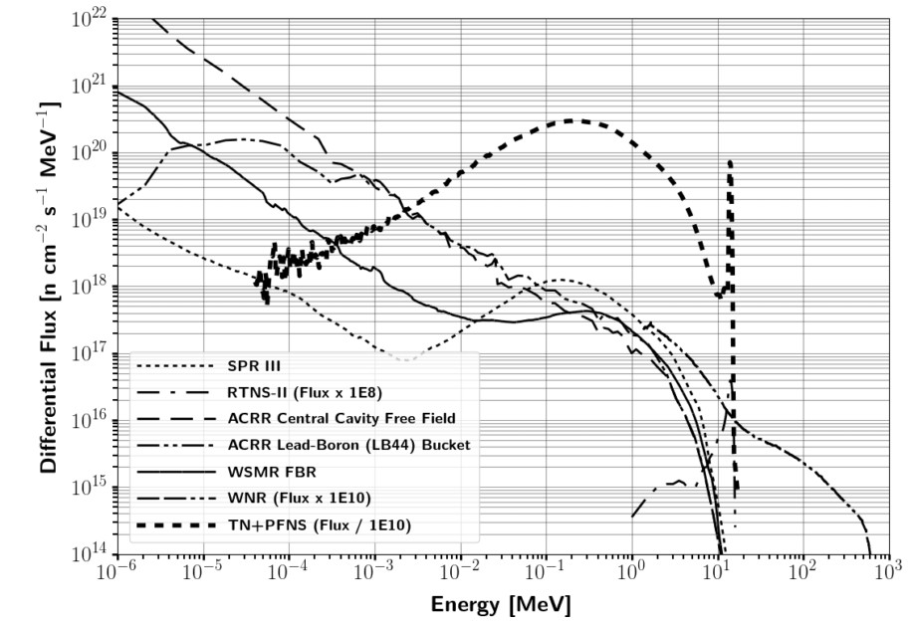particular, the present testing capability does not have the ability to produce neu- tron spectra that combine a thermonuclear (TN) and prompt fission neutron spectrum (PFNS). The vast majority of testing facilities are focused on the Watt-fission spec- trum, while a few are capable of producing the 14.1 MeV TN component from the deuterium-tritium (DT) fusion process [16]. Several examples of testing facilities for prompt neutrons outlined in Table 1 are the Sandia Pulsed Reactor III (SPR), Sandia Annual Core Research Reactor (ACCR), White Sands Missile Range (WSMR) Fast Burst Reactor (FBR), the Los Alamos National Laboratory (LANL) Rotating Target Neutron Source (RTNS), and the LANL Weapons Neutron Research facility (WNR). The differential spectral profile of these sources compared to a notional TN+PFNS is shown in Figure 1.

**Figure 1. Comparison of selected neutron sources to notional TN+PFNS [****5****].**

Each of the available neutron sources has an important purpose for national

security applications; however, they cannot meet the energy and temporal spectrum for every nuclear testing requirement. In comparison with the TN+PFNS, nearly all of the neutron sources are heavily weighted to lower energies and do not contain enough high energy neutrons for the TN component of a nuclear weapon. The RTNS has a high energy component, but the magnitude of the flux is substantially lower than required for nuclear hardness applications where the timing profile and integral fluence is important. The temporal aspect of the neutron flux also does not generally match to a nuclear weapon spectrum for some available facilities. Additionally, these large facilities are often at risk for shutdown, such as the SPR-III decommissioning for storage at the Nevada Test Site in late 2006 [17].

Many of these facilities are discussed for shutdown with growing regulatory demands and security requirements for storing highly enriched uranium (HEU) [18]. Gathering accurate experimental results requires a neutron flux spectrum equivalent to that of a true nuclear event, which creates a need for a neutron source capable of emulating the environment. Therefore, development of a TN+PFNS source would enable production of the correct fission product inventory in surrogate debris and thereby enhance the ability of the TNF community to perform the attribution mission. Additionally, a TN+PFNS source capable of NWE testing would greatly improve the nuclear weapon certification process.

## Background

Many approaches can be used to create nuclear weapon relevant neutron spec- tra in the absence of full-scale nuclear weapons testing. Some mechanisms are more applicable within different communities in nuclear sciences. Four main possible ways that the neutron environments are approximated for synthetic fission product debris production are sample doping, direct production using fission converters, surrogate

methods, and spectral modification of existing sources [5]. In the context of neutron effects on electronics, the key approaches utilize existing sources, computational mod- els, and surrogate charged particle reactions. Each of these methods is limited in representing the neutron environment experienced in a nuclear weapon.

The sample doping technique is accomplished by selectively correcting mass chains to modeled equivalent ratios. The resultant sample is built so as to look like it was produced with a desired energy-dependent fluence. A somewhat common TNF appli- cation using sample doping is the production of glass surrogate fallout debris for use in exercises or training [19]. The glassy matrix is created to emulate the solidified fission debris and entrained environment that is swept up in the stem of a nuclear explosion. The glass is doped with uranium and irradiated under various neutron environments depending on the requirements; however, the irradiation is often done with a thermal neutron reactor.

A key deficiency with utilizing a thermal reactor is that the neu- tron energy spectrum is not a close approximation to a weapon spectrum, and the fission products that follow will therefore not be accurate either. Utilizing a harder, or higher energy, neutron spectrum reactor is a better approximation; however, it is still not an accurate representation. Additionally, the sample doping technique can be approached by irradiating different samples at different facilities. A final sample which has the “correct” fission product ratios can be created by selectively pulling mass chains from the irradiated samples. This sample doping technique creates a fis- sion product debris sample; however, the spectral and temporal nature of the sample is not equivalent to what would be produced in a real nuclear explosion.

Direct conversion utilizes nuclear reactions to create a shaped neutron flux, which can be done via charged particle interactions or through fusion sources with a fission converter. It has been shown that direct production is, “impractical, complex, and unlikely to be implemented for safety or technological limitations” [5].

Surrogate methods rely on the formation of an equivalent compound nucleus through an alternative reaction mechanism [20, 21]. Surrogate methods are popular in studies where forming the product nucleus through the desired reaction is difficult or the energy cannot be fine-tuned. An example of this is neutron-induced fission on U-235 where a possible surrogate for U-235 neutron induced fission reaction, (n,f), is Th-232 (*α*,f), both of which form the U-236 compound nucleus. The surrogate approach has seen success; however, the nuclear data supporting the reactions is not as well understood [22, 23]. Additionally, there are some assumptions on the compound nuclear equilibration and spin-parity state which can impact the decay channels of the studied reactions [20].

Another commonly used surrogate method is to utilize charged particles for neu- tron damage in radiation effects on electronics. Ion beams can be used as a surrogate for neutrons by comparing the relative displacements per atom caused by the charged particle compared to a neutron [24]. A major benefit of using ion beams is that the energy can be finely tuned both in energy and deposition location, whereas neutrons are not as easily controlled. A disadvantage of using charged particles is that a large portion of the energy deposition as it travels through materials is based on electronic stopping power, while the neutral neutrons have negligible electronic interactions.

Neutrons have larger mean free paths in materials than larger charged particles of the same energy, so the flux will also be different. The Qualification Alternatives to the Sandia Pulsed Reactor (QASPR) program is the most significant venture into the use of surrogate ions to perform neutron effects component-level testing as a replace- ment alternative for the SPR [4]. QASPR combines operational irradiation facilities with modeling to predict neutron effects on electronic performance. While there have been substantial improvements to increasing the verification and validation of simu- lated charged particles to experimental outcomes, the validation for the experimental

data benchmarked to neutron experimental data is lacking in many cases [25].

The last main approach that could be used is spectral modification, a method of altering a neutron spectrum through nuclear interactions to generate an energy spec- trum of interest. Fundamentally, spectral modification is the goal of water moderated nuclear reactors to increase efficiency and allow the use of low enriched fuel.

Spectral modification is also performed in beam shaping assemblies used for boron neutron capture therapy (BCNT), where neutrons are used to treat tumors through neutron capture reactions in boron. A somewhat optimized objective neu- tron spectrum focused on the epithermal region is published by the International Atomic Energy Agency (IAEA) [26]. BCNT has been explored with a wide vari- ety of sources including accelerators and deuterium-deuterium (DD) fusion. A beam shaping assembly can be designed to moderate a source neutron flux to appropriate thermal, eipthermal, and fast spectrum for BCNT [27]. The build up of a design is produced primarily through moderation, reflection, and collimation of neutrons to the patient [28].

However, the approach to designing a beam shaping assembly lends itself to inefficiencies from an energy and population perspective. The collimation process blocks out a portion of potentially usable particles. Additionally, the beam shaping assembly resultant spectrum is often under-optimized. The development pro- cess could be enhanced to increase efficiency and spectral profile agreement with the objectives.

A novel spectral modification approach was developed by the University of California-

Berkeley and Lawrence Livermore National Laboratory (LLNL) for the development of an energy tuning assembly (ETA) to modify the National Ignition Facility (NIF) source to produce a TN+PFNS [5]. To perform the spectral modification, the Coeus metaheuristic optimization software package was developed to avoid manpower inten- sive iterative studies and enable the rapid design of future ETAs to convert a facility’s

characteristic source spectrum to any arbitrary objective spectrum, within the con- straints of physics [29]. Gnowee, the Coeus opimization engine, was developed for “rapid convergence to nearly globally optimum solutions” of this class of engineering problems [30]. It is important to note that the Gnowee and Coeus codes have appli- cability over a wide range of engineering problems, not just for the production of a TN+PFNS.

The result of the ETA design produced an acceptable representation of the TN+PFNS with the associated fission product distribution. The ETA design has been built and preliminary validation tests were conducted at the Lawrence Berkeley National Laboratory’s 88-Inch Cyclotron [5, 31]. The preliminary validation utilized 33 MeV deuterium breakup on tantalum as a neutron source and investigated the ability to model the ETA performance [31]. Integral validation is planned in fiscal year (FY) 2019, and a development shot to enhance ETA performance is planned in FY2020.

## Problem

There are several deficiencies that need to be addressed. The broad research objective for ETA is *Can an accurate neutron energy distribution expected from a ”typical” thermonuclear or boosted nuclear weapon detonation be produced using spec- tral modification at the NIF* ? This research effort aims to address three main problem areas for ETA and spectral shaping of neutron sources for simulating nuclear weapon environments that were raised by previous work. The goal of this work is to deter- mine the expected experimental outcomes of the ETA experiment by incorporating nuclear data covariance analysis. Additionally, ETA needs to be characterized as a potential ‘short pulse’ neutron source (SPNS). Each are detailed below along with accompanying research objectives.

1. FY 2019 NIF shot (ETA): Systematic uncertainty is not fully addressed in the

previous ETA calculations:

* + Quantify the impact of nuclear data covariances of the simulated results for the neutron energy spectrum, foil activation rates, and fission product production rates
  + Design a foil activation diagnostic pack to provide better resolution in the epi-thermal neutron energy range
  + Prioritize and estimate production of fission products for radio-chemical analysis using recently published data

1. The ETA at NIF was not evaluated for use as a SPNS
   * Model the neutron timing profile and expected flux in the ETA experimen- tal cavity

## Questions and Hypotheses

The research questions and hypotheses associated with the problems outlined in Section 1.3 are detailed below. They are organized by the problem and capability that they support.

1. 2019 ETA Fission Product Production Experiment
   * **What is the effect of nuclear data covariance on the simulated results?** It is expected that including nuclear data uncertainty will in- crease the relative error by approximately 1% for integrated and well un- derstood reactions and may extend over 10% for less studied reactions, thereby dominating Monte Carlo statistical uncertainty.

## Does the activation foil pack have sufficient coverage of the neu- tron spectrum to be used for unfolding? Previous work indicated

that the current foil pack design has poor coverage in the epithermal re- gion and is not sufficient to robustly unfold the neutron spectrum, should the model deviate from experimental results. Incorporation of better foil characteristics will improve this deficiency, and the performance can be tested through unfolding the ETA-generated neutron spectrum using per- turbed samples generated from including the nuclear data uncertainty.

1. ETA SPNS Characterization
   * **Can an ETA be useful as a capability for testing of prompt neu- tron environments?** It is anticipated that ETA can provide a TN+PFNS electronic testing capability due to the short NIF neutron pulse (∼ 300 ps), although the sample cavity is smaller than would be required for larger component testing.

## Assumptions and Limitations

An omnipresent limitation in many studies of science and engineering is the qual- ity and quantity of available data for applications. Nuclear engineering commonly draws from published works containing the relevant nuclear data and the uncertain- ties behind them. There is also compounded uncertainty in the published uncertainties as much of the available data is derived from models and never directly tested. The results presented are limited by the currently accepted understanding of nuclear physics phe- nomena and by the limitations of published data that is consistently being improved upon by the nuclear science community.

One delimitation, which was chosen for convenience and publishing ability, is that the nuclear weapon environments are presented at an unclassified level. All information used to develop the neutron flux and profile is available in open literature

or derived from unclassified information to produce a representative environment. The accuracy of the representative neutron environment compared to a specific real-world nuclear weapon scenario was not analyzed and will not be presented. The scope of this work aims to provide a position where, if desired, one could easily go from the unclassified spectrum to one that fully meets a requirement.

A delimitation for this work was the choice of the NIF as the neutron source. Other sources may be present that would also perform the role, but NIF has unique benefits, such as the prompt nature of the neutron yield and the fast neutrons arising from DT fusion. Although the NIF has been in operation since approximately 2010, there is a potential insertion of systematic error based on the source characterization and variability in the source output.

Nuclear weapons can be categorized into three general classes: fission, boosted and TN [16, 32]. Research has shown that the majority of the present capability to produce synthetic debris is most focused on the fission devices [5]. The TN+PFNS was chosen in previous work because it is an area that lacks substantial source development. It is important to note that there is not just one spectrum that can classify the TN+PFNS. The TN portion of the weapon spectrum is assumed to be pure DT fusion [32]. The impact of weapon design, which can vary substantially and play a large role in the resultant neutron energy spectrum, is not evaluated in this work.

Some physical phenomena present in a full-scale nuclear event are not taken into consideration for this analysis. First, the temperatures in nuclear weapons are on the order of 107 K, which is not experimentally feasible for configuration into the NIF [33]. Second, the time dependency of the internal neutron flux as the weapon is configured is not taken into account. Additionally, there will be large changes to the flux from initiation to burnout; this work only considers a time and volume average result.

Third, the synthetic weapon debris is created without induced fractionation. Chemical fractionation occurs when the nuclear debris formed solidifies based on the condensation point of the constituent materials. It is feasible to perform some level of fractionation; however, the levels of refractories and volatiles will not be altered in this work. Finally, the neutron spectrum considered is the internal weapon spectrum, which would be attenuated in magnitude and energy through material and the atmosphere. For fission product generation, the internal weapon spectrum is the key item of interest; however, nuclear certification testing would require modifications to determine a transported neutron flux for a requirement.

## Approach

The spectral shaping problem was defined by the objectives and constraints. For this research, the objectives for ETA were the TN+PFNS and the ultimate generation of spectrally accurate fission products. The problem constraints were based on the NIF source term and mechanical envelope. The input objectives and constraints were utilized in Coeus to produce a nearly globally optimum solution for an ETA [5]. The constraints for the problem were governed by the NIF source, which is modeled as the polar direct drive exploding pusher (PDXP), stay-out angle defined by the incident lasers to drive the fusion, and the constraints of the NIF Target and Diagnostic Manipulator (TANDM). The work performed previously completed a baseline design for the original ETA that will be used for analysis of the expected experimental performance.

The point design was modeled with MCNP5, MCNP6, and SCALE version 6.2 to perform neutron radiation transport. MCNP was used for the continuous energy solution, while SCALE was used for group-wise nuclear data covariance analysis. Ad- ditional post-processing incorporated nuclear data uncertainty associated with the activation cross sections. MCNP versions 5 and 6 were both used depending on com-

patibility with surface source read (SSR) files generated by LLNL for a full NIF model simulation to account for “room return” and scattering off ancillary equipment. Uti- lizing two different radiation transport models also increased the degree of confidence in the results. The radiation transport simulations provided results for the reaction rates for foil activation, neutron energy spectra, and temporal aspect of the neutron flux.

The General Description of Fission Observables (GEF) code was utilized for developing the expected fission product yields. GEF is a Monte Carlo- and theory-based approach that incorporates experimental data to determine fission observables, such as fission product yields [34]. Empirical methods for determining fission product distributions also exist. A formulation of this fit by S. Nagy was also used and is beneficial for comparison to GEF in addition to providing unique isotope yields [35]. These empirical methods often include simplifications, such as ignoring neutron multiplicity, to create a simpler equation and more direct tie to existing data—both a benefit and limitation of this approach.

A foil pack designed to be placed in the ETA experimental cavity was created to to successfully unfold the incident neutron spectra from the activation foils. The activation foils were selected with many important factors including the confidence in the nuclear data and energy range covered. The modeled foil activities were used with the underlying nuclear data to unfold the neutron spectrum using Pacific Northwest National Laboratory (PNNL) STAYSL. STAYSL relies on least- squares spectral adjustment based on the chi-squared of the measured activities to determine the incident neutron flux [36].

## Innovations

This research advanced the field of nuclear science and engineering in a few key ways:

1. **Demonstrated further abilities to incorporate nuclear data covariance into fixed radiation transport simulations:** The standard methodology for determining nuclear data uncertainty from stochastic sampling approaches is discussed in Chapters 2 and 3. This work utilized an approach to encompass the full range of uncertainty on the nuclear reactions when sampling from a multivariate normal distribution, thereby generating a more accurate depiction of the resultant uncertainty.
2. **Improved the ability to generate synthetic fission product debris:** A major goal of this research was to provide an improvement in spectrally accu- rate fission product debris production and improve the ability to model the production and predict the resulting debris.
3. **Advanced the field of neutron spectral shaping for radiation effects testing simulators:** The ETA design characterization represents a stepping stone in nuclear certification testing for providing a time- and energy-representative neutron environment.
4. **Developed methodology for quantifying the neutron flux uncertainty for foil activation unfolding of neutron energy spectra:** The techniques to map the systematic nuclear data uncertainty to an arbitrary group structure are discussed in Chapter3.
5. **Contribution to future improvements to SCALE:** Various pieces of feed- back were provided to Oak Ridge National Laboratory (ORNL) for future im-

provements to the SCALE package including inconsistent uncertainties from published data, the need for parallelization in individual Monte Carlo simula- tions, and the need for a high energy group structure with covariance data.

# Theory

This chapter outlines the major nuclear science and engineering theory relevant to spectral shaping and analysis of ETA. First, the basic neutron interaction theory that impacts the ability of a source to be shaped into an objective spectrum is discussed. Next, the nuclear fission process is outlined with a primary focus on fission prod- uct generation. After, fundamental aspects of nuclear data and their application in Monte Carlo neutron transport codes and an associated stochastic sampling approach utilizing nuclear data covariance matrices are outlined. Finally, neutron activation foil theory relevant to the unfolding of a neutron spectrum is examined.

## Neutron Interactions with Matter

Neutron interaction mechanisms with matter serve as a physical constraint to spectral shaping of a neutron flux spectrum. Neutron interactions can act to moder- ate, absorb, or even emit more neutrons. The major reaction mechanisms available in the range of the fast to thermal energies that are relevant to nuclear weapon envi- ronments are elastic scattering, inelastic scattering, radiative capture, and the release of ‘x’ particle (n,xn) reactions. Fission reactions are an extremely important reac- tion mechanism for the formation of synthetic weapon debris; however, fission does not contribute largely to the spectral modification problem for this application. A diagram summarizing the important neutron reactions is shown in Figure 2.

The neutron interaction probability is described by the neutron microscopic re- action cross section (*σrxn*), which is a function of the target isotope and incident neutron energy (*En*). The microscopic cross section multiplied by the atomic number density, *N* , provides macroscopic cross section (Σ*rxn*), a measure of the interaction probability in bulk material per unit path length traveled.

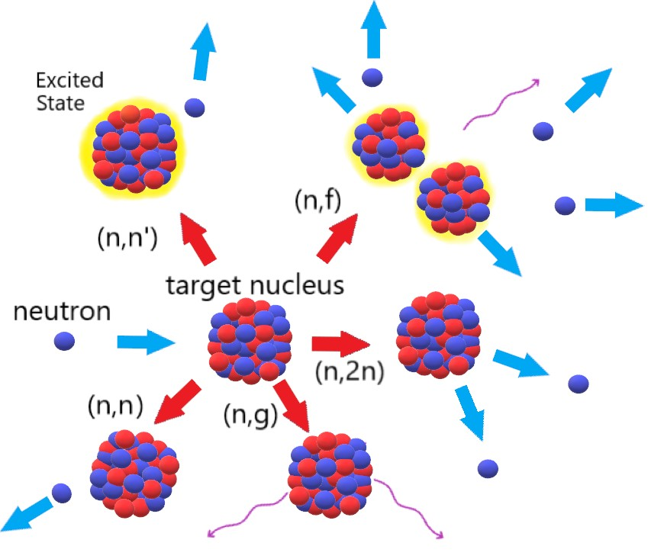

**Figure 2. Diagram of selected neutron reactions of importance to spectral shaping and fission product generation [****37****].**

## n,n

Elastic scattering (n,n) is an extremely important reaction for lowering the av- erage energy of the neutron population by downscattering [38]. An elastic collision does not place the target nucleus in an excited state, which allows for the simplified use of conservation of energy and momentum to describe the interaction. A selected group of elastic scattering cross sections relevant to the application in an ETA are shown in Figure 3.

The maximum energy lost in a neutron elastic collision with an isotope is a

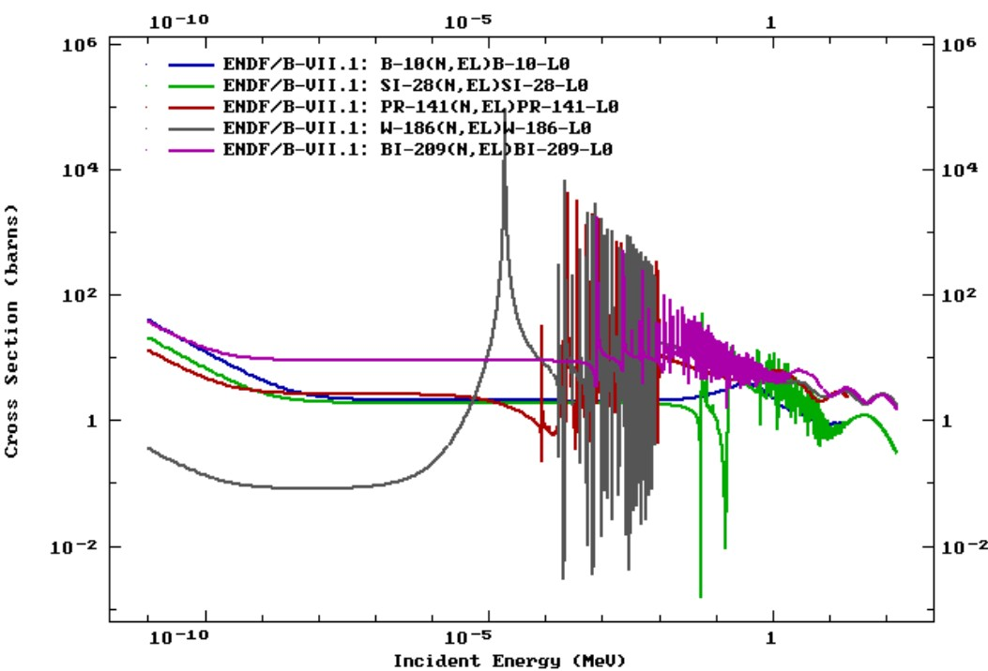

**Figure 3. Comparison of various elastic scattering cross sections for materials in the ETA design [****1****].**

function of the target isotope atomic mass (M). Elastic scattering off higher mass isotopes produce a smaller energy loss per collision compared to interactions with low atomic mass nuclei. Elastic scattering can transfer nearly all of a neutron’s kinetic energy with a collision on hydrogen, while scattering off bismuth will produce very little energy loss. The maximum energy transfer (Q) to the target nucleus per collision is given by

*Qmax*

4*MEn*

= *.* (1)

(*M* + 1)2

## n,n’

Inelastic scattering is similar to the reaction dynamics of elastic scattering; how- ever, the target nucleus is placed in an energetically excited state [38]. These excited

states are governed by quantum mechanics and are unique to particular isotopes. An incident neutron, or other particle, can populate an excited state of the atom. For inelastic scattering, this is typically one of the lower discrete energy levels. However, the incident neutron and target nucleus can form a quasi-continuous spectrum during a compound reaction, which gives rise to resonances [39].

Inelastic scattering is a threshold reaction, meaning an incident neutron must have a minimum amount of energy to enable the reaction channel. Additionally, neutrons generally lose more energy per collision on high Z isotopes if the interaction is inelastic compared to elastic scattering. The energy that would normally be conserved in an elastic collision is reduced in the conservation equations by the energy of the state populated. Examples of inelastic scattering cross sections are shown in Figure 4.

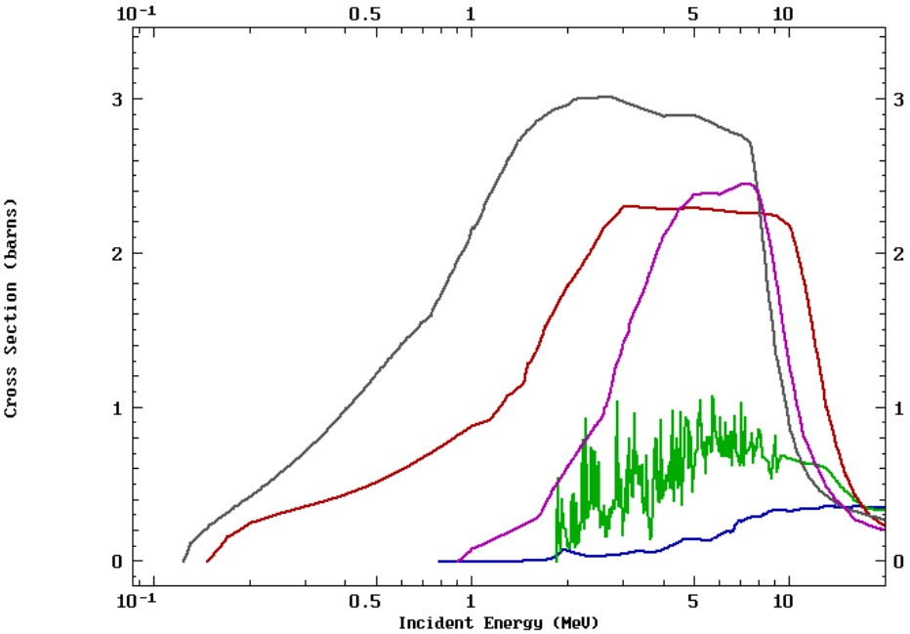

**Figure 4. Comparison of various inelastic scattering cross sections for materials in the ETA design [****1****].**

Inelastic scattering is one of the lower threshold energy neutron reactions. As

shown in Figure 4, there is no general functional form of the threshold energy to enable the reaction by isotope. The threshold for incident neutron energy to cause inelastic scattering with 27Al, a lighter isotope, is between 184W and 208Pb. These cross sections indicate the energy levels of the nuclei itself.

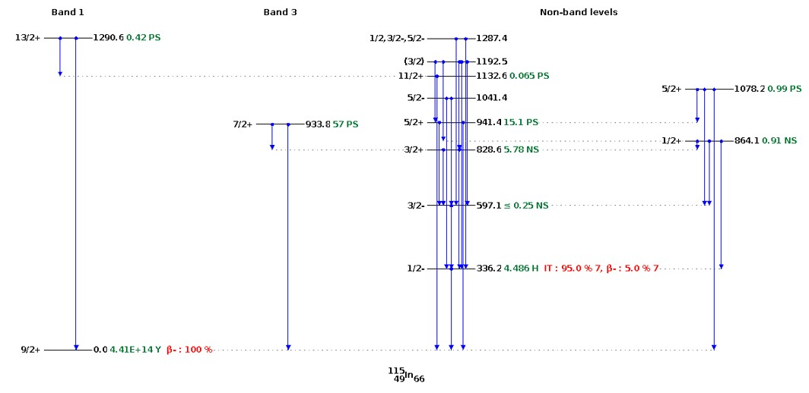The excited state nucleus can de-excite via gamma emission or other channels if energetically favorable. The excited nucleus usually decays in a short time; however, metastable isomeric states can be populated with inelastic scattering and have half- lives on the order of hours or much longer [39]. These isomeric states have applications in foil activation experiments used for neutron spectrum unfolding, where it may take some time to start measuring the foil activity. An energy level and decay mode diagram of 115In is shown in Figure 5.

**Figure 5. 115In energy level and decay mode diagram truncated at 1.3 MeV. The metastable state at 336 keV with spin parity** *J π* = 1*/*2*−* **is important for foil activation experiments for the higher epithermal region. Plots produced using the Online Ser- vice retrieval code package written by C. L. Dunford, National Nuclear Data Center, Brookhaven National Laboratory.**

## n,xn

A neutron can interact with a nucleus and eject additional particles, such as neutrons or protons. (n,xn) reactions such as (n,2n) and (n,3n) require a threshold energy to separate the neutron from the original nucleus, appropriately called the neutron separation energy. Neutron separation energies are on the order of a few MeV to tens of MeV [39, 40]. Increasing the incident neutron energy allows for the evaporation of more neutrons from the nucleus.

The (n,xn) mechanism can occur as a direct reaction, where the incident neutron interacts with only a few particles in the nucleus, or as a compound reaction, where the incident neutron interact with the entire nucleus and is absorbed [38]. Example (n,2n) reactions are shown in Figure 6. The cross section threshold is generally lower for higher atomic mass isotopes, which have neutrons that are not as tightly bound to the nucleus.

In the context of spectral shaping, (n,xn) reactions are significant for two reasons. First, the interaction increases the total neutron population by sacrificing a high en- ergy neutron. Second, the neutron energy post-reaction is lower because of the reaction required to overcome the potential barrier and losses through gamma emission. The lowered neutron energy is beneficial for building up lower energy neutron populations. Additionally, this reaction mechanism has applications in foil activation experiments for determining the high energy neutron population.

* + 1. **n,***γ*

Radiative capture, labeled (n,g) and (n,*γ*) in literature, is a reaction mechanism most prominent at low energies where an incident neutron is absorbed into the nucleus and a gamma-ray is emitted [39]. At low energies (below approximatley 1 keV, isotope dependent) the absorption cross section follows the “1/v” law, so the probability

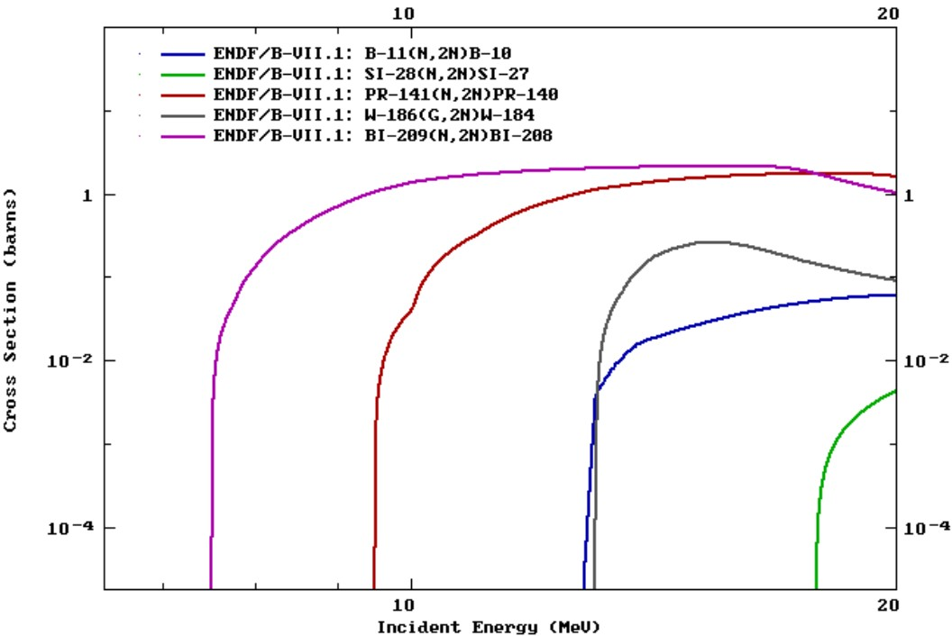

**Figure 6. Comparison of various (n,2n) cross sections for materials in the current ETA [****1****].**

increases with the inverse of the square of *En* [38]. Figure 7 provides examples of selected (n,*γ*) cross sections.

Radiative capture is an important absorption reaction mechanism in a few ways. (n,*γ*) reactions are of interest to foil activation experiments, specifically for determin- ing the thermal spectrum. The resonance structure in the epithermal region can also be used to generate a unique response. Radiative capture is generally undesirable for spectral shaping, acting as a poison for the neutron economy. Fortunately, the 14 MeV NIF source, is not largely affected by radiative capture until the neutrons have been moderated, but the (*n, γ*) reaction can be used to absorb an excess of thermal neutrons [5].

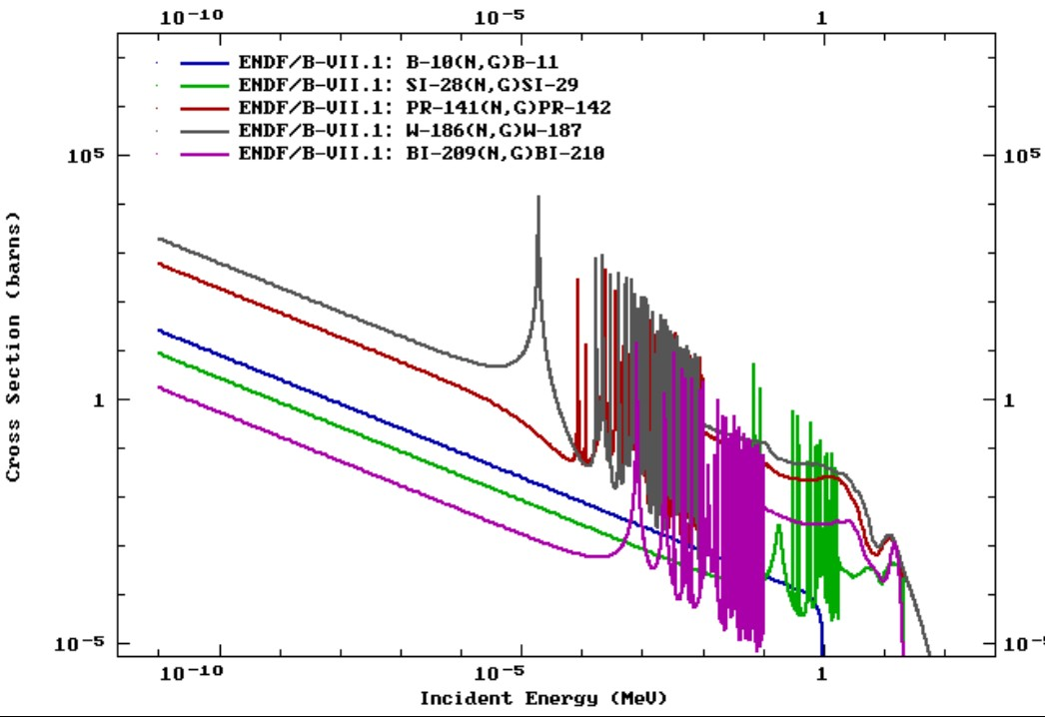

**Figure 7. Comparison of various (n,***γ***) cross sections for materials in the current ETA [****1****].**

## Nuclear Fission

* + 1. **Fission Theory**

In nuclear fission, an excited nucleus breaks up into two or more fission fragments. Fission releases a large amount of energy, which is distributed as kinetic energy in the fission fragments, neutrons, gamma-rays, and delayed decay energy. The amount of energy liberated is dependent on the specific reaction products, so an average number (approximately 200 MeV) is usually given. The delayed portion is associated with the decay of the unstable fission products, which includes energy in the form of beta (*β*) particles, additional gamma-rays, anti-neutrinos, and neutrons. A schematic of the fission process is shown in Figure 8.

Fission occurs most often in high atomic mass nuclei, such as 235U, 238U, or 239Pu;

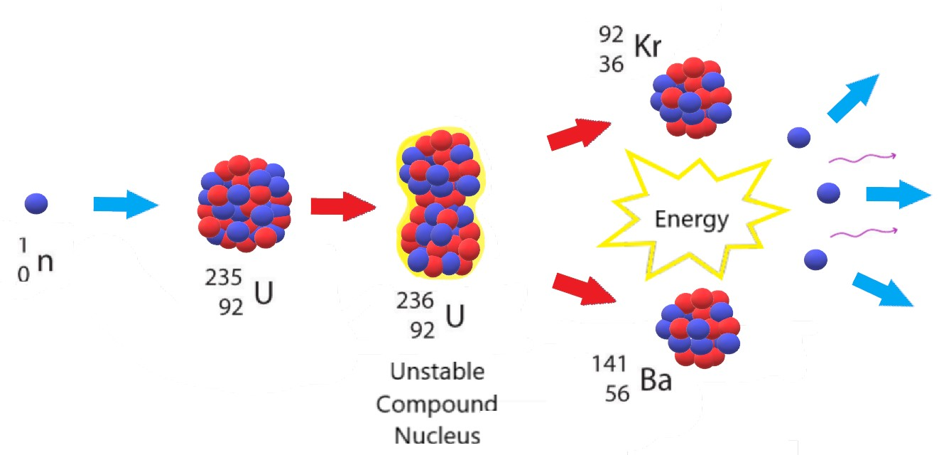

**Figure 8. Schematic overview of** 235**U neutron induced fission.**

however, any isotope can be fissioned at large enough incident energies. The fissioned isotope separates into two or occasionally three nuclei [16]. Fissionable isotopes like 238U, 240Pu, 242Pu have a significant fission barrier and are incapable of sustaining a nuclear chain reaction. Fissile isotopes like 235U and 239*Pu* are capable of sustaining a nuclear chain reaction and have cross sections with similar characteristics to the radiative capture cross section shown in Figure 7.

The unstable compound nucleus can be modeled at high excitation energies, well above the fission barrier, as an incompressible liquid drop [39,41]. The deformation of the nucleus causes increased surface energies, which are balanced with the Coulomb force (charge repulsion), the strong nuclear force, and shell pairing effects. The per- turbation creates an increase to the surface energy and decrease of the Coulomb re- pulsion because the charge is spread out [42]. During the fission process, the evolving compound nucleus can emit pre-fission neutrons, known as multi-chance fission [42]. First-chance fission is the emission of no neutrons, second-chance fission is the emis- sion of one neutron, and so on. Multi-chance fission is of particular importance to the mass chains observed in the fission product distribution.

Immediately following the fission event, the fission fragments are at a highly ex- cited state. Fission fragments are generally very neutron rich compared to the valley of stability. The excited fragments emit photons to de-excite and may have enough energy to evaporate more neutrons [42]. The prompt fission product yield is the distri- bution of products post neutron evaporation from the fission fragments. The average fission process releases 2-3 neutrons, and the average increases with incident neu- tron energy due to multi-chance fission and an increase in fission fragment excitation energy.

## Fission Products

The fission product distribution from thermally induced fission tends to be cen- tered around isotopes with closed nuclear shells. These isotopes have a “magic number” of protons and neutrons, similar to the filled electron structure of the noble gases. The fission fragment distribution of thermal neutrons incident on 235U is shown in Figure 9.

Low-Z stable nuclei have approximately equal numbers of protons and neutrons, but larger nuclei require more neutrons to mitigate Coulomb repulsion [39]. Most of the decay processes following fission are beta emitters, which occurs because the products are neutron rich and become more stable upon the conversion of a neutron to a proton. Figure 10 shows the primary decay modes of isotopes as they decay

to the valley of stability. In the region of fission products, the primary competing decay mode to *β*− is neutron emission, resulting in cross-mass chain transfers after

the initial fission process.

Fission yields can be described by the independent, cumulative, and chain yields. The independent yield, *Yind*, is the prompt fission product distribution directly after the fission event before successive decay [44]. *Yind* for 235U thermal fission is shown

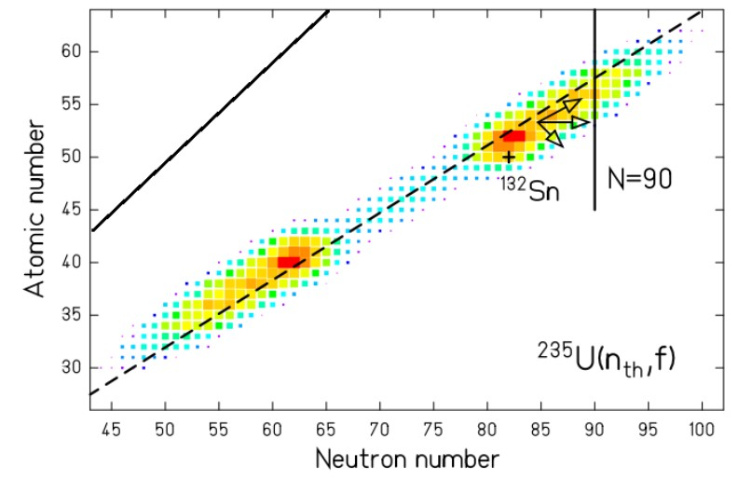

**Figure 9. GEF calculated thermal fission product distribution prior to prompt neutron emission. The dashed line is the neutron to proton ratio of 235U prompt fission products and the solid line is a ratio of 1 [43].**

in Figure 11. The independent isomeric yield is defined as [45]

*Yind*(*A, Z, I*) = *Y* (*A*) *f* (*A, Z*) *R*(*A, Z, I*)*,* (2)

where the sum yield (*Y* (*A*)) the sum of all independent fission products for a given mass A, the isomeric yield ratio (*R*(*A, Z, I*)) is the the production of each isomer (*I*) for a given independent yield, and the fractional independent yield (*f* (*A, Z*)) defines the yield of a particular isotope.

The independent yield produces a cascade of decay chains leading to the cumula- tive yield, *Yc*(*A, Z, I*). *Yc* represents the production of an isotope produced over all time after all prompt and delayed emissions and decays. *Yc* is normally the quantity

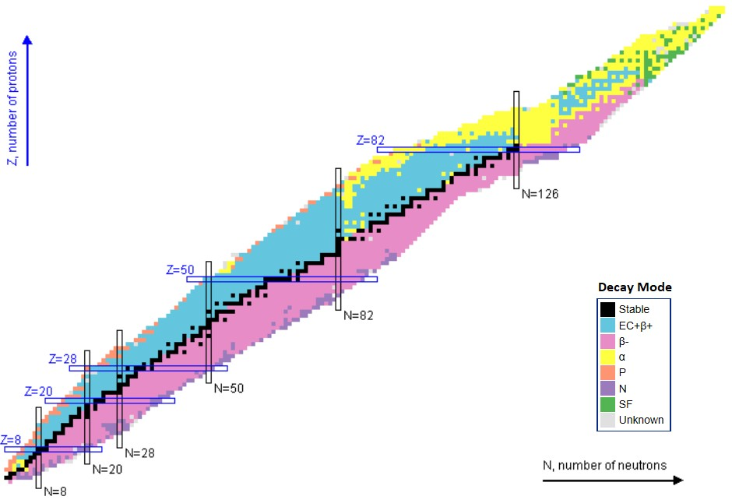

**Figure 10. Primary decay modes of isotopes. Plots produced using the Online Ser- vice retrieval code package written by C. L. Dunford, National Nuclear Data Center, Brookhaven National Laboratory.**

that is measured in experiments. The cumulative yield is given as [46]

*N*

,

*Yc*(*A, Z, I*) = *Yind*(*A, Z, I*) + *Yc*(*Aj , Zj , Ij* ) *bj .* (3)

*j*=0

where *bj* represents the branching from from isotope *j* into the cumulative yield and *N* defines the total decay channels into the cumulative yield isotope. The cumulative yields for thermal, fast, and high energy fission of 235U are shown in Figure 12.

As shown in Figure 12, fission product yields are dependent on the energy of the incident neutron and the fissioning nucleus. The fission products populate one heavy and one light peak. The region between the peaks is referred to in this work as the valley, and the low population tails falling off either peak are the wings. As the energy of the neutron is increased, the valley and wings of the fission product distribution

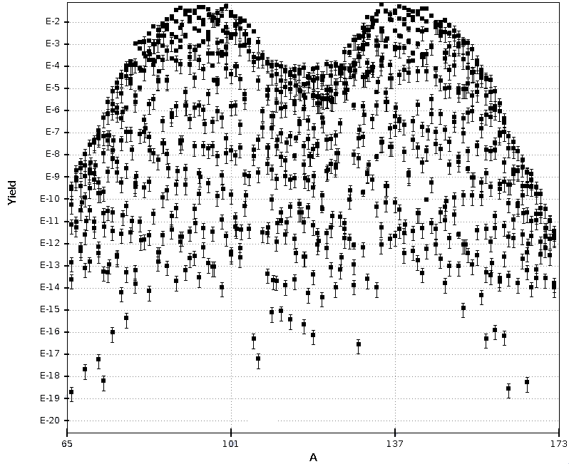

**Figure 11. Independent fission product yield of thermal fission of 235U. Plots produced using the Online Service retrieval code package written by C. L. Dunford, National Nuclear Data Center, Brookhaven National Laboratory.**

are raised as the fission process becomes more symmetric [41]. The uncertainty in the fission product yields varies significantly; the fast fission relative uncertainty ranges from 1.6% for mass chain 137 to 64% for mass chain 109 [1].

Finally, the chain yield for a particular mass chain is defined as the sum of the cumulative yields to the final decay to a stable or very long lived isotope in that mass chain [44]. The chain yield leads to the cumulative distribution accounting for branching in and out of a mass chain through neutron emission when; in particular, the chain yield equals the cumulative yield for the last stable member of a decay chain. An example is shown in Figure 13 for the A = 89 mass chain, where the stable

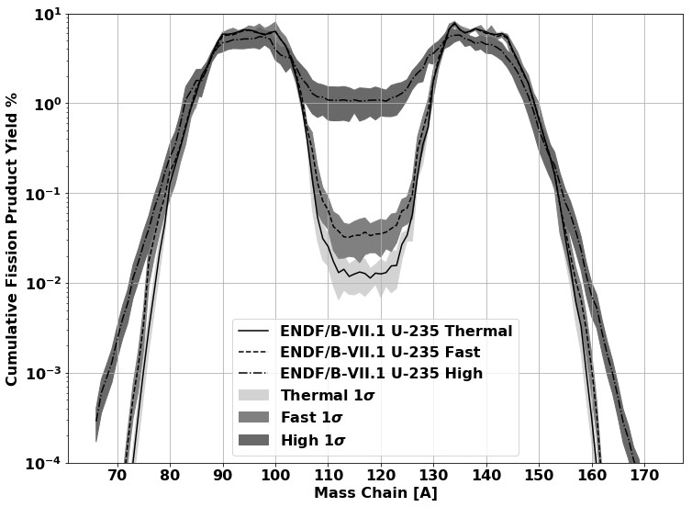

**Figure 12. Comparison of energy dependent 235U cumulative fission product distribu- tions from ENDF/B-VII.1 [****1****].**

isotope is Y-89 [47]. The neutron deficient decay scheme has not been shown as it has negligible contribution to the fission product decay scheme.

## Nagy Fits for Fission Product Isotopes

The three fissioning isotope energies provided in ENDF describe part of the behav- ior of the fissioning system; however, including fit experimental data enables better energy resolution and predictions consistent with observed experiments. Empirical relations developed by Nagy provide an approach to predict the fission product yield as a function of energy given sufficient yield measurement data. Nagy fits the fission

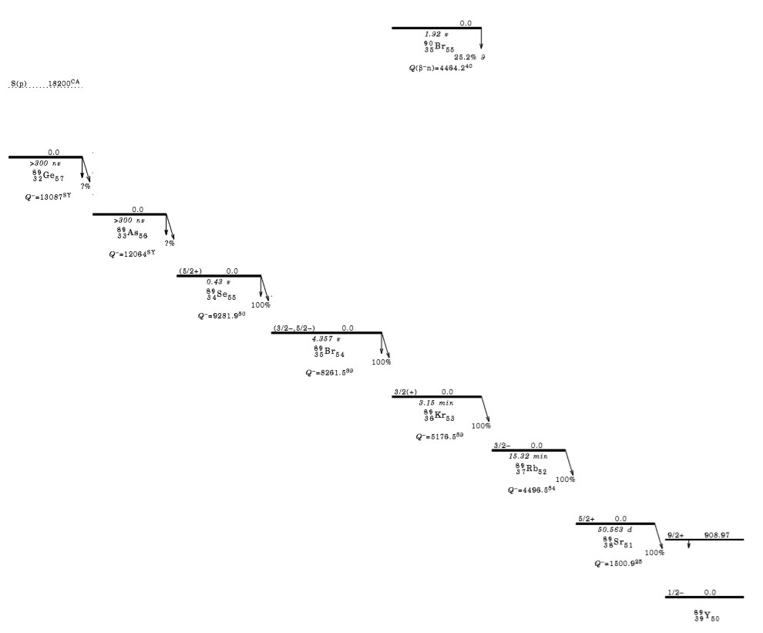

**Figure 13. Neutron rich decay scheme for mass chain A=89 where the 89Sr decay to**

**89Y represents the final decay to the stable isotope [47].**

product experimental data to an exponential equation

*Y* (*En*) = *Y*0*ebEn .* (4)

where the fitting parameters *b* and *Y*0 represent the slope of the function in logarithmic form and thermal fission yield, respectively [35]. The slope is the primary measure of the energy dependency of the fission product yield, which requires modifications for multi-chance fission. First chance fission is dominant from up to 5.5 MeV, and second-chance fission up to 14.1 MeV [35]. Multi-chance fission effects on the fission product yield are less pronounced in asymmetric regions but can have a large impact

in symmetric fission (109 ≤ *A* ≤ 129) [5] [35].

It is important to note that data-based phenomenological models are not per- fect predictors of determining fission products *a priori*. In particular, recent pub- lications have findings that cannot be accurately modeled with current theoretical approaches [41]. In general, there are large uncertainties in the predictive power of calculating energy-dependent fission product yields. Still, this type of empirical fit is more predictive than GEF for individual isotopes where sufficient energy-dependent measurements exist.

## Nuclear Data

* + 1. **Nuclear Data Libraries**

Nuclear data relevant to neutrons has been collected for the better part of the last century. Nuclear data available for modeling and simulations is collected and published in evaluated data files. There are many versions of evaluated nuclear data, which all aim to characterize the relevant physics backed by experimental results. For example, the primary U.S.-based nuclear data file is the Evaluated Nuclear Data File (ENDF). Other nations or organizations also have independent evaluations of the available nuclear data. Examples of other nuclear data libraries are the Russian National Library of Nuclear Data (ROSFOND), the European Joint Evaluated Fission and Fusion (JEFF) Nuclear Data Library, and the International Reactor Dosimetry and Fusion File (IRDFF).

Figure 14 shows the evaluation of 197Au (n,2n) reaction for various libraries. In some cases, the library evaluation can be drastically different. However, sometimes the libraries are drawing from the same data and models, which can be noted by the overlapping evaluations.

The experimental data that feeds into ENDF is contained in EXchange FORmat

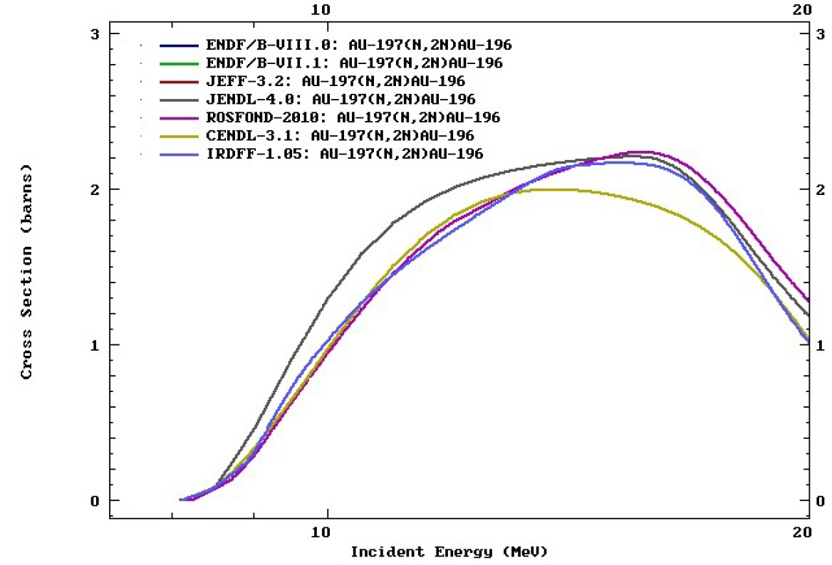

**Figure 14. Comparison of various library evaluations of the 197Au (n,2n) cross section [****1****].**

(EXFOR), where the experiment uncertainty, if available, is tracked. Experiments with sub-electron-volt neutron energy resolution are not feasible at the present time, so the nuclear data evaluators need reaction models to fill in the gaps. ENDF relies on evaluations of EXFOR data based on experimental quality, statistics, and theoretical basis to fill in areas lacking experimental data [48]. ENDF then stores the underlying nuclear data (cross sections, angular distributions, half-lives, ect.) that can be used in simulations.

Benchmarking the evaluated nuclear data is done primarily through testing of integral results, such as the effective neutron gain-to-loss ratio (*keff* ) of a critical assembly [48]. These integral measurements provide a more accessible measurement that can be done with high precision and accuracy, as precise as a relative error of 0.01%, to validate microscopic cross sections. The use of integral benchmark experi-

ments is important for comparing the net result of the nuclear data; however, there are uncertainties and correlations in the independent reactions that combine to create the integral results.

Validation experiments, applications, studies, and integral benchmarks performed increase the base and accuracy of the nuclear data [48]. However, it is important to note that the experiments used to measure nuclear data may have uncertainties that vary by orders of magnitude. An interesting feature of this fact is that the relative nuclear data uncertainty does not always decrease over time that the reaction is studied. One example is the increase in uncertainty in the neutrons released per thermal fission of 235U, which increased from 0.311% to 0.385% between ENDF/B-

VII.0 to VII.1 [49]. Another example demonstrating the nuclear data problem is that 6He half-life has changed by approximately 5% with large increases in the relative error over the last 50 years [50].

Another prevalent issue is that the majority of accurate measurements were per- formed for nuclear reactor studies, which limits accessibility to reliable data for dif- ferent applications. As a consequence of this, ENDF only contains fission production data at thermal, fast (0.5 MeV), and high energy (14 MeV). To combat this challenge, smaller, more application-specific libraries have been developed.

The International Atomic Energy Agency (IAEA) provides data for the bench- marked neutron dosimetry reaction IRDFF library [51]. This library is noted because it is used in the PNNL STAYSL code system, discussed in Section 3.4.2. The IRDFF

v.1.05 library contains “state-of-the-art” covariance information and has continuous improvement through testing and integral experiments [52].

The IRDFF library also includes feed through from fast decaying excited states to metastable states for important dosimetry reactions. An example is the 115In (n,n’) 115m1In reaction; the 115m1In reaction product decay scheme was depicted in

Figure 5. The first metastable state at 336 keV (spin parity *J π* = 1*/*2*−*) has a half-life of 4.5 hours, which makes it a good candidate reaction for foil activation experiments [53]. The IRDFF v.1.05 library contains reaction data that includes the decay of additional metastable states and higher excites states into 115m1In. Under standard measurement timing conditions, all of the higher energy 115In states will have decayed, thus contributing to the activity measured for the first metastable state.

## Nuclear Data Covariance

Covariance arises in nuclear related experiments when one process affects another or the nuclear data measurement energy ranges are correlated. Unfortunately, nuclear data covariance analysis is not standard to experimental analysis. Often er- rors are attributed to model fidelity, measurement, or setup problems when nuclear data covariance may have been the root cause [54]. In many nuclear decay processes, the correlation between decays is unity because the decays happen in a series. How- ever, covariance can occur if there is branching from a radioactive state. Covariance is defined with the expectation values, (*X*), and mean value (*µ*) providing for the covariance between variables X and Y as

*cov*(*X, Y* ) = (*XY* ) − *µX µY ,* (5)

A correlation matrix combined with the uncertainty in the nuclear data can be used to form the covariance matrix. The diagonal of the correlation matrix is one, so the diagonal of the covariance matrix is the variance for the group. As such, the covariance of an observable compared to itself reduces to the variance

*cov*(*X, X*) = (*X*2) − (*X*)2 = *σ*2 *.* (6)

*X*

The conversion from a correlation matrix to a covariance matrix is given by

*cov*(*X, Y* ) = *corr*(*X, Y* )*σX σY .* (7)

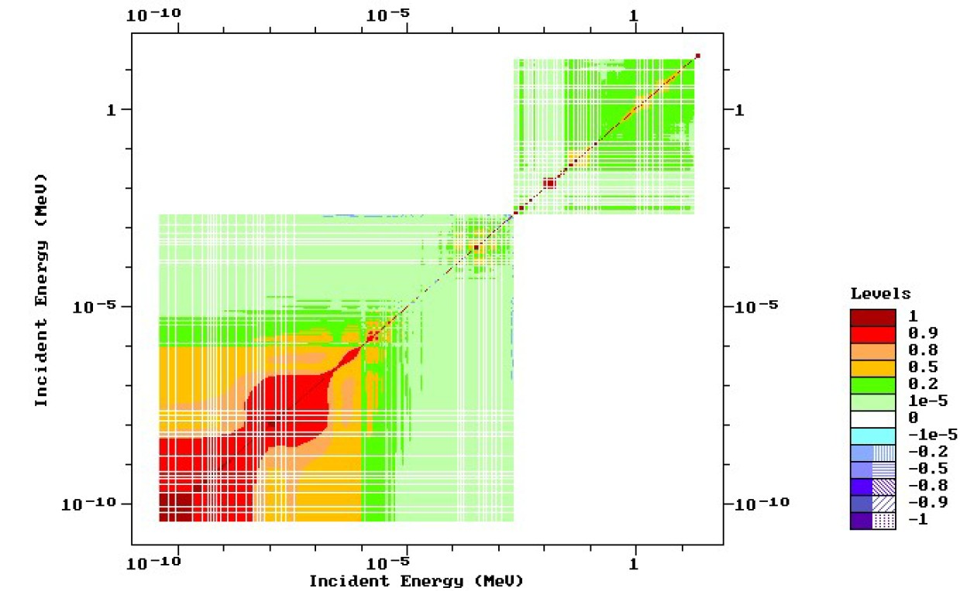Instead of the covariance matrix, nuclear data often stores the correlation matrix in a group structure format, as shown in Figure 15. In general the largest correlations occur in nearby energy groups, where the experimental uncertainty in the incident *En* is largest. Correlations also exist between reactions, in addition to correlations in a single energy-dependent reaction channel, but this data is rarely quantified.

**Figure 15.** 235**U (n,f) correlation matrix [****1****].**

Integral experiments are extremely dependent on the underlying reactions that make up the net result. Therefore, there are generally larger variances in the reactions that are part of the total cross section. Figure 16 displays the relative uncertainty of the 235U (n,f) cross section compared to the total. Figure 17 displays the total cross section of 209Bi compared to the (n,2n) reaction.



**Figure 16. 235U (n,f) compared to 235***U* **(n,tot) cross section uncertainties [****1****].**

The uncertainty in 235U (n,f) and 209Bi highlight a couple key attributes relevant to nuclear data. First, the component reactions that make up the integral cross section almost always have a higher relative uncertainty because integral cross section experiments can more accurately be measured through attenuation of a “beam” of neutrons. The underlying reactions are generally more difficult to characterize. Sec- ond, the 235U (n,f) relative uncertainty near 2.2 keV is 133.6%, which implies that when utilizing a Gaussian distribution, the cross section must go negative to cap- ture the full distribution of possible total cross sections within a given confidence interval. This is obviously non-physical; however, it gives scope to the magnitude of uncertainty of the underlying cross sections over difficult experimental energy ranges. Next, the 235U reactions are more thoroughly studied as compared to 209Bi. Over the majority of the energy range, 235U is below one percent relative error, largely driven down by thermal nuclear reactor experiments, while 209Bi has a larger error



**Figure 17. 209Bi (n,2n) compared to 209Bi (n,tot) cross-section uncertainties [****1****].**

of around 5%. Finally, areas where the cross sections are low have representative larger relative errors; this is the case near the threshold of the 209Bi (n,2n) reaction shown in Figure 17.

## Nuclear Data Stochastic Sampling

The two primary methods that exist for uncertainty quantification of radiation transport simulations are linear perturbation and stochastic sampling Monte Carlo approaches [55]. First order linear perturbation theory is not always adequate for large uncertainties or incorporating second order effects from the uncertainty in the neutron transport; however, it does have broad uses in the reactor community. Stochastic sam- pling has grown in popularity as computational resources have improved. Stochastic methods rely on performing independent neutron transport calculations with per- turbed nuclear data libraries sampled based on the covariance of the cross sections

using the multivariate normal distribution to build up a distribution of responses [56]. The generalized multivariate normal distribution as a function of the nuclear cross section mean values (***µ***) of length k, random solution vector (***X***), covariance matrix (**Λ**) is is given by

*f* (***X***) =

*exp*( 0*.*5(**X *µ***)*T* **Λ***−*1(**X *µ***))

/(2*π*)*k* | **Λ** | *.* (8)

− − −

Several Monte Carlo sampling methods have been created to capture the effect of nuclear data covariance on nuclear engineering problems, including SCALE Sampler, NUSS, SHARK-X, amongst others [57] [58] [59] [56]. Many collections of software capable of performing these types of uncertainty quantification are not available for distribution or focus solely on reactors.

Deficiencies with the stochastic sampling approach are generally associated with the nuclear data libraries utilized and the sampling method. First, nuclear data uncertainty is often above 100% in energy regions where a measurement was never taken, so the value of the cross section is not well characterized. Second, the nuclear data uncertainty is assumed to be normally distributed; however, alternative forms may be more appropriate. In stochastic sampling approaches, these two factors leads to truncation of large uncertainties to prevent performing neutron transport calcula- tions with negative cross sections. Although negative cross sections are non-physical, the truncation may underestimate the uncertainty, which can have an effect if the experiment is performed in these energy domains when using the Gaussian distri- bution. Finally, component cross sections which make up the total cross section are constrained to add up to the total cross section.

## Monte Carlo Neutron Transport

* + 1. **Monte Carlo Neutron Transport Theory**

Monte Carlo methods for neutron transport leverage pseudo-random sampling, nuclear data, and material specifications to build up a simulation of the particle transport in space, direction, energy, and time [60]. Neutron interactions are sampled with probability distribution functions (PDFs) for aspects such as path length traveled and interaction type [61].

An objective of a neutron transport calculation is to determine the average be-

havior of particles within the system. This can be captured with the volume averaged scalar flux, *φ*¯*V* , defined as

*φ*¯*V*

= 1 *dV*

*V V t*

r

r

*dt*

*E*

r

*dE φ*(*rr, E, t*)*,* (9)

where *φ*¯*V* is given as a function of energy (*E*), position (*rr*) and time (*t*). Monte Carlo methods approximate the scalar flux with either track length or collision estimates [61]. The track length estimator is

*φ*¯*V*

*W Tl*

= *,* (10)

*V N*

where the path length score for the flux is based on the length traveled (*Tl*) and is normalized by the particle weight (W), cell volume (V), and number of histories sampled (N).

Statistics often drive the uncertainty in a Monte Carlo simulation as systematic uncertainties are generally not considered due to computational costs. The “true” mean value, *µ*, of a response PDF is the expectation value, *E*(*x*), which is estimated with a sample mean, *x*¯. According to the Central Limit Theorem, the sample mean approaches the real mean as the number of samples, *N* , goes to infinity, and the

distribution of sampled *xi* follows a Normal distribution. The sample mean can be calculated as

1

*x*¯ =

*N*

*N*

*xi.* (11)

,

*i*=1

Therefore, sample variance, (*S*2) can be computed as

*x*

*S*2 = 1 ,(*x*

*N*

*x*

*N* − 1

*i*

*i*=1

− *x*¯) *,* (12)

*i*=1

and the variance of the mean, (*Sx*2), is simply

2

¯

2

*S*

*S*2 = *x ,* (13)

*x*¯ *N*

where *S*2 is defined with the sample variance. Therefore, the statistical uncertainty in the results decreases with √*N* . The precision of the result can be improved with

*x*

more histories, shrinking the spread in *xi*. However, the accuracy cannot be improved. Accuracy is impacted by systematic errors, such as uncertainty in the nuclear data.

## Comparison of Monte Carlo Neutron Transport Results

The results from different Monte Carlo simulation codes often produce slightly different results. The outputs are generally in better agreement for criticality calcula- tions of critical assemblies and nuclear reactor analysis. It is important to gauge the effect of utilizing different transport codes to see how much variance is expected. Some of the differences that effect Monte Carlo simulations are within the structure of the code itself, statistical error, or different starting seeds, while others are based on the nuclear data that may be altered, geometry or source implementation, or user error.

Criticality is a well-understood nuclear engineering problem that the nuclear data

libraries are validated against. A study conducted on a high temperature pebble-bed reactor compared SCALE’s CSAS6 module for criticality calculations to MCNP5’s kcode [62]. The results showed a difference for calculating *keff* to be on the order

of a few hundred percent mile (105 ∗ (*keff* − 1)*/keff* ). This variance can easily be

handled for reactor operations; however, this highlights that even well understood problems do have differences based on operating code. A similar study of a pebble-bed reactor determined that the difference in *keff* in MCNP to SCALE was near half a percent [63]. Another study compared the average gamma-ray dose outside of a spent nuclear fuel cask [64]. The difference in dose rates between the modeled SCALE and MCNP simulations varied as much as 27%. Again, this shows that the less benchmarked studies can have large code-to-code disagreements.

## Foil Activation

* + 1. **Foil Activation Theory**

Foil activation is a method of characterizing an incident neutron flux through unfolding the response of the foils using the energy-dependent nuclear reaction chan- nels in the foil. Activation experiments are essential for testing that require small geometry to fit in the apparatus or where electronics equipment for higher fidelity measuring techniques will be damaged.

Activation foils produce measurable radioactive isotopes during the course of irra- diation. The production rate of radioactive isotopes is negated by radioactive decay processes, which place an upper limit on the radioactivity of a foil [65]. The saturated activity

*A∞* = *R* =

*E*2

*φ*(*E*)Σ(*E*)*actV* (14)

r

*E*1

is equivalent to the reaction rate (*R*), which is a function of the energy dependent flux (*φ*), the macroscopic reaction activation cross section (Σ(*E*)*rxn*), and the volume of the foil (*V* ). The energy term (*E*1) is zero in many cases; however, threshold reactions require the incident neutron to be of higher energy to enable the reaction channel.

At six half-lives, a foil will have reached approximately 98% of its saturation activity, neglecting spatial and energy self-shielding effects [65]. When the activation is not sufficient to fully saturate the foil, a correction needs to be made. The activation of the foil for a given irradiation time (*ti*) is given as

*A*0 = *A∞*(1 − *e−λti* )*,* (15)

where *λ* is of the decay constant of the radioactive product.

The formula can be simplified in the limit of irradiation times much less than the half-life of the activation products. In this case, the reaction rate is much larger than the decay from radiation, so the rate of production of the radioisotope is driven only by the reaction rate. The neutron pulse length at the NIF is on the order of shakes, so this approximation can be made for the foil activation. The time integrated flux, or neutron fluence (Φ), can be used to determine the total reactions, (*Rtotal*), over an irradiation period, given by

*Rtotal* =

*E*2

Φ(*E*)Σ(*E*)*actV dE.* (16)

r

*E*1

Experimental measurements of the activity must be corrected to deduce the orig- inal activity of the foil (*A*0) immediately after irradiation as shown in Equation 17. The activity is corrected for the radioactive decay for the time between the end of ir- radiation and the start of counting (*td*). A similar correction factor based on the count

time (*tc*) provides a correction for radioactive decay during counting that can result in a reduction of counting rates by the end of the counting period. Additionally, the detector efficiency for the given gamma-ray energy (*E*) and relative gamma intensity (*Iγ* ) must be taken into account. The gamma intensity may also include a branch- ing ratio if applicable to the decay mechanism. Finally, the measured counts (*C*) is reduced by the background counts (*B*). All corrections included, less self-shielding effects, provide a formulation for converting counts to post-irradiation activity as

*λ*(*C* − *B*)*eλtd*

*A*0 = *E*(1 − *e−λtc* )*I*

*γ*

*.* (17)

## Selection of Experimental Foils

The method of foil activation has been studied in-depth in the nuclear sciences and engineering community. A list of the various requirements that are of importance for a neutron activation foil experiment with energies in the range of thermal to approximately 20 MeV are summarized below [60, 65, 66].

* The reaction neutron cross section is extremely important for foil activation, and there are a few key parameters that should be considered. First, the magni- tude of the cross section determines the reaction rate of the product nuclides. A large cross section allows for more activation, and therefore, better results when analyzing the activation foils. Second, the uniqueness of the cross section shape is used to unfold the incident neutron energy spectrum. An (n,*γ*) cross section may peak in a particular region, which is essential to providing information of the neutron flux in that energy region. Alternatively, a threshold reaction, such as an (n,2n), is important for providing information of the flux at higher energies. Third, the selected foils for an experiment should cover the entire en- ergy range of the incident neutron flux. Finally, the cross section must be well

characterized with low uncertainty over the neutron energy range of interest.

* The range of activation product half-lives applicable for a particular experiment depend on availability of detectors and the foils post-irradiation. A long-lived radioisotope will be available for counting for longer times at the expense of the total activity. The opposite is true for short half-lives. Half-lives on the order of an hour to a few years are generally used; however, the half-life must also be balanced with the production of the radioisotope to understand the entire picture.
* The elemental and chemical purity of the activation foil should be well known. An unknown composition foil can produce erroneous results.
* Interfering reaction channels and decay emissions should be avoided. An ex- ample of this is natural copper, which has multiple 511 keV emissions from different reaction channels. It is difficult to distinguish these gamma-rays to determine activation in counting. Similar problems arise in multi-isotope ma- terials that have multiple reactions producing the same nuclide. For example, the 106Cd (n,*γ*) reaction produces the same isotope as a 108Cd (n,2n) reaction, which complicates the determination of contributions to the reaction products.
* The activation foil should be optically thin to not cause perturbations of the neutron flux. An additional benefit of relatively thin foils is that the gamma-ray emissions for detection are not significantly attenuated through self-shielding. In general, adding additional foils helps to improve the unfolding results, as long as the entire foil set remains generally optically thin [67].
* The decay nature of the product nuclide should preferably be a gamma-ray emitter. Gamma-ray detection can provide fine energy resolution to determine activation. The discrete gamma-ray emissions provide a means of determining

the source and magnitude of the the foil activation. The energy of the gamma is also of importance. Semiconductor detection methods have a peak intrinsic efficiency near 100 keV with some variance depending on whether the semiconductor is p-type or n-type. Beta spectroscopy is also a potential option that may be considered; however, the resolution is not as good as gamma spectroscopy.

## Neutron Energy Spectrum Unfolding

Foil activation experiments are a well-documented method for determining an inci- dent neutron energy spectrum [65]. The foils are irradiated under a nearly equivalent neutron flux, which serves to activate the foil samples through nuclear reaction chan- nels, each of which has a unique response function with respect to the neutron flux. The nuclear data and activities of the foils can be used to unfold the incident neutron energy spectrum.

In an ideal situation, the number of foil reactions (*i*) would be selected based on the number of energy groups (*j*) required, and the problem would be formulated as [60, 67]

*N*

,

*Ai* =

*j*=1

Σ*i*(*Ej* ) Φ(*Ej* ) *V, i* = 1*..m.* (18)

In practice, this formulation of the unfolding problem is not used as it often provides nonphysical results. The issue is caused by the varying shapes of reaction cross sections, which create a poorly constructed matrix and a limit on the number of foils that can be used at a time to prevent changing the neutron flux. There are many methods that aim to provide solutions to the generally degenerate neutron spectrum. A few examples unfolding methods include matrix inversion, least-squares spectral adjustment, and stochastic algorithms [68]. Direct matrix inversion was previously discussed in the setup of the unfolding problem. Matrix inversion is generally seen

as “ill-posed” and can lead to non-physical results, such as negative fluxes [67, 68]. Stochastic methods rely on random sampling to derive a best-fit or average over a group of reasonably well-fitting spectra [68]. The least-squares method minimizes the chi-square based on a guess spectrum, activation information, and nuclear data [69]. The least-squares method is also known as spectral adjustment and can incorporate more information, most notably the underlying energy dependent nuclear data, into the determination of the resultant spectrum [69].

The general formulation of the least-squares method is derived from minimizing the activation results to the nuclear data and input spectrum [69]. The chi-square (*χ*2) is given as per degrees of freedom (*ν*) as a function of the uncertainty, activation rates, nuclear data, and measured results. The *χ*2 formulation of the least-squares approach can be reduced if there is no time dependency of the neutron flux as

*χ*2 1 ,

*m*

*N*

*j*=1

(

*Ai*

Σ (*E* ) Φ(*E* ) )2

*i j j* −

*VFoil*

*σ*

*i*

=

*ν ν* 2

*i*=1

*.* (19)

Providing an initial spectrum is generally required for the unfolding methods. The activities produced for the foils is often highly degenerate, where an infinite amount of spectra could provide the same observable end-point. The initial spectrum allows for the insertion of more physics-based results to unfold. For neutron spectra, an initial guess spectrum is often created with a particle transport code or a deterministic solution. Alternatively, an initial spectrum could be selected from published results, where in some applications provide similar results [70].

# Methodology

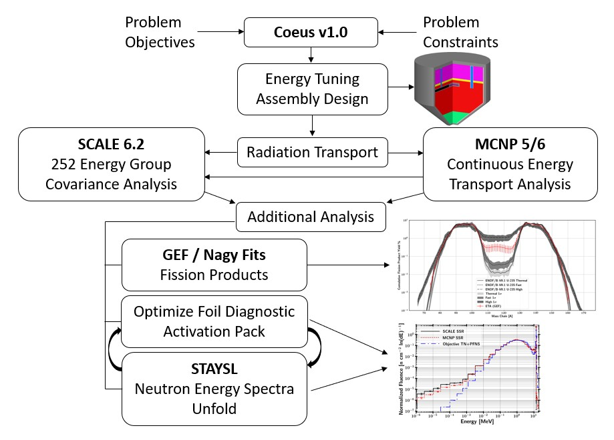Figure 18 displays the overarching research approach. First, the objectives and constraints that provided the ETA design are outlined. Next, the radiation trans- port simulations for MCNP and SCALE are discussed along with sampling from the nuclear data covariance data for the SCALE Sampler runs. The activation foil pack and neutron flux unfolding methodology is then provided in the context of the data available from the radiation transport calculations. Additionally, the fission product isotope and mass chain models are provided. Finally, the statistical analysis tests utilized throughout the results are discussed to interpret the results.

**Figure 18. Overview of the major research components from ETA design to key analysis areas.**

## Energy Tuning Assembly Design

The ETA analyzed in this research was taken as an initial condition; however, it is important to understand the motivation that went into the design. Each of the objectives and constraints have impacts on the ability of ETA to effectively shape the neutron source to a TN+PFNS.

The TN+PFNS was created utilizing the Godiva bare critical assembly, a metal- lic sphere of HEU, to approximate the down-scattered components from the TN and PFNS source neutrons. A Watt fission spectrum volume source and a 14.1 MeV cen- tered point source at a 10 keV plasma temperature were transported through Godiva using MCNP6 [5, 71]. The Godiva transmitted components combined to generate the TN+PFNS with 15% fusion-born neutrons and 85% Watt-fission neutrons. The objective spectrum was created with the 46 group DPLUS structure, which is utilized in radiation shielding problems and in the DABL69 library [5, 72].

## NIF Constraints

There were a few limits to the constraints imposed by NIF that do not directly affect the analysis performed in this study but did affect the ETA design and the spec- tral shaping capability and fission product production. The three main constraints were a weight limit, stay-out angle, and distance from the DT source, all of which are linked together to form the experimental envelop available for the designed ETA.

The first constraint was a maximum weight of 75 kg. The weight limit lowers the ability of ETA to match the objective spectrum by decreasing the scope of design possibilities and mass available to modify the spectrum. The weight constraint was derived based on the limits of the diagnostic and instrument manipulator (DIM) planned to field ETA at the NIF. The closest standoff range was 15 cm from the DT source mounted on the target positioner (TARPOS) given the allowable weight.

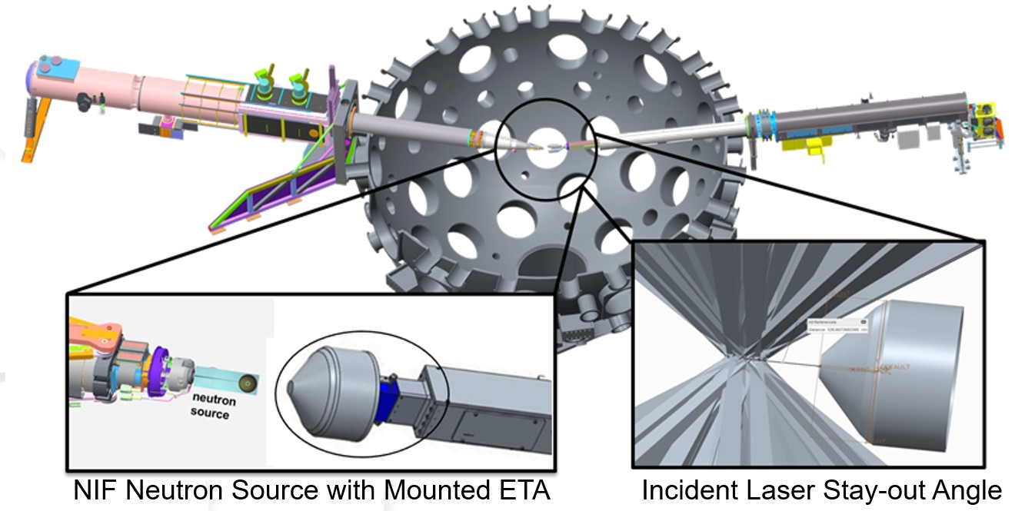Finally, the stay-out angle provides the laser paths a clear line of sight from the beam ports to the DT capsule. A diagram of the planned ETA experiment is shown in Figure 19. Since the original design, the experiment has been moved to target and diagnostic manipulator (TANDM) 90-124, which provides opportunities to re-evaluate the overall constraints due to increase lift capacity.

**Figure 19. Diagram of ETA experiment at the NIF showing ETA installed on TANDM 90-124 with neutron source mounted on TARPOS 90-239. The bottom left graphic shows a notional mounting of ETA on TANDM 90-124. The bottom right graphic highlights the laser path clearance requirement constraint.**

## NIF Source

The NIF source used in the original design of ETA was a “high foot” shot at the NIF and is shown in Figure 20. The indirect drive “high foot” source utilized a hohlraum, shown in Figure 21, responsible for the large downscattered source com- ponent shown in Figure 20 [73].

However, source development is a continuing process, and direct drive sources with high neutron outputs and a reduced downscattering component have been developed. The current NIF source modeled for this work was a DT Polar Drive Exploding Pusher



**Figure 20. Comparison of objective TN+PFNS to NIF source constraint utilizing the 140520 NIF shot.**

(PDXP) target with a nominal yield of 3*.*7 × 1015 neutrons from laser-driven inertial confinement fusion. The PDXP source is a DT mixture (65:35 ratio DT) compressed to 8 atmospheres [74]. The capsule is comprised of a hydrocarbon glow discharge polymer (GDP) 2.9 mm in diameter [75]. The PDXP source does not utilize auxiliary systems to achieve compression, unlike other NIF sources that require a hohlraum to smooth out the ablation surface. Instead the compression is driven solely by the NIF laser configuration. The large benefit of using a low-mass target is the removal of downscattering within the source hohlraum. This has enabled the PDXP source to be modeled as a 14 MeV point source in previous NIF experiments. The plasma burn width is approximatley 300 ps, so all of the neutrons were modeled as being emitted instantaneously [74].

Many experimental models at NIF utilize a zero-temperature plasma value for the neutron source because the inertial confinement process is not at equilibrium, making

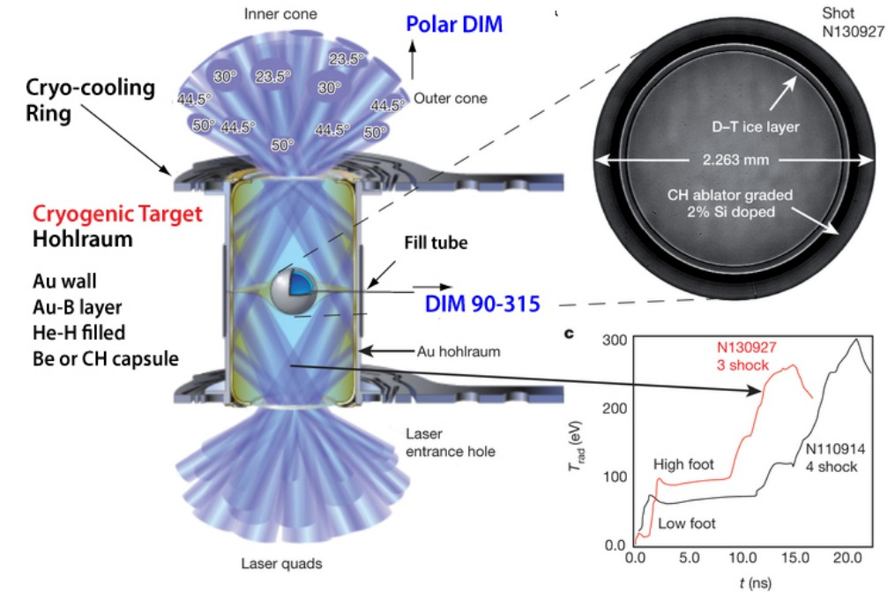

**Figure 21. NIF shot N130927 utilizing a hohlraum and image of DT source [****73****]**

.

any temperature value an indirect measurement. These models often use DT neutrons modeled as a 14.03 MeV isotropic point source. However, this is an approximation that neglects the spread in neutron energies due to the plasma temperature.

The plasma temperature from the fusion reaction will result in a distribution of neutron energies due to differences in reaction rates and imparted energy from conversation of mass and energy [76]. The distribution of neutron energies produced by the NIF was taken as a theoretical thermal plasma at a temperature of 10.75 keV [77]. The resultant Gaussian distribution centered at 14.06 MeV has a full width at half maximum of approximately 0.58 MeV. The unnormalized source probability distribution function for the source used in this work is shown in Figure 22.



**Figure 22. 10.75 keV plasma temperature DT fusion source distribution.**

## Radiation Transport

Three radiation transport simulations were performed to analyze ETA. Both MCNP5 and the SCALE MAVRIC sequence were utilized to increase the degree of confidence in the results. The radiation transport simulations provided results for the reaction rates for foil activation, neutron energy spectra, and temporal aspect of the neutron flux. The modeling efforts and purpose of each code are described in the sections that follow.

## Nuclear Data Libraries

A few nuclear data libraries were utilized depending on the application and code system. First, the continuous energy neutron transport simulations performed in

MCNP and SCALE utilized the ENDF/B-VII.1 library [1]. ENDF is a comprehen- sive nuclear library that contains the data necessary for the transport calculation. ENDF/B-VII.1 was also used for response functions not available in IRDFF or where the IRDFF data was consistent with ENDF. The multi-group nuclear data transport calculations were performed with the 252 group SCALE library based on ENDF/B-

VII.1. The 252 group structure is the largest fidelity multi-group SCALE library with samples distributed to utilize in Sampler. The activation foil reactions largely utilized the IRDFF v.1.05 library [51].

It is commonplace for nuclear data libraries to have equivalent information when drawing from the same experimental sources or from each other directly; however, differences do arise in the evaluated data as highlighted in Figure 23. While there is good agreement in the 197 Au (n,g) uncertainty, IRDFF had a much larger uncertainty from 1 to 4 keV, and the SCALE 252 group library drops to zero uncertainty after approximately 2.5 MeV. Some of the deviations were based on the group structure utilized.

A few reactions utilized the SCALE ENDF data when the SCALE 252 group data was consistent with the IRDFF or data was not available in the IRDFF. The activation foils and tallied reactions that did not use the IRDFF were 55Mn (n,g), XXX*U* (n,f), and 186W (n,g). A comparison between the uncertainties for 55Mn(*n, g*) is shown in Figure 24. Overall, there was agreement between the uncertainties. The energy region where the uncertainty has been truncated encompassed a negligible percentage of the reactions, so the effect is minimal.

## MCNP

A continuous energy radiation transport simulation was performed in MCNP5 in collaboration with the NIF [78]. The NIF model in MCNP5 has been utilized for



**Figure 23. Comparison between IRDFF v.1.05, ENDF/B-VII.1, and SCALE 252 Group ENDF/B-VII.1 197Au (n,g) reaction cross-section uncertainties.**

numerous experiments and moving from MCNP to other radiation transport codes is cumbersome due to the high fidelity model that has been built up. ETA was modeled in the full NIF chamber including TARPOS 90-239, TANDM 90-124 with mounted ETA, TANDM 90-348 with diagnostics, the polar DIM, and the first panel walls [79]. The ancillary equipment and surroundings were incorporated into the model to account for ‘room return’ in the NIF chamber. The mean flux at the HEU sample, expected activities of foils, and fission numbers were determined using 2 × 1011 source particles. The variance reduction techniques utilized were the SSR and importance cells.

The MCNP SSR file was used to create sources representing the incident flux from the DT source and room return from supporting equipment. The SSR surfaces were



**Figure 24. Comparison between IRDFF v.1.05, ENDF/B-VII.1, and SCALE 252 Group ENDF/B-VII.1 55Mn (n,g) reaction cross-section uncertainties.**

a disk 17.5 cm in diameter at the front (source facing) and bottom of ETA and a connecting cylinder as shown in Figure 25.

The normalized probability distribution functions for the source locations are shown in Figure 26. The effect of the room return in the NIF chamber is most clearly shown in the cylindrical and back surface. The front-facing surface also con- tains room return; however, the source 14.03 neutrons dominated the spectrum.

The MCNP5 results were used to benchmark the continuous energy solution in MAVRIC. Although it was not feasible to perfectly replicate the source distribution because there are many scattering angles crossing a surface in different directions, it was possible to approximate the behavior for the purpose of quantifying the effect of nuclear data covariance.

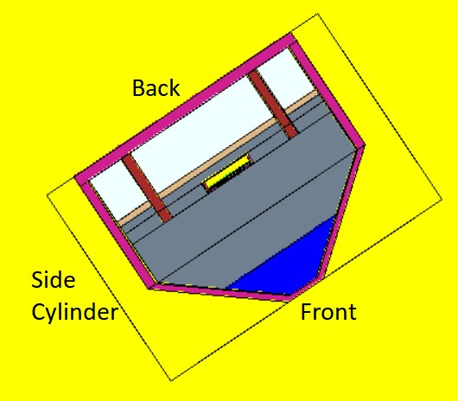

**Figure 25. Surfaces for NIF source SSR file. The front source faced the DT point source and the back surface was mounted to TANDM 90-124.**

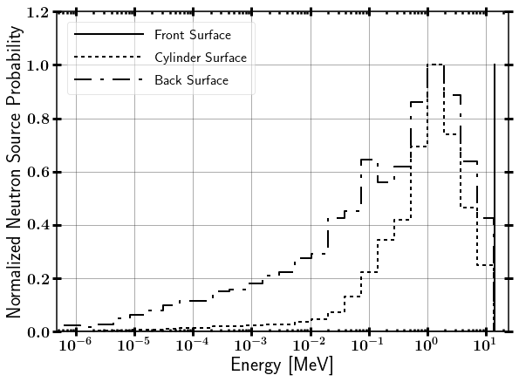

**Figure 26. Surfaces source probability distribution functions mapped to SCALE.**

## SCALE MAVRIC

A continuous-energy radiation transport simulation was performed in the SCALE MAVRIC sequence which utilizes automated variance reduction techniques along with the traditional Monte Carlo transport calculation. The three SSR sources were mapped over to SCALE by approximating the behavior with source definitions. The total fluence of neutrons passing through the front, back, and cylindrical SSR surfaces were 6*.*5 × 1014, 3*.*5 × 1012, and 2*.*4 × 1012, respectively. The front source was ap- proximated as a point with the strength determined from a the spherical divergence (1*/R*2) of the source neutrons to the front facing surface. The back source was a disk, and the cylinder was four equal strength line sources facing ETA and emitting in 2*π*. Ideally, the cylindrical source could be mapped over with a cylindrical source; however, the reference directions for emission in SCALE are in Cartesian coordinates. The benchmarking of the mapping of MCNP to SCALE was performed by com- paring the reactions in the foil pack and neutron flux in the HEU foil. Two key aspects were important to determining a goodness of fit. First, the magnitude of the reaction difference between the continuous MCNP and MAVRIC results was nearly equivalent to 1%. Second, there is not a systematic pattern to the differences between the threshold or thermal reactions modeled in SCALE and MCNP. A com- parison between MCNP and SCALE MAVRIC reactions products in the foils and

fissions is summarized in Table 1.

The continuous energy SCALE reactions matched fairly well to the MCNP reac- tions. There was a noted bias of approximately 1% for increasing reactions in SCALE; however, these are within the differences documented in Section 2.4.2. Nonetheless, there were some key deficiencies in the way that the sources were mapped over. First, the SSR source had 109 sample written points. In MCNP, these points re-sampled at the same entry location on the SSR with new random numbers. For SCALE, the

**Table 1. Activation foil reactions comparison between continuous energy MCNP SSR and SCALE MAVRIC mapped SSR. All statisitcal uncertainties were below 0.2%.**

|  |  |  |  |
| --- | --- | --- | --- |
| Reaction | MCNP SSR  Continuous Energy | SCALE MAVRIC  Continuous Ennergy | |
| Reactions | Reactions | Percent Change Relative to MCNP |
| 90Zr (n,2n) 89Zr | 1.89E+09 | 1.91E+09 | 1.5 |
| 58Ni (n,2n) 57Ni | 1.87E+08 | 1.90E+08 | 1.4 |
| 58Ni (n,p) 58Co | 6.54E+09 | 6.64E+09 | 1.5 |
| 197Au (n,2n) 196Au | 2.91E+09 | 2.91E+09 | -0.1 |
| 197Au (n,g) 198Au | 1.00E+09 | 1.02E+09 | 2.0 |
| 115In (n,n’) 115Inm1 | 3.81E+09 | 3.82E+09 | 0.05 |
| 115In (n,g) 116Inm1 | 5.14E+09 | 5.19E+09 | 1.0 |
| 27Al (n,a) 24Na | 1.08E+09 | 1.08E+09 | -0.02 |
| 186W (n,g) 187W | 7.21E+08 | 7.30E+08 | 1.2 |
| 55Mn (n,g) 56Mn | 3.14E+08 | 3.23E+08 | 2.8 |
| 235U(*n, f* ) | 1.94E+09 | 1.96E+09 | 0.5 |
| 238U(*n, f* ) | 2.70E+07 | 2.67E+07 | -1.1 |
| Total Fissions | 1.99E+09 | 2.00E+09 | 0.5 |

effect of the SSR was homogenized over the surface. Also, there was a systematic bias of the room return that was not captured in the source approximations. The ancillary equipment in the room increased the scattering back to ETA in that region. Again, this was homoginized over the entire surface for SCALE. The angular resolu- tion for the SCALE sources was restricted to equal probability in 2*π*; however, there is undoubtedly a systematic trend that was missed.

## SCALE Sampler Sequence

A 252 group radiation transport simulation was performed for 182 discrete trials in Sampler to build up a distribution of Monte Carlo responses to capture the systematic nuclear data uncertainty. The Sampler sequence is a “super-sequence” that acts as a wrapper above the MAVRIC sequence [59]. The nuclear data libraries were

randomly perturbed to determine the distribution of responses due to uncertainty in the transport due to nuclear data.

The SCALE Sampler module enabled analysis of nuclear data covariance. The unperturbed nuclear data was executed for the first sample along with a user-defined number of samples. The sample nuclear data libraries were perturbed nuclear data based on the covariance largely developed from ENDF/B-VII.1; however, additional information has been included from ENDF/B-VI, ENDF/B-VII.2 (proposed at the time), JENDL-4.0, and collaborative research between Brookhaven National Labora- tory, Los Alamos National Laboratory, and Oak Ridge National Laboratory. Finally, the nuclear data covariance libraries included information completed in the Working Party on International Nuclear Data Evaluation Cooperation Subgroup-26 [59].

The associated Sampler libraries contained 1,000 pre-sampled neutron cross sections limited to 56 and 252 group structures. It is important to note the weighting functions for SCALE’s library which are a Maxwellian from 10*−*5 eV to 0.1 eV, a Watt Fission spectrum from 80 keV to 10 MeV, and 1*/E* between 0.1 eV to 80 keV and for 10 to 20 MeV. A notable issue with utilizing a single group structure for all applications is the weighting function to process the continuous energy cross sections will impact results if the flux is dramatically different. This problem is difficult in that a group structure would be needed for each individual problem and is further complicated by changes in the neutron spectra in different regions of a problem.

The continuous energy MAVRIC script was modified by changing the library to the 252 group version and adding the Sampler wrapper to maintain the same inputs. Table 2 presents a comparison between MCNP and SCALE MAVRIC 252 group re- actions products in the foils and fissions. There are some important discrepancies that are caused by the 252 group structure. The 252 group Sampler mean total re- actions were generally in agreement with the continuous energy solutions with three

exceptions: 89Zr, 57Ni, and 56Mn. The first two threshold reactions were attributed directly to the flux weighting of the 13.8 to 14.6 MeV group utilized in the energy re- gion where the reaction occurred. The 252 group 55Mn reaction difference from MCNP was caused by the flux weighting used to create the group cross section, and the bulk of the difference occurs below 80 keV. The 252 group library performed well for the majority of the reactions because many of the activation reactions are saturated by the PFNS, which is synonymous with the Watt Fission neutron spectrum.

**Table 2. Activation foil reactions comparison between continuous energy MCNP SSR and 252 group SCALE MAVRIC mapped SSR. All statisitcal uncertainties were below 0.2%.**

|  |  |  |  |
| --- | --- | --- | --- |
| Reaction | MCNP SSR  Continuous Energy | SCALE MAVRIC  Continuous Ennergy | |
| Reactions | Reactions | Percent Change Relative to MCNP |
| 90Zr (n,2n) 89Zr | 1.89E+09 | 2.05E+09 | 8.6 |
| 58Ni (n,2n) 57Ni | 1.87E+08 | 2.20E+08 | 17.4 |
| 58Ni (n,p) 58Co | 6.54E+09 | 6.65E+09 | 1.5 |
| 197Au (n,2n) 196Au | 2.91E+09 | 2.93E+09 | 0.6 |
| 197Au (n,g) 198Au | 1.00E+09 | 9.92E+08 | -0.8 |
| 115In (n,n’) 115Inm1 | 3.81E+09 | 3.86E+09 | 1.2 |
| 115In (n,g) 116Inm1 | 5.14E+09 | 5.14E+09 | -0.1 |
| 27Al (n,a) 24Na | 1.08E+09 | 1.06E+09 | -1.1 |
| 186W (n,g) 187W | 7.21E+08 | 7.09E+08 | -1.8 |
| 55Mn (n,g) 56Mn | 3.14E+08 | 2.64E+08 | -15.9 |
| 235U(*n, f* ) | 1.94E+09 | 1.95E+09 | 0.01 |
| 238U(*n, f* ) | 2.70E+07 | 2.70E+07 | 0.03 |
| Total Fissions | 1.99E+09 | 1.99E+09 | 0.004 |

Sampler was performed for 182 trials until the responses converged to a solution to build up the distribution of responses to use for random sampling and bootstrapping. Figure 27 displays the convergence of the mean and uncertainty of the bootstrapped values for a few selected reactions. The 55Mn (n,g) was the least converged and largest

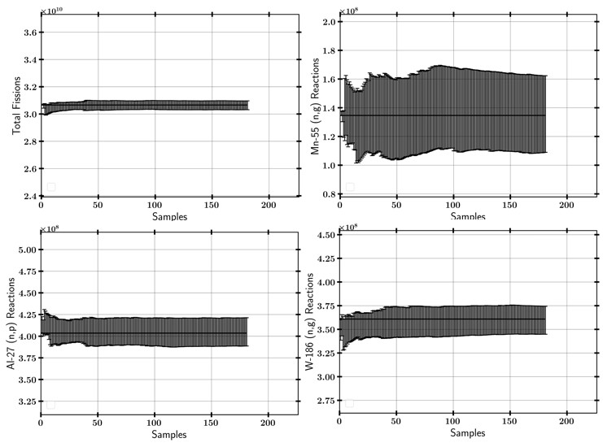relative error reaction due to high systematic uncertainty and relatively large nuclear data uncertainty over the ETA spectrum.

**Figure 27. U(n,f), 55Mn (n,g), 27Al (n,p), and 186W (n,g) sampled histogram and reaction convergence as a function of Sampler trial. The convergence graphs included the IRDFF nuclear data covariance.**

## Nuclear Data Covariance

Capturing the full nuclear data uncertainty is essential because it is often a domi- nant unknown in nuclear applications [80]. The majority of uncertainty analysis done to date focus on integrated quantities such as the effective criticality of a nuclear reactor [81] [82]. However, applications such as radionuclide production rely on a sin- gle reaction channel that is observed, which can have much larger uncertainties than noted in integral quantities. Furthermore, it is important to note that ENDF-based

uncertainties may also be underestimates of the general nuclear data uncertainty [49].

The methodology to incorporate the IRDFF nuclear data in the SCALE Sampler module is shown in Figure 28. There are three key contributions to the uncertainty of a result in this radiation transport simulation. First, the uncertainty in the neutron transport was quantified using the SCALE Sampler module. Second, the uncertainty in the reaction cross section was assessed using IRDFF data. In most uncertainty quantification analysis, these two nuclear data systematic uncertainties (*σsys*) are treated at the same time. However, these were separated in this analysis to incor- porate the IRDFF reactions and uncertainty. Last, every Monte Carlo-based result has statistical uncertainty *σstat*, which can be driven to negligible values with enough computation resources.

## Sampling Transport Related Uncertainties

The SCALE Sampler module was utilized to assess the neutron transport response uncertainty by generating independent samples to characterize the distribution of re- sponses. The transport-related uncertainties are quantified in the neutron fluence on the HEU and activation foils. For each trial, Sampler utilized a different set of nuclear data to transport the source neutrons through the geometry. The variance in the energy-dependent fluence over the trials determined the transport-related un- certainties. One benefit of the 252 group structure utilized by SCALE was that the uncertainty in the reaction rates follow linearly from the fluence, so better statistics at low energy are easier to achieve in comparison with a continuous energy solution.

## Sampling Nuclear Data Covariance Libraries

Sampler can perturb additional variables; however, there were presently no methods to include correlations to allow for a user-defined response function in Sam-

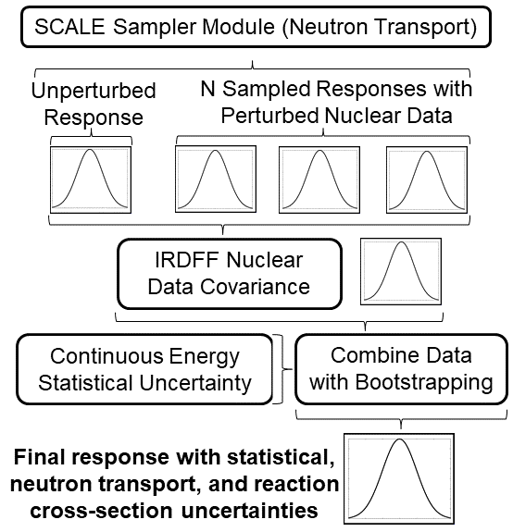

**Figure 28. Methodology flowchart to insert nuclear data uncertainty for reaction chan- nel from alternative library into SCALE.**

pler (i.e., IRDFF cross section) to be sampled with a covariance matrix. Instead, the reaction rate response was calculated independently of the Sampler runs assuming that the nuclear data followed a correlated multivariate normal distribution utilized by the SCALE Sampler sequence [83] [84] [85] [59]. The nuclear cross sections were converted to a 252 group format in SCALE, while the uncertainties were converted from the IRDFF format by linear interpolation of the midpoint bin energies. The linear interpolation was used to approximate the uncertainty when the bin structure did not align with the mapped energy group structure, which was deemed appropriate due to the uncertainty varying linearly over small energy ranges.

The nuclear data and uncertainty were sampled from the multivariate normal distribution for each independent Sampler trial. The reaction tally (*R*) result was perturbed by the ratio of the macroscopic cross sections (Σ) before and after multi- variate random sampling to create group-wise perturbation parameters (*Q*) with the neutron flux (*φ*) over 252 groups (g).

252

,

*R* =

*g*=1

*φg* Σ*g Qg* (20)

The net result effectively modified the microscopic cross section to form the perturbed R. The multivariate normal distribution sampled data acted as a set of constants that are multiplied to each energy group [85].

## The Case for Sampling with Alternative Probability Distribution Functions

Common practices for stochastic sampling approaches are built around the mul- tivariate normal distribution, which is a straightforward way to sample from nuclear data covariance matrices. However, the log-normal distribution is more appropriate for physical properties that cannot take on negative values such as neutron cross sections, which can have uncertainties greater that 100% [86]. The log-normal dis- tribution and normal distribution produce similar approximations for small relative uncertainties, but the distributions diverge significantly for large variances. For ex- ample, the 55Mn (n,g) reaction had large uncertainty at higher neutron energies. The evaluated cross section and experimental data informing the (n,g) reaction cross section near 14 MeV in ENDF/B-VII.1 is shown in Fig. 29.

The experimental data is spread over an order of magnitude, but it is most dense around the evaluated cross section, thereby supporting the use of a log-normal dis- tribution over the normal distribution. The sampling of the nuclear data covariance



**Figure 29. Experimental nuclear data informing** 55**Mn (n,g) reaction in comparison with the evaluated nuclear data contained in ENDF/B-VII.1 [****1****].**

matrices assuming a log-normal distribution instead of a normal distribution can produce drastically different results in radiation transport simulations.

To illustrate why a log-normal or similar distribution may be more appropriate, a Monte Carlo simulation was conducted simulating darts thrown on a board with a mean value in the x and y Cartesian coordinates of 0.5. This example assumes negative values are a non-physical quantity. Three distributions were compared over varying uncertainty, a normal distribution, a normal distribution with negative num- bers rejected as is done with the multivariate normal distribution approach, and a log-normal distribution1. The mean dart position and mean radius were compared, and the outcome is shown in Table 3. The distribution of darts is shown in Figure

1The SCALE Sampler sequence utilizes a multivariate normal distribution with negative numbers

rejected and reassigned.

30.

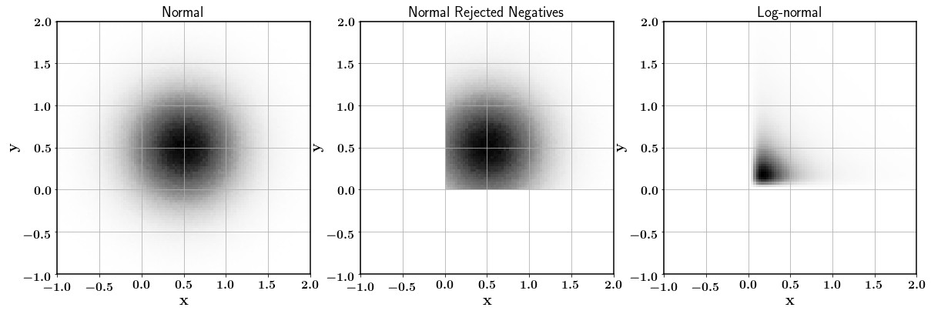

**Figure 30. Normal, normal with rejected negatives, and log-normal distribution of darts in example Monte Carlo simulation with a mean value of 0.5 in the x and y Cartesian directions and an position uncertainty of 100% in each direction.**

**Table 3. Monte Carlo Darts results with normal, normal with rejected negative values, and log-normal distributions.**

|  |  |  |  |
| --- | --- | --- | --- |
| Distribution | Normal | Normal Rejected | Log-normal |
| *µ* = 0.5 *σ* = 0.5 | | | |
| *x*¯ and *y*¯ | 0.5 ± 0.5 | 0.64 ± 0.4 | 0.5 ± 0.5 |
| *r*¯ | 0.63 ± 0.32 | 0.50 ± 0.25 | 0.51 ± 0.49 |
| *µ* = 0.5 *σ* = 0.25 | | | |
| *x*¯ and *y*¯ | 0.5 ± 0.25 | 0.51 ± 0.24 | 0.5 ± 0.25 |
| *r*¯ | 0.31 ± 0.16 | 0.29 ± 0.15 | 0.29 ± 0.19 |
| *µ* = 0.5 *σ* = 0.05 | | | |
| *x*¯ and *y*¯ | 0.5 ± 0.05 | 0.5 ± 0.05 | 0.5 ± 0.05 |
| *r*¯ | 0.06 ± 0.03 | 0.06 ± 0.03 | 0.06 ± 0.03 |

There were important aspects of the outcomes in the very simplistic example. First, all distributions performed well at low uncertainty, which was expected given that a log-normal and normal distribution are close approximations in this range. This shows that a normal distribution is a good approximation for stochastic sam- pling radiation transport codes for materials with low relative uncertainties. At large uncertainty, where negative values are drawn often, there were many differences that affect the results of sampling.

The normal and log-normal distributions predicted the mean Cartesian coordinate values well. However, the range of radii from the points were different as the underlying distributions behaved differently at large uncertainty as the log-normal distribution most probable value is lower value but has a larger likelihood of sampling relatively large numbers. The negative value removed normal distribution overestimated the mean value as more emphasis was placed on the larger numbers. Manipulations could have been made to weight lesser valued non-negative samples to create a better fitting solution; however, this would still not be completely representative of the normal distribution. In any case, sampling from a normal distribution was not the optimal solution when the uncertainty in the data was large. The neutron transport uncertainties and sampling method are fortunately somewhat mitigated because uncertainties are generally larger in regions where the reaction cross section is lower, so the net result on the problem may be reduced.

The methodology for sampling the nuclear data libraries utilized the multivariate normal distribution to stay consistent with Sampler and the other versions of stochastic sampling methods noted. The uncertainties of the reaction cross sections utilized by the IRDFF are below 10%, so the impact of utilizing the multivariate normal distribution instead of one more closely following the physics is minimal. It is important to understand the implications of utilizing each sampling method. The effect on this research is that the true nuclear data uncertainty may not be fully achievable, but rather an estimation of the uncertainty is determined.

## Statistical Bootstrapping of Sampler Results

The results of each of the perturbed nuclear data samples were combined using statistical bootstrapping. Bootstrapping is a method to determine uncertainty in a given dataset by using random sampling with replacement. The bootstrapped values are equivalent to a Gaussian distribution if the underlying data is Gaussian in shape.

However, bootstrapping is most useful to use here if a distribution of responses does not follow a Gaussian distribution.

SCALE’s functionality can automatically perform some of this work; however, the addition of IRDFF covariance to the responses made it necessary to develop a set of Python 2.7 functions to process the data. First, a sample is randomly selected from the *n* samples in the dataset. The “0” sample contained the unperturbed nuclear data result, while the 1 through n samples have perturbed nuclear data. Next, the 252-group energy structure was collapsed into a smaller group size to reduce *σstat* uncertainty in the lower energy bins. Finally, the value and the relative uncertainty associated with the response were used to sample from a Gaussian distribution to include the statistical error from that trial. The process was repeated to 10,000 times, with replacement to provide under 0.1% convergence of the bootstrapped value relative error. The final value and relative uncertainty are used as the final result, which includes *σstat* and *σsys*.

## Mapping Nuclear Data Systematic Error to Alternate Group Structures

One important approximation that must be made for group-wise cross section uncertainty models is that the uncertainty is not largely dependent on the group structure. A study benchmarking nuclear data uncertainty between two methods showed that the integral uncertainty is relatively insensitive to the group structure utilized [83]. Additionally, there is uncertainty in published uncertainties making any small differences found between alternate group structures potentially negligible.

A test case for the 58Ni (n,2n) reaction was performed to outline the impact of the weighting function and group structure on uncertainty results. The 58Ni (n,2n) reaction in ENDF was linear in energy and in cross section which enabled straight-



**Figure 31. Comparison between 58Ni (n,2n) continuous energy (CE) and 252 group 1***/***E weighted cross sections. The relative uncertainty of the reaction cross section is shown.**



**Figure 32. 58Ni (n,2n) case study constant differential flux.**

forward analytical solutions. The cross sections from ENDF/B-VII.1 available in SCALE are shown in Figure 31 along with the SCALE relative uncertainty of the reaction cross section.

## Case Study

The test case utilized a normalized flux integral of 1 *ncm−*2*s−*1 from the threshold energy of 12.4 MeV up to 20 MeV with the flux bin weighted by the bin widths. The flux profile was chosen to eliminate bias from the energy bin shapes for the 252 group structure. The test flux is shown in Figure 32.

The 252 group structure underestimated *R* compared to the continuous energy solution by 0.4% for the test case. More importantly, the reaction uncertainty differed by 0.2%, which means uncertainties may differ from the continuous energy solution by approximately the same magnitude as *R*. Although, a flux could possibly be created to skew this much further. This conclusion presents an issue of determining the uncertainties when the group structure produces results that are significantly different. The implication for this research means that the 89Zr, 57Ni, and 56Mn reaction uncertainties can vary by approximately 10-20% of their nominal value.

## Integral Data

The total reaction uncertainty was determined by the uncertainty in the boot- strapped 252 group value. The integral uncertainty was used with the mean value from the continuous energy solution. It is important to note that the uncertainty in this uncertainty is on the order for which the group-wise transport analysis misrep- resents the continuous energy solution based on the previous section.

## Differential Data

The differential uncertainties were treated as being a function of energy through linear interpolation of the midpoint bin energies. This approach provided an approxi- mation of the total uncertainty for the target bin structures. The 252 group structure results were assumed to be a combination of *σstat* and *σsys* through quadrature. The 252 groups were collapsed at low energy to create a 66 group structure.

*σtotal* = I*σ*2

*sys*

2

+ *σ*

*stat*

(21)

Thereby *σsys* was determined for each group. The reverse treatment was performed to add in *σsys* to the target group structure.

## Activation Foil Pack and Neutron Energy Spectra Unfolding

## Activation Foils Selection

A study concluded that Au, As, Cd, In, Ir, Er, Mn, Ni, Se, Sm, W, and Zn were suitable to fully cover the neutron energy spectrum ranging from 0.01 eV to 18 MeV which is of interest to the TN+PFNS [67]. In addition to this identified set, the ETA experiment will have a large amount of high energy neutron flux necessitating the use of additional high energy foils. Unfortunately, the experimental cavity in the ETA will not have enough space to fit all of these foils.

The foil pack designed to be placed in the ETA experimental cavity was created to be able to successfully unfold the incident neutron spectra from the activation foils. The activation foils were selected with many important factors including the cross section, gamma emission, and half-life as discussed in Section 2.5.2. However, the most notable aspects were the confidence in the nuclear data, the inclusion in the IRDFF database, and energy range that the foils are activated. The final set

of foils, containing Zr, Ni, Au, In, Al, W, and Mn, was analyzed for the this study. The relevant nuclear data and foil thicknesses for each selected foil are summarized in Table 4.

**Table 4. Activation foils selected for ETA experiment to be utilized to unfold the neutron energy spectrum. Each reaction has well documented nuclear data and is available within the IRDFF utilized by STAYSL.**

|  |  |  |  |  |
| --- | --- | --- | --- | --- |
| Foil (Thickness) | Reaction | Threshold [MeV] (@ 10 mb) | Decay Radiation [keV] (Intensity) | *T*1*/*2 |
| Zr (1 mm) | 90Zr (n,2n) 89Zr | 12.1 (12.1) | 909.2 (0.9904) | 78.41 hrs |
| Ni (1 mm) | 58Ni (n,2n) 57Ni | 12.4 (13.3) | 1,378 (0.817) | 35.6 hrs |
| 58Ni (n,p) 58Co | 0 (1.3) | 810.8 (0.9945) | 70.86 days |
| Au (0.1 mm) | 197Au (n,2n) 196Au | 8.1 (8.3) | 355.7 (0.87) | 6.17 days |
| 197Au (n,g) 198Au | Thermal | 411.8 (0.9562) | 2.69 days |
| In (1 mm) | 115In (n,n’) 115Inm1 | 0.336 (0.597) | 336.24 (0.459) | 4.49 hrs |
| 115In (n,g) 116Inm1 | Thermal | 1293.56 (0.848) | 54.29 min |
| Al (1 mm) | 27Al (n,a) 24Na | 3.25 (6.7) | 1368.63 (0.9999) | 15 hrs |
| W (1 mm) | 186W (n,g) 187W | Thermal | 685.51 (0.332) | 24 hrs |
| Mn (1 mm) | 55Mn (n,g) 56Mn | Thermal | 846.8 (0.9885) | 2.58 hrs |

Many additional foils were considered for the experiment; however, they were not utilized for various reasons:

* + Cd, Cu - Multiple reaction channels contribute to produce the same activation products
  + Nb, Eu, Dy, Sm, Se, Er, Ir - Large nuclear data uncertainty in activation region
  + Zn - 64Zn (n,p) nearly equivalent to Aluminum reaction
  + Sc, As, Co, Nb - Low activity at 2 hours (small cross section, too long of half-life, too short of half-life)
  + Fe - Low abundance of activation isotope of interest

## Neutron Flux Unfolding with STAYSL

The modeled foil activities were used with the underlying nuclear data to un- fold the neutron spectrum using STAYSL. STAYSL determines the incident neutron flux using a generalized least-squares spectral adjustment based on a *χ*2 comparison of the measured activities and the activities calculated from an adjusted flux [36]. STAYSL utilizes data from the IRDFF v1.05 library because of the increased level of benchmarking for dosimetry applications.

Additionally, STAYSL required an initial guess spectrum. The activities produced for the foils is often degenerate, where an infinite amount of spectra could provide the same end-point. The initial spectrum allowed for the insertion of more physics to guide the overall result. The initial guess spectrum utilized the MCNP-calculated neutron fluence in the HEU foil with *σsys* mapped from the Sampler results to the 129 group STAYSL format .

STAYSL had several modules that were used to unfold the neutron spectrum from the calculated activities. The main components used in this analysis were SHIELD, SIG-PHI Calculator, and PNNL STAYSL. The Beam Correction factor was not used because the NIF irradiation time was much less than the half-lives of the reaction products. SHIELD was used to generate energy-dependent neutron self-shielding factors for non-threshold reactions. SHIELD was not used on high energy threshold reactions because there was negligible shielding. The SIG-PHI Calculator was used to consolidate all of the reaction information and generate gamma-ray self-shielding factors. The STAYSL input decks were created from these modules and the modified MCNP spectrum. The cross section library utilized was the 129 group IRDFF v.1.05 library.

STAYSL utilizes activity information (*A◦*), a neutron flux, a nuclear data ma- trix (*P* ), and covariance matrices in the formulation of the *χ*2 statistic. The *χ*2 is

minimized based on the activity information (*A*¯) and neutron flux and nuclear data parameters (*P*¯). The *χ*2 statistic utilized in STAYSL is given by [69];

 *†*  *−*1  







=



¯*A◦* − *A*

• 



• 

(22)

¯*A◦* − *A*



*χ*

2 *P* − *P*¯  *NP* 0 *P* − *P*¯ 

0 *NA◦*

0 *NA◦*

where *NP* is the covariance matrix from the flux and nuclear data and *NA◦* is the activity covariance matrix. However, the STAYSL *χ*2 has a possibility to go negative as the activities are not directly squared. The *χ*2 statistic presented in Chapter 4 neglects uncertainty in the neutron fluence that would otherwise be incorporated into STAYSL *χ*2 results.

The sensitivity of the activation foil pack unfolding was assessed by unfolding the spectrum for each of the sets of activation data available from the Sampler results. STAYSL was executed on each trial to build up a set of *χ*2 and unfolded neutron flu- ence responses. Each set of activation products produces a test point that contained the reaction products produced under the same neutron fluence but varying activa- tion cross sections. The incident fluence on the foils was the only correlated value for each reaction trial. The activation cross sections contained no correlations between foils. The unfolding process contained a mix of increases and decreases between varied reactions.

## Fission Product Isotopes

Three key aspects were important for the selection of individual fission prod- ucts for this study. First, data must exist in order to estimate the fission product production. Second, the radioactive decay characteristics or radiochemical analysis techniques must exist to determine the relative production. A consideration for ra- diochemical analysis is that all of the gaseous fission products will be lost in the dissolution. Last, the fission products were selected to sample from key regions of the fission product distribution.

The fission products yields were normalized to a single, peak fission product. Using relative activities and production can improve the statistics of the experimental results and remove some detection biasing. 95Zr was chosen to compute the relative activities of the other fission products, and Table 5 outlines the fission products used for the experiment analysis. It is important to note that some isotopes will require other forms of detection such as beta spectroscopy or low energy photon spectroscopy, not through gamma-ray spectroscopy using a high purity germanium detector.

## GEF

GEF utilizes a combination of Monte Carlo, theory, and experimental data to determine fission observables, such as fission products [34]. GEF is applicable over a wide array of fissioning systems including isotopes with an atomic number from 80 to 112 [87]. The underlying model has been shown to have good predictive power, albeit with relatively large uncertainties, using potential energy surfaces of the fission barrier of the fissioning system, theory, and adjustments based on empirical param- eters [43]. GEF incorporates covariance information, multi-chance fission, and many other unique capabilities. Depending on the fissioning system, there are approxi- mately 50 parameters that have been fit to align with experimental results.

The values for the chain yield distribution calculated by GEF were determined uti- lizing separate calculations for each energy group defined by the midpoint bin energy of the fissioning system, 236U for neutron-induced 235U fission. The uncertainty was determined using a combination of the GEF Monte Carlo statistical and systematic uncertainty and the systematic uncertainty from the Sampler results.

**Table 5. Selected fission products for analysis of the NIF experiment**

|  |  |  |  |  |  |
| --- | --- | --- | --- | --- | --- |
| **A** | **FP** | **Location** | **T1***/***2** | **E***γ* [**keV**] | **BR***γ* **%** |
| 91 | 91Sr | Light Peak | 9.65 hrs | 1024.3 | 33.5 |
| 92 | 92Sr | Light Peak | 2.66 hrs | 1383.93 | 90 |
| 95 | 95Zr | Light Peak | 64.032 days | 756.725 | 54.38 |
| 97 | 97Zr | Light Peak | 16.749 hrs | 743.36 | 93.09 |
| 99 | 99Mo | Light Peak | 65.976 hrs | 739.5 | 12.2 |
| 103 | 103Ru | Light Peak | 39.247 days | 497.085 | 91 |
| 105 | 105Ru | Valley | 4.44 hrs | 724.3 | 47.3 |
| 109 | 109Pd | Valley | 13.7012 hrs | 88.03 | 3.67 |
| 111 | 111Ag | Valley | 7.45 days | 342.13 | 6.7 |
| 112 | 112Pd | Valley | 21.04 hrs | 18.5 | 27 |
| 113 | 113Ag | Valley | 5.37 hrs | 298.6 | 10 |
| 115 | 115gCd | Valley | 53.46 hrs | 527.901 | 27.4 |
| 132 | 132Te | Heavy Peak | 3.204 days | 772.6 | 77.9 |
| 140 | 140Ba | Heavy Peak | 12.7527 days | 537.3 | 24.39 |
| 141 | 141Ce | Heavy Peak | 32.511 days | 145.4 | 48.29 |
| 143 | 143Ce | Heavy Peak | 33.039 hrs | 293.3 | 42.8 |
| 144 | 144Ce | Heavy Peak | 284.91 days | 133.5 | 11.09 |
| 147 | 147Nd | Heavy Wing | 10.98 days | 531 | 13.4 |
| 149 | 149Pm | Heavy Wing | 35.08 hrs | 385.95 | 3.1 |
| 151 | 151Pm | Heavy Wing | 28.4 hrs | 340.08 | 22.5 |
| 153 | 153Sm | Heavy Wing | 46.284 hrs | 103.2 | 29.25 |
| 156 | 156Eu | Heavy Wing | 15.19 days | 1153.8 | 11.5 |
| 161 | 161Tb | Heavy Wing | 6.89 days | 25.65 | 23.2 |

## Nagy Fits for Fission Product Isotopes

Experimental data published from the 1960s to 2016 was fit to Equation 4 through a least squares minimization [1,35,88–95]. Multi-chance fission was taken into account by fitting the fission products in the symmetric region with one fit up to 5.5 MeV and a second fit above. The asymmetric fission isotopes were fit with one equation over the entire energy range.

The uncertainty in the experimental measurements was taken into account by

modifying the data consistent with the experimental uncertainty. Each energy data point was sampled according to the mean and uncertainty assuming a normal distri- bution. One thousand Monte Carlo’d fits were performed for each isotope to provide convergence of approximately 0.1%. The neutron fluence uncertainty was added in quadrature to the fission product production calculated by convolving the fits to ex- perimental yield with the neutron energy spectrum. The final value reflects the total yield expected with the systematic nuclear data, statistical simulation, and experi- mental uncertainties.

## Systematic Uncertainties

Systematic uncertainties, if known, were propagated with the error propagation formula given as

*σ* = I( *∂q σ*

*q*

*∂x*

*x*

)2 + ( *∂q σ* )2 + *...* + ( *∂q σ* )2*.* (23)

The the propagation of uncertainty for a function (*q*(*x, y, z, ...*)) is the square root of the sum of squared uncertainty, (*σx*), of the variables, (*x, y, z, ...*) multiplied by the partial derivative of the function with respect to that variable [96].

*∂y*

*y*

*∂z*

*z*

Geometric systematic uncertainty based on the positioning of the ETA, DT cap- sule, or components of ETA has the possibility to introduce systematic uncertainty. The NIF facility has rigid tolerances for positioning systems. It is assumed that the geometric uncertainty of this type is negligible.

A related uncertainty that may arise is the configuration of the NIF chamber. The planned configuration may not be the exact experiment performed, which ultimately may require that this analysis is repeated post-experiment if large perturbations are seen. An example of a possible change is the addition of another experiment in the NIF target chamber. A first-order assessment tested spheres of aluminum and lead

simulating other experiments nearby showed that the total number of fissions for 2019 experiment can deviate by a few percent for medium to high Z experiments similar in size to ETA. Few experiments in the NIF chamber are as massive as the ETA, but all material in the chamber can cause backscattering and effect the solution to some degree.

Another source of systematic uncertainty is the neutron source itself, which is dif- ficult to characterize completely. The source strength of the NIF is a potentially large contribution to error from the expected results. However, this is an experimentally measurable quantity, and any increase or decrease in the number of source neutrons will produce a linear response in all of the data presented in this work. Therefore, the uncertainty in the source strength is not a large concern.

A scoping study was performed to analyze the impact of the source energy dis- tribution on the results. The results are discussed further in Chapter 4; however, it is important to understand to what extent the source may have affected the solution. A 14.03 MeV point source that was used for this work was compared to a 10.75 keV plasma temperature Appelbe-derived point source centered at 14.06 MeV, a 14.06 MeV point source, the full NIF transported MCNP SSR, and the SCALE continuous energy results with the MCNP SSR mapped [77]. The results for the comparison are shown in Figure 33.

The comparison highlights a few key details that affect the solution set as a function of source neutron energy and inclusion of the room return. First, source distributions containing higher energy neutrons (Appelbe or 14.06 MeV) affected the threshold reactions by as much as 2%. This is due to increasing cross section for the threshold reactions at higher energy. Second, the thermal reactions increased substantially by including the room return and scattering back from the DIM. The down-scattered neutrons have lower energy and contributed more to the total re-

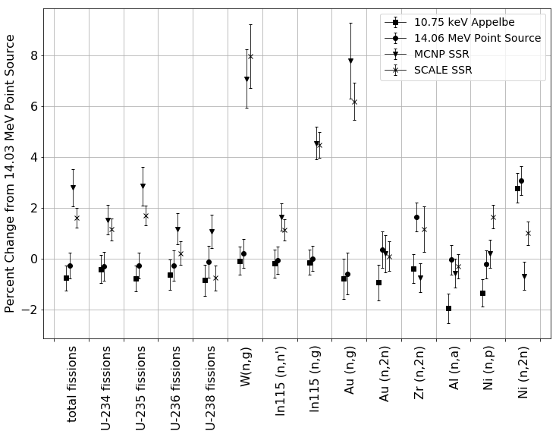

**Figure 33. Comparison of results based on NIF source term. The statistical uncertain- ties of the underlying datasets are all less than 1%. Utilizing a higher energy source term provides larger production of threshold reactions while including the room return increases the thermal reactions.**

sponse for these non-threshold reactions. Last, the comparison between MCNP and SCALE SSR results was generally consistent. The deviations from the mean were not systematically distributed as highlighted in Table 1.

## Statistical Analysis Tests

The statistical tests utilized for this research included the Chi-squared statistic, Pearson correlation coefficient, and the Kolmogorov-Smirnov (K-S) statistic. The Chi-squared is primarily utilized to test categorical distributions to assess if the results were governed by the expected distribution. The Pearson correlation coefficient and

KS statistic both provide information regarding the similarity of two distributions.

* + 1. Chi-squared Statistic The chi-squared statistic (*χ*2) is a useful tool for the in- terpretation of categorical results to expected values. The reduced *χ*2, as used in the foil activation neutron flux unfolding, is [96]

*χ*2 1 *n observed value - expected value*

,

= ( )2*.* (24)

*i*=1

*i*=1

*ν*

*ν*

*observed standard deviation*

The degrees of freedom are defined with the observed data points and param- eters computed to fit the equation. The degrees of freedom are the number of measurements in one data set minus one for the case of comparing two data sets of equal size.

*χ*2*/ν* can be used to assess goodness of fit between two distributions. The expected value for *χ*2*/ν* is unity if the calculated distribution is described by the expected distribution. *χ*2*/ν* much greater than one indicates that there is indeed a difference between the expected distribution and the observed.

The null hypothesis for the *χ*2 statistic is that the two sets of data are governed from the expected distribution. The test of independence shows the probability of rejecting this null hypothesis. The p-value can be used to compare the results of the expected distribution to the calculated *χ*2*/ν*. The p-value is the probability of finding a larger *χ*2*/ν*, given the calculated result. A small p-value (*<*0.05) signifies there is a strong significance level for the results not being governed by the expected distribution. P-values above the cutoff significance level fail to reject the null-hypothesis. A p-value of 0.05 or greater is generally accepted as statistically significant; however, this can change depending on the field of study.

* + 1. Pearson Correlation Coefficient

The Pearson correlation coefficient provides a measure of the linear relation- ship between two sets of data. This metric is often used for comparative signal analysis. Like the *χ*2 statistic, the Pearson correlation coefficient is best suited to normally distributed data. Additionally, the statistic is meant for linear datasets, so a non-linear function correlation may be misrepresented. The for- mula for the Pearson correlation coefficient is given as a function of *n* data points for two distributions defined by points *xi* and *yi* as

*r* = /*n*

*n x y* ( *x y* )

*x*2 − ( *xi*)2/*n*  *y*2 − (

*i i* − *i i*

*i*

*i*

*yi*)2

*.* (25)

The null hypothesis of this statistic is that there is no correlation between the two datasets. The p-value indicates the probability of an uncorrelated system producing a correlation coefficient at least as large in magnitude. Small p-values (*<*0.05) indicate a statistically significant Pearson correlation coefficient.

* + 1. Kolmogorov-Smirnov (K-S) statistic

K-S two-sample statistic compares the cumulative distribution functions (CDF) between two sets of data. The K-S statistic provides information on the relative magnitude of the distributions, so it is useful in combination with the Pearson correlation coefficient to quantify the similarity between two distributions. The K-S statistic is given as a function of the supremum (maximum) between the expected and observed CDF as shown in Equation 26. The null hypothesis for this test is that the two samples were drawn from the same distribution. Unlike the other statistical tests shown earlier, a large p-value (*>* 0.05) from the K-S statistic fails to reject the null hypothesis.

*D* = sup | *CDFexp*(*x*) − *CDFobs*(*x*) | (26)

*x*

# Analysis and Results

This sections provides the simulated ETA results including the propagation of systematic nuclear data uncertainty. The neutron flux timing profile does not include the *σsys* as the source mapping removed the time history data from the initial trans- port problem. First, the Monte Carlo simulation results pertaining to the neutron flux environment and foil pack activations are provided. The Monte Carlo results determined the effect of nuclear data covariance on the radiation transport simula- tion. Covariance analysis was only performed on ETA, not the objective TN+PFNS. As such, the final results are indicated by the MCNP-derived mean value with the bootstrapped uncertainty from the Sampler trials performed. Next, the results of the neutron flux unfolding are shown which indicate the level of confidence of the foil pack to unfold the neutron flux for the ETA experiment. Finally, the fission product distribution and individual isotope production is provided.

## ETA Monte Carlo Simulation Results

* + 1. **ETA Performance - Neutron Fluence Environment Comparison to TN+PFNS**

The main objective of ETA was to spectrally shape the DT source neutrons to the TN+PFNS. Therefore, the spectrum achieved was a key metric for determining the performance of ETA. Figure 34 displays the nominal neutron fluence on the HEU foil as a function of energy with *σstat* for the continuous energy neutron transport calculations.

Overall, there was agreement between the TN+PFNS and ETA fluence. Com- paring the nominal values, there were a few main areas of disagreement between the ETA result and TN+PFNS. First, below 50 keV, there was an increase in thermal



* + - 1. Logarithmic energy scale



* + - 1. Linear energy scale

**Figure 34. Neutron fluence for SCALE MAVRIC, MCNP and objective TN+PFNS spectra. Only** *σstat* **is captured for these results.**

neutrons; however, this portion of the spectrum only represents 1% of the ETA flu- ence. The NIF room return and low A spectral shaping components contributed to the majority of this fluence. Additionally, from 7 to 14 MeV there were relatively large differences caused by the method used to generate the TN+PFNS. Godiva, com- posed of HEU, has very little pathways to populate this region. Inelastic scattering and (n,xn) reactions often completely skip over this portion, and there would need to be many elastic scattering events to lower neutron energies to the range from the fusion source. The 14 MeV region disagreement was caused by the lack of attenua- tion of the source neutrons from weight constraints. Also above 14 MeV, there was a severely depressed neutron flux in ETA. A portion of the disagreement was caused by the mono-energetic source implementation; however, neutrons above 14.03 MeV would also be thermalized through ETA at nearly the same rate.

A summary of the fractional fluence of the TN+PFNS and ETA is shown in Table

1. The deviations produced are theoretically discernible within the experimental foil activation portion of the experiment. However, the predictable fission product distribution from each fluence is currently not as precise.

**Table 6. 5 energy group fractional fluence for ETA design compared to TN+PFNS**

|  |  |  |
| --- | --- | --- |
|  | Fractional Fluence | |
| Energy Range | ETA Φ | TN+PFNS Φ |
| 0 - 3 keV | 3.24E-04 | 7.23E-05 |
| 3 keV - 0.11 MeV | 4.85E-02 | 3.80E-02 |
| 0.11 MeV - 6.4 MeV | 7.83E-01 | 8.23E-01 |
| 6.4 MeV - 10 MeV | 1.93E-02 | 1.31E-02 |
| 10 MeV - 19.6 MeV | 1.49E-01 | 1.26E-01 |

Two statistical tests were conducted for additional confidence in the performance of ETA to spectrally shape the NIF source to the TN+PFNS. The results of the Pearson correlation coefficient and K-S statistic are summarized in Table 7. The in-

terpretation of the PCC result indicates that no correlation between the data sets was rejected with strong significance, and the K-S statistic indicates the null hypothesis that the samples were drawn from the same distribution could not be rejected.

**Table 7. Statistical test result comparisons between TN+PFNS and ETA performance. The** *H*0 **results indicated that there was a strong correlation between the data sets and the samples were likely drawn from the same distribution.**

|  |  |  |  |
| --- | --- | --- | --- |
|  | Pearson Correlation Coefficient  (p-value) | K-S Statistic (p-value) | *H*0 |
| TN+PFNS  versus MCNP SSR | 0.90 (p « 0.05) | 0.11 (p = 0.94) | Pearson - Rejected K-S Failed to Reject |
| MCNP SSR  versus SCALE MAVRIC  Mapped SSR | 0.9999 (p « 0.05) | 0.067 (p = 1.0) | Pearson - Rejected K-S - Failed to Reject |

The nominal value was utilized to determine the similarities between the TN+PFNS and ETA; however, the affect of nuclear data covariance on the neutron transport operated to provide a variability in the expected differential neutron fluence. The neu- tron flux uncertainty mapped to the 46 group structure DPLUS in comparison with the TN+PFNS is shown in Figure 35. The systematic uncertainty was mapped as described in Section 3.3.5. The fluence is shown per unit lethargy to remove binning artifacts.

The nominal value for each flux bin in Sampler was centered on the unper- turbed nuclear data transport as expected because the cross sections were sampled from a multivariate normal distribution. Additionally, the fluence results highlight the issue of different bin structures and the requirement to estimate the uncertainty for alternative bin structures. The 252 group and continuous energy MCNP results have very similar characteristics; however, the 252 group bin structure is much coarser



* 1. Logarithmic energy scale



* 1. Linear energy scale

**Figure 35. Neutron fluence per unit lethargy scale for Sampler, MCNP and objective TN+PFNS spectra.**

at high energy. The uncertainty results showed approximately 4% uncertainty for a large portion of the spectrum and rising where *σstat* was large. The form of the uncertainty is discussed further in Section 4.1.2. Although the DPLUS library was important for comparing the objective spectrum, the main target group structure was the 129 group STAYSL format.

## STAYSL Neutron Fluence with Mapped Systematic Uncertainty

The 129 group STAYSL structure was utilized for the group structure for the neutron flux unfolding. This group structure has fine resolution at high energy which allowed for higher fidelity unfolding of the primarily high energy ETA spectrum. The uncertainty from the Sampler bin structure mapped to the 129 group format is shown in Figure 36.

*σsys* was mapped over utilizing the midpoint energy bin linear interpolation. This is a reasonable approximation due to the behavior of the uncertainty as shown in Fig- ure 36. Alternative mappings may have been more appropriate if the uncertainty was not relatively constant. *σsys* dominated over *σstat* for nearly all of the fluence. At en- ergies close to the source energy of 14 MeV, the total uncertainty was approximately 4-6%, which is near the uncertainty of the total scattering cross section of tungsten and bismuth at higher energies. The intermediate energies between 0.01 and 8 MeV comprised a large portion of the neutron fluence and had total uncertainties of ap- proximately 3-4%. Due to multiple pathways to populate the peak of the PFNS, this region of the spectra was affected less than others. *σstat* and *σsys* are nearly the same magnitude at very high energy (*>* 14 MeV) and low energy (*<* 1 keV) where the neutron population is reduced. In these regions *σstat* was a much more significant contribution to the overall uncertainty, which generally was approximately 10% but approached 100% at the lowest energy bins.



* + - 1. Logarithmic energy scale



* + - 1. Linear energy scale

**Figure 36. Neutron fluence uncertainty from Sampler 252-group structure mapped to the 129 group STAYSL structure. The total uncertainty for Sampler (solid blue) and STAYSL (dash-dot blue) includes** *σsys* **from the nuclear data covariance and** *σstat* **from the Monte Carlo simulation.**

The ETA fluence in the 129-group STAYSL structure with mapped uncertainties is shown in Figure 37 in comparison with the SCALE/Sampler 252-group results from Figure 35. The STAYSL format again matched the characteristics of the 252 group format as seen with the DPLUS format; however, the bin width near the DT fusion source neutrons was smaller resulting in a more defined peak. Up-sampling in this region due to the finer resolution required the assumption that the uncertainty was relatively insensitive to group structure. Additionally, the nominal SCALE 252-group results were compared to the Sampler bootstrapped values which showed that the mean Sampler value is centered on the nominal unperturbed nuclear data case.

## Neutron Flux Timing Profile

Two major characteristics for a neutron flux environment for use in certification testing are the total fluence of neutrons and the temporal aspect. The incident fluence on the HEU foil was 4.9 × 1011 n cm*−*2 ± 1.4%. The time that the neutrons interacted with the volume has implications for applicability of the ETA concept to effects testing. The neutron fluence per unit area from an unshaped point source with a strength of 3.7 × 1015 neutrons at 29 centimeters (distance from source to ETA foils) is 3.5 ∗ 1011 n cm*−*2, so there was an increase in the net neutron population from the spherical divergence. The cumulative fluence on the HEU foil as a function of time is shown in Figure 38.

The total neutron pulse length in the ETA cavity was approximately 10 shakes or 100 nanoseconds. The uncollided source neutrons arrived at foil in approximately 0.6 shakes, consistent with the time required for a 14.03 MeV neutron to travel from the source to the HEU foil. The source neutrons make up a negligible portion of the total fluence seen by the foils as most are downscattered to nearly produce the objective TN+PFNS. The higher energy neutrons from 2 to 14 MeV took the shortest time



* + - 1. Logarithmic energy scale



* + - 1. Linear energy scale

**Figure 37. 129 group STAYSL fluence compared to Scale 252 group nominal fluence and Sampler values.**



**Figure 38. Cumulative fluence on HEU foil as a function of time broken into four broad energy groups.**

to arrive at the HEU foil as expected because these neutrons are moving faster and generally experience only a few interactions. The mid-range energy neutrons from

0.1 MeV to 2 MeV encompassed the bulk of the neutron fluence and took a slightly longer time or path to interact with the foils. Finally, the lower energy neutrons below 0.1 MeV took approximately 15 shakes to completely pass through the foils; however, this portion of the spectrum made up a very small percentage of the total fluence. For potential certification testing purposes, a notional electronic component would see the complete fluence in the 100 nanoseconds.

## 4.1.4 Activation Foil Activities

The resultant activities in the activation foils are presented in Table 8. The individual reactions from Table 1 in Section 3.2.3 were combined with the radioiso- tope decay constant based on the half-life. The initial activity post-irradiation was

compared to the activity at 2 hours, the anticipated time that the foil pack could be removed from the NIF for analysis. The foil activities, on the order of a kilo- Becquerel [kBq] with the exception of the indium foil, are acceptable for gamma-ray spectroscopy using the LLNL facilities. The indium product half-lives are relatively short in comparison to the other isotopes, so a higher activity allows for detection hours later.

**Table 8. Activation foil activities predicted with bootstrapped nuclear data covariance uncertainty.**

|  |  |  |  |
| --- | --- | --- | --- |
| **Reaction Product** | *T*1*/*2 | **Initial Activity [kBq]** | **2-hour Activity [kBq]** |
| 89Zr | 78.41 hrs | 4.63 ± 4.7% | 4.55 ± 4.7% |
| 57Ni | 35.6 hrs | 1.01 ± 4.8% | 0.97 ± 4.8% |
| 58Co | 70.86 days | 0.74 ± 2.5% | 0.74 ± 2.5% |
| 196Au | 6.17 days | 3.78 ± 4.8% | 3.75 ± 4.8% |
| 198Au | 2.69 days | 2.98 ± 2.6% | 2.92 ± 2.6% |
| 115Inm1 | 4.49 hrs | 164 ± 2.3% | 120 ± 2.3% |
| 116Inm1 | 54.29 min | 1,094 ± 3.4% | 236 ± 3.4% |
| 24Na | 15 hrs | 13.8 ± 4.6% | 12.6 ± 4.6% |
| 187W | 24 hrs | 5.79 ± 4.1% | 5.46 ± 4.1% |
| 56Mn | 2.58 hrs | 23.5 ± 20% | 13.7 ± 20% |

The bootstrapped uncertainty results showed there was a fairly large variance in the foil activities produced. Uncertainty in the radioactive half-life was not propa- gated as they were comparatively negligible. Most foils resulted in an uncertainty of a few percent; however, there is high uncertainty (20%) in the 55Mn reaction due to relatively large cross-section uncertainty over the activation range compared to other reactions. Additionally, this reaction was affected by lower energy neutrons where the net transport uncertainty was greater. A histogram of 58*Ni* (n,2n), 27Al (n,a), 115In (n,g), and 55Mn (n,g) reactions compiled from the post-processed Sam- pler results is shown in Figure 39. The remaining histograms’ deviation from these are minimal; the results indicated a quasi-Normal distribution centered on the

mean value determined from the non-perturbed nuclear data.

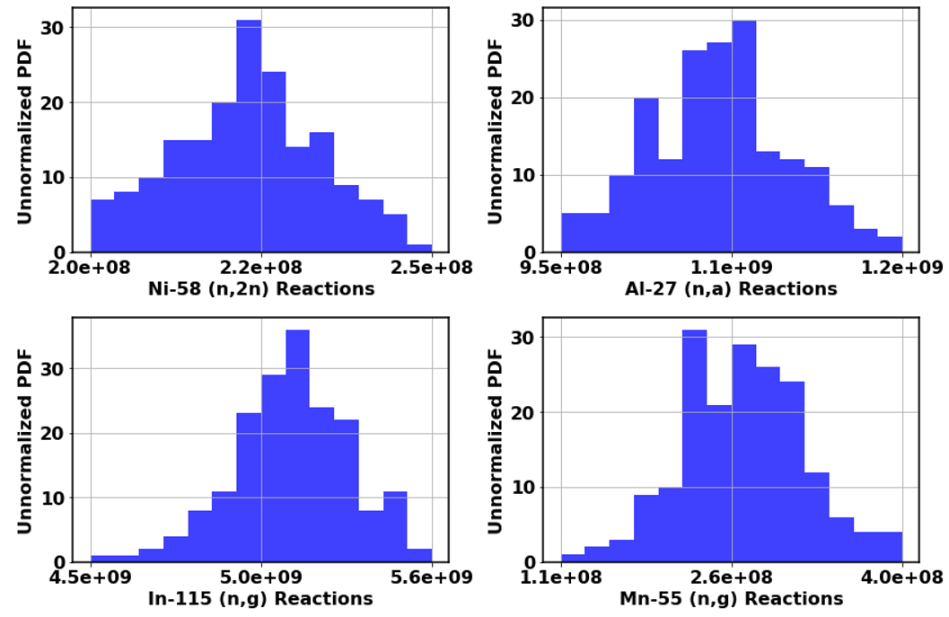

**Figure 39. Histograms of several activation foil reactions produced with Sampler re- sults.**

The contribution to the total uncertainty from neutron transport, as manifested in the fluence uncertainty, and reaction cross-section uncertainty was determined for the reactions that utilized the IRDFF nuclear data. Reactions that were completed solely in Sampler had this information convolved in the results and were not included in Table 9. The

The uncertainty contributions were largely dominated by the fluence uncertainty as expected since the reactions were chosen for low uncertainty over the activation range. The fluence uncertainty was nearly constant for all high energy threshold reactions covering the TN portion of the spectrum, which was caused by all four reactions having a very similar functional form and energy coverage. In general, non-threshold reactions experienced lower transport uncertainty because the reaction occured over all energy ranges, which reduces volatility in the reaction mechanism.

**Table 9. Contributions to total uncertainty for activation reactions utilizing IRDFF nuclear data.**

|  |  |  |  |
| --- | --- | --- | --- |
| **Reaction** | *σtotal* **[%]** | **Transport** *σ* **[%]** | **Reaction** *σ* **[%]** |
| 90Zr (n,2n) 89Zr | 4.66 | 4.60 | 0.78 |
| 58Ni (n,2n) 57Ni | 4.76 | 4.57 | 1.34 |
| 58Ni (n,p) 58Co | 2.50 | 2.14 | 1.29 |
| 197Au (n,2n) 196Au | 4.84 | 4.63 | 1.42 |
| 115In (n,n’) 115Inm1 | 2.33 | 1.85 | 1.42 |
| 115In (n,g) 116Inm1 | 3.45 | 2.59 | 2.28 |
| 27Al (n,a) 24Na | 4.62 | 4.59 | 0.45 |

## STAYSL Neutron Flux Unfolding Results

The 129-group STAYSL unfolded spectrum is shown in Figure 40. The results utilized the starting guess MCNP spectrum outlined in Section 4.1.2. The guess spectrum uncertainty provided physics-based input to restrict the range of spectrum adjustments performed by STAYSL. STAYSL was executed on all 182 sets of foil activities from Sampler to build up a distribution of possible modeled experimental outcomes. The largest *χ*2 trial and bootstrapped neutron fluence from all trials were added to Figure 40 for comparison with the initial guess MCNP spectrum. Addition- ally, the 5-95% activation ranges for each reaction are shown indicating the region informed in the unfolding procedure by a given reaction.

An important result from the unfolding procedure was defining the region that produced 90% of the activation for each reaction. These regions were important for determining the coverage of the activation foil set. Overall, the threshold reactions provided coverage at high energy and were mostly saturated by the 14 MeV peak. However, lower energy threshold reactions provided coverage between approximately 1 and 14 MeV. Finally, the thermal reactions were functionally epithermal neutron foils. Although these thermal reactions are not best suited for the epithermal region where the cross section is low, they proved beneficial by having a low cross section at

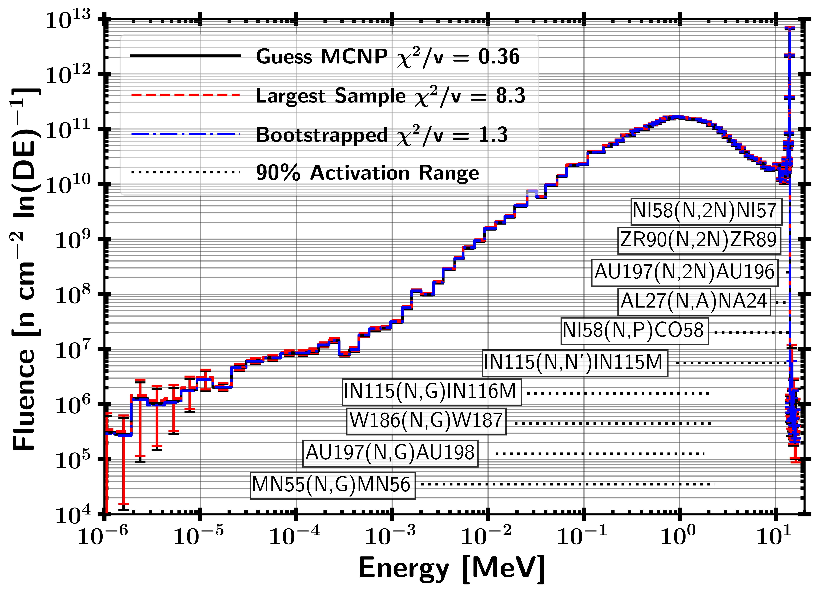

* + 1. Logarithmic energy scale

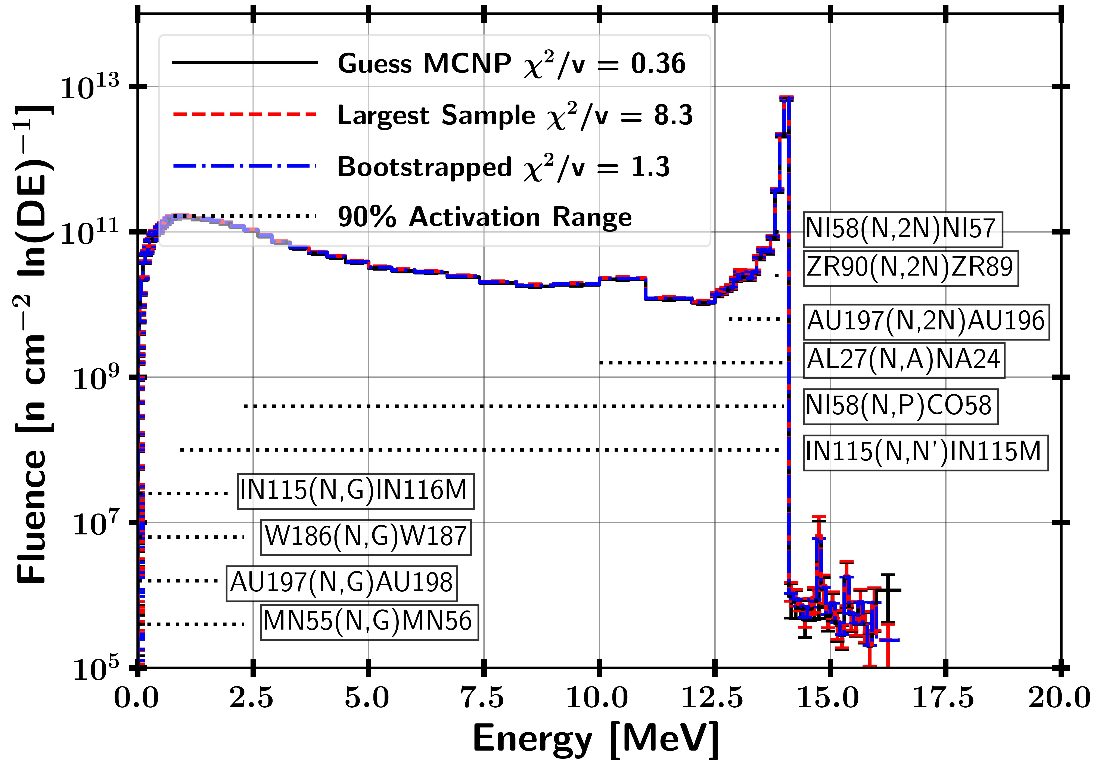

* + 1. Linear energy scale

**Figure 40. STAYSL unfolded spectra per unit lethargy for nominal guess, largest deviation, and bootstrapped values. The 90% activation range represents the saturation region for the foil reactions utilized in the neutron flux unfolding.**

high energy where the vast majority of neutrons were. This low cross section allowed for higher resolution in unfolding the epithermal portion of the neutron spectrum at the expense of having little coverage at thermal energies.

The *χ*2 results indicate that *H*0, that the two sets of data were governed from the expected distribution, could not be rejected for most of the trials with any amount of confidence. The *χ*2 was derived from the unfolded activities, not the neutron flux as the flux is not a categorical variable. The p-value reflects the probability of finding a greater *χ*2. The *χ*2 for the nominal guess, largest sample, and bootstrapped unfolded

activities was 0.36, 8.3, and 1.3 with p-values of 0.96, « 0.05, and 0.22, respectively.

The p-values indicated the probability of achieving a larger *χ*2 given the results, so the nominal case was within reasonable expectation while the largest *χ*2 value was rejected with strong significance. The bootstrapped activity p-value was closer to the rejection value of 0.05, but the result was large enough to not reject the unfolded activities. It is important to note that the *χ*2 values did not include the fluence uncertainty, only the bootstrapped activity uncertainty as outlined in Section 3.4.2. The distribution of *χ*2*/ν* values for the set of trials is shown in Figure 41.

The distribution of *χ*2 values peaked around 1; however, a non-negligible portion

of the unfolds provided results that rejected *H*0. A few cross sections may generally increase and other decrease, which had a negative effect on the ability to unfold the spectrum. Of the 182 trials, the hypothesis that activities come from the ex- pected distribution was not rejected 81.9% of the time and rejected 18.1% with 95% confidence.

## Fission Products

The fission product distribution and isotopes were the predicted observable quan- tity reflective of the neutron fluence incident on the HEU sample. First, the fissioning

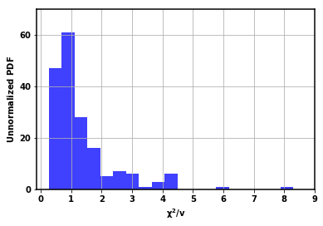

**Figure 41. Histogram of STAYSL unfolded ETA spectrum** *χ***2 for each unfolded trial.**

neutron energy spectra are described for 235U and 238U. These spectra were then used with the GEF and Nagy approach to provide an estimate of the non-volatile gases expected to be produced in the HEU.

## HEU Fission Spectra

The energy-dependent neutron fluence convolved with the fission cross section can be used to determine the fission rate as a function of energy for the various isotopes in the HEU foil. The resultant ETA fissions as a function of energy for 235U and 238U are shown in Figure 42.

The 235U fissions provide a similar functional form to the ETA sample cavity fluence. However, lower energy fissions comprise a much larger relative contribution to the total fissions, which motivated the necessity for lower statistical uncertainty at lower energies. Still, the majority of the fissions were produced by neutrons above 0.1 MeV in 235U. 238U is a fissionable isotope with a fission threshold at approximately



* + - 1. Logarithmic energy scale



* + - 1. Linear energy scale

**Figure 42. ETA HEU sample fissions as a function energy.**

1 MeV and was at a lower number density, so there were significantly fewer fissions overall. The remaining uranium isotopes were neglected as their contribution was negligible. The spectra here were utilized to provide the compound nucleus energy states for GEF.

## GEF

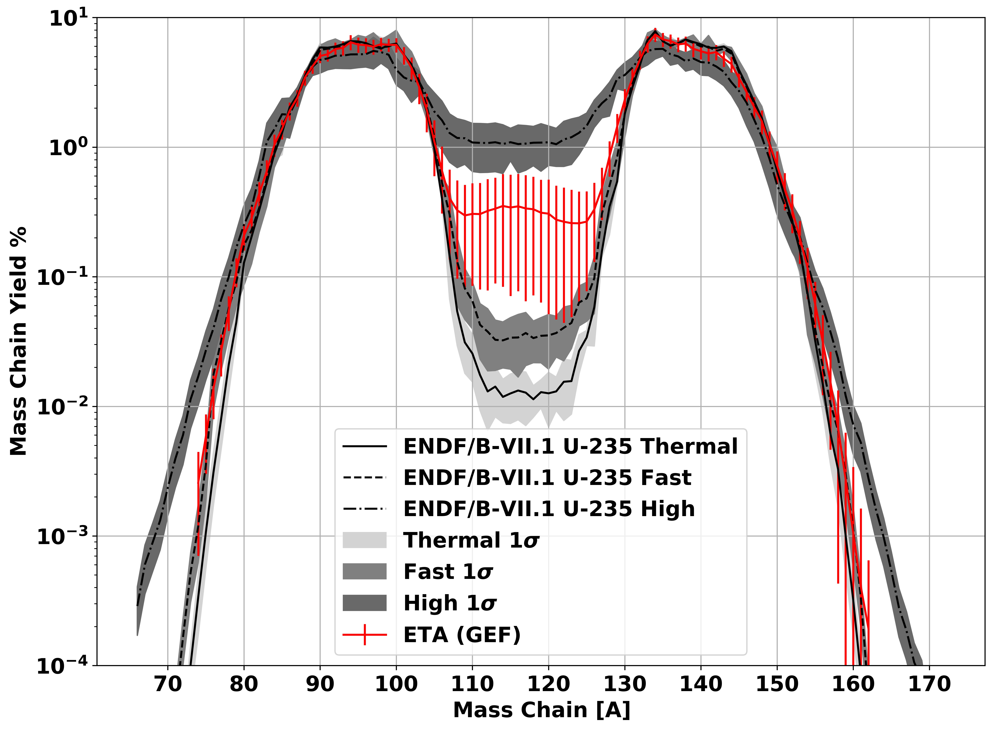GEF is a useful tool for generating the entire fission product mass chain yields over a large range of fissile and fissionable isotopes. A comparison between the ETA produced fission products and the previously shown ENDF-published data is shown in Figure 43. The resultant ETA fission product distribution is on average between the fast and high energy ENDF data. The error associated with the GEF results was large due to the Monte Carlo approach utilized by GEF which included perturbations to the constants utilized in addition to the neutron flux uncertainty.

**Figure 43. ETA fission product mass chain distribution calculated with GEF in com- parison to ENDF values.**

The resultant GEF mass chain distribution for ETA and the original objective TN+PFNS are displayed in Figure 44. Overall, there was large agreement in re- producing the fission product distribution expected from the TN+PFNS. The high uncertainty reflects the limited capability to predict mass chain fission products *a priori*.

**Figure 44. TN+PFNS versus ETA fission product mass chain distributions calculated with GEF values.**

The mass chain residual yields comparing ETA to the objective spectrum are shown in Figure 45. There were a few areas of disagreement between the mean value of ETA and the TN+PFNS. The symmetric valley fission products are systematically larger due to the increased high energy flux produced by ETA as highlighted in Table

6. Accordingly, the asymmetric fission products saw an increase. However, neither were substantial compared to the error.

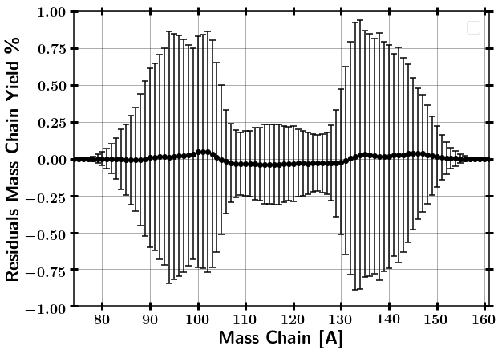

**Figure 45. Residual mass chain yields of ETA compared to TN+PFNS from GEF values.**

## Nagy Fits

The Nagy fit experimental data as a function of incident neutron energy was applied to the ETA fluence. The Nagy fit values represent the cumulative fission product yield for the individual isotope. The resultant fission product yields are compared between ETA and the objective TN+PFNS in Table 10 along with the relative activities compared to 95Zr. 95Zr has a longer half-life and a strong gamma- ray to use as a baseline for comparison to the other fission products.

The cumulative fission product yields in Table 10 are often the precursor to the stable state. In the case of additional steps in the decay chain before the stable state, the independent yield of isotopes down the decay chain have negligible yields. Therefore, all of the decay feeding passes through these cumulative fission product isotopes with the exception of 132Te. 132Te is in competition with 132I further in the decay chain. Therefore, the experimental yields, with the exception provided,

**Table 10. ETA and TN+PFNS produced Nagy fit cumulative fission product yield from experimental data. The fission product activities were compared to the longer-lived**

**95Zr**

.

|  |  |  |  |  |
| --- | --- | --- | --- | --- |
| **Fission Product** | **Fission Product Yield [%]** | | **Relative Activity to** 95Zr | |
| **ETA** | **TN+PFNS** | **ETA** | **TN+PFNS** |
| 91Sr | 5.36 ± 0.15 | 5.39 ± 0.08 | 141 ± 3.7% | 142 ± 1.7% |
| 92Sr | 5.40 ± 0.16 | 5.43 ± 0.10 | 517 ± 3.9% | 517 ± 2.0% |
| 95Zr | 6.04 ± 0.15 | 6.07 ± 0.06 | 1 ± 3.6% | 1 ± 1.3% |
| 97Zr | 5.71 ± 0.16 | 5.74 ± 0.08 | 86.8 ± 3.7% | 86.8 ± 1.6% |
| 99Mo | 5.61 ± 0.16 | 5.63 ± 0.08 | 21.6 ± 3.8% | 21.6 ± 1.7% |
| 103Ru | 3.15 ± 0.09 | 3.15 ± 0.05 | 0.851 ± 3.8% | 0.847 ± 1.7% |
| 105Ru | 1.37 ± 0.05 | 1.34 ± 0.04 | 78.3 ± 4.6% | 76.5 ± 3.0% |
| 109Pd | 0.32 ± 0.02 | 0.29 ± 0.02 | 6.00 ± 6.0% | 5.30 ± 5.3% |
| 111Ag | 0.28 ± 0.01 | 0.25 ± 0.01 | 0.400 ± 4.7% | 0.351 ± 3.6% |
| 112Pd | 0.27 ± 0.01 | 0.23 ± 0.01 | 3.23 ± 5.3% | 2.82 ± 4.5% |
| 113Ag | 0.20 ± 0.01 | 0.18 ± 0.01 | 9.54 ± 6.5% | 8.33 ± 6.0% |
| 115gCd | 0.29 ± 0.01 | 0.25 ± 0.01 | 1.38 ± 5.5% | 1.20 ± 4.8% |
| 132Te | 4.30 ± 0.12 | 4.31 ± 0.07 | 14.2 ± 3.8% | 142 ± 1.9% |
| 140Ba | 5.55 ± 0.15 | 5.60 ± 0.07 | 4.62 ± 3.7% | 4.63 ± 1.5% |
| 141Ce | 5.46 ± 0.16 | 5.49 ± 0.10 | 1.78 ± 3.9% | 1.78 ± 2.0% |
| 143Ce | 5.06 ± 0.15 | 5.11 ± 0.08 | 39.0 ± 3.8% | 39.2 ± 1.9% |
| 144Ce | 4.68 ± 0.13 | 4.74 ± 0.06 | 0.174 ± 3.7% | 0.175 ± 1.6% |
| 147Nd | 2.07 ± 0.06 | 2.08 ± 0.03 | 2.00 ± 3.7% | 2.00 ± 1.7% |
| 149Pm | 1.00 ± 0.04 | 1.00 ± 0.03 | 4.78 ± 4.8% | 4.79 ± 3.3% |
| 151Pm | 0.47 ± 0.02 | 0.46 ± 0.02 | 1,360 ± 5.0% | 1,340 ± 3.6% |
| 153Sm | 0.17 ± 0.01 | 0.17 ± 0.01 | 0.950 ± 6.0% | 0.936 ± 4.7% |
| 156Eu | 0.027 ± 0.001 | 0.025 ± 0.001 | 0.0187 ± 5.0% | 0.0176 ± 3.7% |
| 161Tb | 0.0012 ± 0.0001 | 0.0010 ± 0.00004 | 0.00185 ± 5.4% | 0.00160 ± 4.2% |

enable lower uncertainty approximations of the mass chain yields than GEF where experimental data exists. Figure 46 displays the ETA results with Nagy fit data in their given mass chains, which substantially improves the picture of predicting fission product yields. In particular, these isotopes serve as excellent verification data points for the ETA experiment in confirming the ETA fission products.

In a real world scenario, these fallout particles may be collected on the ground

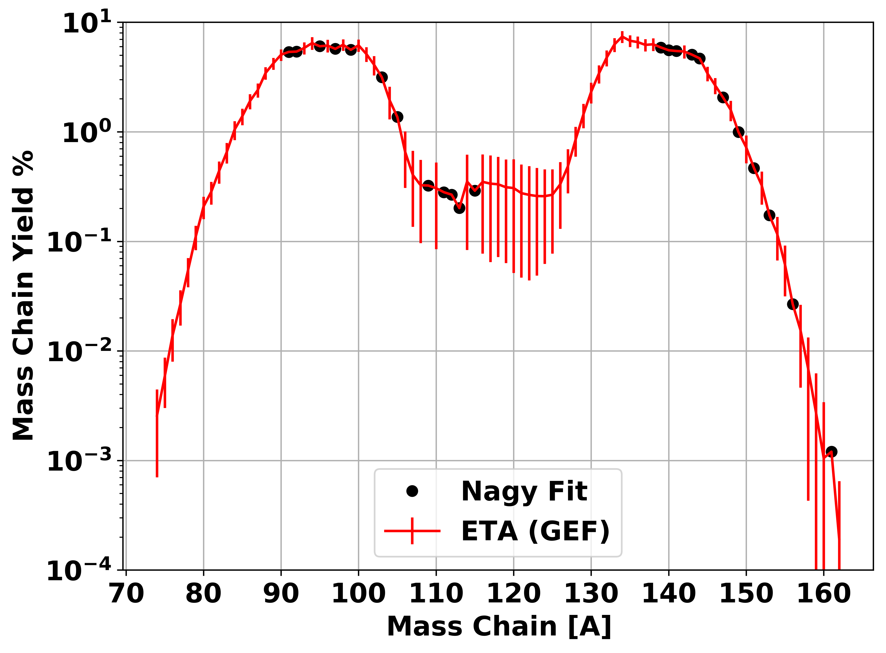

* + - 1. Logarithmic energy scale

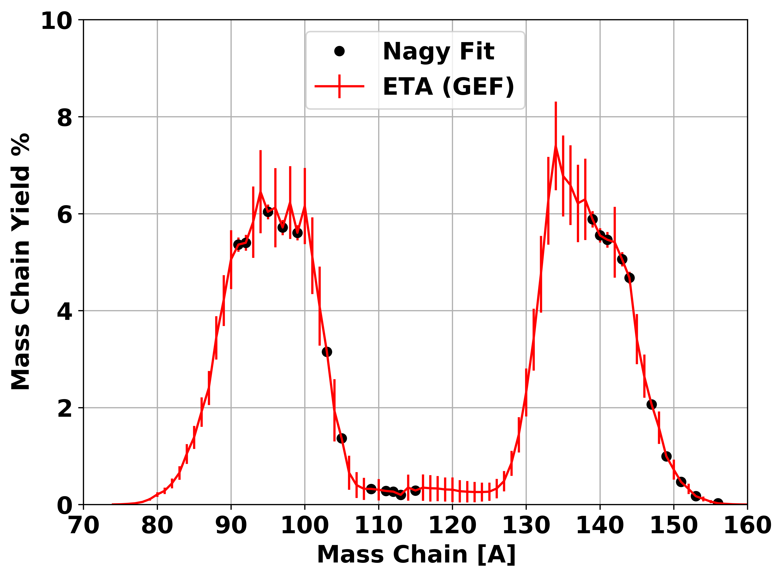

* + - 1. Linear energy scale

**Figure 46. Experimental predictions of ETA mass chain yields utilizing GEF and Nagy fit data where experimental measurements were taken.**

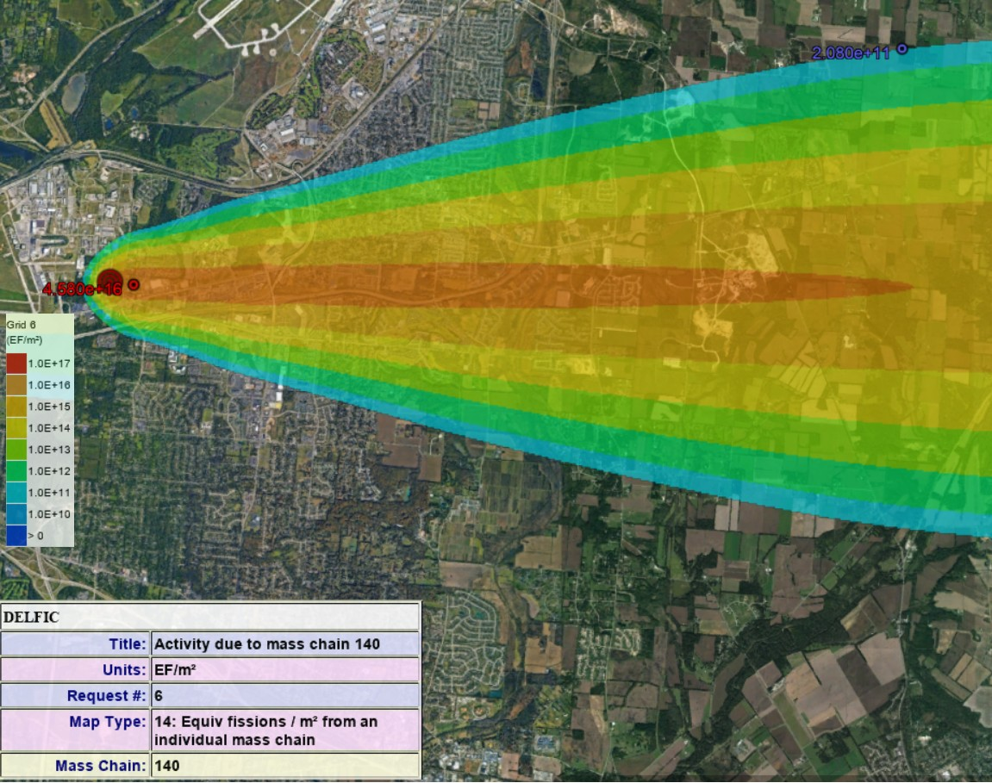or air as with the CTBT monitoring. The Department of Defense Fallout Prediction System, DELFIC, can model the fallout distribution on the ground following a nuclear event [97]. A 10 KT fission weapon at ground level was modeled using data from 16 August 2017 at Wright-Patterson Air Force Base, OH. The ground dispersal in effective fissions per meter square from the 140 mass chain is shown in Figure 47; the 140 mass chain was chosen because the yield does not change drastically with the fissioning system. ETA produced an equivalent number of fissions in 0.1 m2 of the lowest contour band. As the number of fissions increased, the quality of the sample was more useful. Nevertheless, the modeled ETA performance has promising capabilities to create spectrally accurate fission product debris.

**Figure 47. DELFIC calculated fission product equivalent fissions on the ground per unit area from mass chain 140.**

# 5. Conclusions and Recommendations

## 5.1 Modeled ETA Experiment

ETA can fill the technical nuclear forensics and nuclear weapon certification capability gaps that require a spectrally accurate neutron energy spectrum. The correct fission products associated with the thermonuclear plus prompt fission neu- tron spectrum (TN+PFNS) will follow directly from the neutron flux, which serves as an extremely valuable piece of information for attribution capabilities. Likewise, an accurate energy distribution of neutrons enhances nuclear weapons certification testing credibility. The objective of the ETA research was to determine if the neu- tron energy distribution in a ”typical” boosted nuclear weapon detonation can be produced using spectral modification with an energy tuning assembly (ETA) at the National Ignition Facility (NIF). The goal of this work was to determine the expected experimental outcomes of the ETA experiment by incorporating nuclear data covari- ance analysis. The novel ETA experiment is of high cost, so understanding the full effect of uncertainties including nuclear data was important to capture.

The ETA experiment characterization performed in this research indicated a very strong probability of the achieving the surrogate TN+PFNS as designed but found that the effect of nuclear data uncertainty and covariance on the ETA performance was non-negligible. The neutron transport effect on the fluence uncertainty was assessed with the SCALE Sampler sequence with 182 trials and found to be on the order of a few percent over the broad spectrum; however, the systematic uncertainties increased at lower neutron energies. The statistical testing performed on the ETA-pro- duced neutron fluence compared to the TN+PFNS showed large spectral agreement. The Pearson correlation coefficient between the nominal results and TN+PFNS was

0.9, which indicates strong agreement between the spectra. Also, the Kolmogorov-

Smirnov statistic comparing the cumulative distribution functions between the nom- inal results and TN+PFNS was 0.11 which has a p-value of 0.94 indicating the two samples were drawn from the same distribution with high confidence.

The ETA served as a candidate for neutron-induced radiation effects testing for nuclear weapon certification. The fluence of neutrons in the ETA sample cavity was

4.9 × 1011 n cm*−*2 ± 1.4%, which is near a useful range for testing (1012 - 1014 n

cm*−*2). The neutron pulse length for ETA was approximately 10 shakes, which may be useful depending on experimental timing requirements; however, the combination of fluence, spectrum, and timing provides a unique testing capability. However, it is worth noting that the current ETA design was not directly optimized to provide a nuclear weapons effects testing capability, and the TN+PFNS is not representative of the transmission neutron flux through material or atmosphere. Nonetheless, these results provide a step forward in progress toward a short pulse neutron source.

The foil reaction uncertainties utilized the International Reactor Dosimetry and Fusion File (IRDFF) v.1.05 nuclear data library and were sampled according to a multivariate normal distribution. The propagated nuclear data uncertainty on the foil activities resulted in uncertainties on the order of a few percent for all but the 55Mn (n,*γ*) reaction where the nuclear data was not as well characterized and the systematic error was found the be 20%. The foil activities produced in the ETA cavity were found to be sufficient sources for gamma-ray spectroscopy post-shot at the NIF.

Additionally, the activation foil pack designed to unfold the neutron energy spec- trum in the ETA experiment was found to have broad neutron energy spectrum coverage and multi-reaction coverage at epithermal energies, typically a trouble area for unfolding. The STAYSL unfolded results on each of the 182 Sampler trials pro- vided an 80+% probability of being able to successfully unfold the neutron spectrum

with the foil set and the modeled spectrum based on the *χ*2 of each unfolded trial. In the context of technical nuclear forensics and attribution capabilities, the ob-

servable quantity is the fission product distribution created from the neutron flux interaction with the fissile material. ETA’s modeled performance produced 2 × 109

± 1% fissions, which is near the order of those collected in forensics ground samples.

Selected fission products were analyzed with the General Description of Fission Ob- servables (GEF) code and experimental data was used to create energy dependent Nagy fits. The fission products produced by ETA have an equivalent cumulative fis- sion product distribution to the defined objective TN+PFNS with current predictive capabilities. Spectrally accurate fission product distributions are extremely impor- tant to nuclear forensics and attribution linked to counter-proliferation efforts and attribution techniques for deterrence.

## Future Work

The NIF experiment to validate the ETA is planned for late 2019. The future work related to the analysis performed here will compare the experimental outcomes to the predicted reactions. The experimental results create a verification of the nuclear data covariance analysis technique utilized. Updates to this analysis will include changes to the fielded configuration of ETA for the experiment. The tools generated for this work will heavily expedite the re-analysis.

Although ETA is a huge step forward for developing synthetic weapon debris, improvements will be made to develop a second generation ETA. A THErmonuclear and prompt fission Neutron spectrum energy tuning Assembly (ATHENA) will be developed to generate a more representative neutron spectrum. Additionally, facility improvements to the NIF and updated constraints will be incorporated to increase the optimization. The goal of ATHENA is to develop a new ETA design to increase

the ETA efficiency to produce ∼ 1012 fissions. Attaining a higher number of fissions is extremely important to create better quality samples and achieve better detection

of low production fission products.

Finally, the goals focused on generating a spectrally accurate neutron source and the generation of fission products; however, real-world scenario deposits as nu- clear fallout and includes fractionation based on the physical properties and chemistry of the fission products. A fractionation technique can most readily focus on refractory fission products with low condensation points, as opposed to volatile mass chains, as many of these are gases that may be lost in chemical separations. Incorporating the fractionated synthetic fission product debris into a matrix representative to a nuclear forensics collection would be of great benefit to technical nuclear forensics training and exercises.

# Appendix A. Reproducibility

All of the underlying documentation presented for this research is available in an online repository at <https://github.com/nickquartemont/NIF_ETA>. Several Python 2.7 scripts were created to read in data files produced from Sampler as an al- ternative to the built-in version in SCALE to work more with the data. Much of this work may prove useful to others needing the tools created for this work with some simple modifications. The organization of the repository follows the major efforts taken for the research. A list of tools that will be most beneficial for others is below. The main page includes the thesis, experiment collaboration, documents, briefs, and the models used.

* + - Sampler Tools ([https://github.com/nickquartemont/NIF_ETA/tree/master/Models/Scale/](https://github.com/nickquartemont/NIF_ETA/tree/master/Models/Scale/ScalePy) [ScalePy](https://github.com/nickquartemont/NIF_ETA/tree/master/Models/Scale/ScalePy))

Instructions for utilizing the tools to read in and analyze response functions from Sampler are described in readme.txt. This tool can be directly utilized for response functions text files generated by SCALE Sampler. The Sampler files are saved to a pickle file containing the dictionary dataframe of the energy dependent response data.

* + - STAYSL with Sampler Trials ([https://github.com/nickquartemont/NIF_ETA/tree/master/Models/STAYSL_](https://github.com/nickquartemont/NIF_ETA/tree/master/Models/STAYSL_Unfold/SAMPLER) [Unfold/SAMPLER](https://github.com/nickquartemont/NIF_ETA/tree/master/Models/STAYSL_Unfold/SAMPLER))

This tool utilizes the Sampler dataframe to generate independent trials for STAYSL and build up the distribution of unfolded responses. STAYSL Analysis.py provides the user interface for the tool.

* + - Fission Product Estimation with GEF ([https://github.com/nickquartemon](https://github.com/nickquartemont/NIF_ETA/tree/master/Models/FissionProduct/GEF)t/NIF_ETA/tree/master/Models/FissionProduct/ [GEF](https://github.com/nickquartemont/NIF_ETA/tree/master/Models/FissionProduct/GEF))

The GEF data has been saved as an Excel file to reduce the size and fit within GitHub’s storage restrictions. Users who use the 46 group DPLUS library structure can directly utilize this framework. GEF.py provides the user interface for the GEF data.

* + - Fission Product Estimation with Nagy Fits ([https://github.com/nickquartemon](https://github.com/nickquartemont/NIF_ETA/tree/master/Models/FissionProduct/NagyFits)t/NIF_ETA/tree/master/Models/FissionProduct/ [NagyFits](https://github.com/nickquartemont/NIF_ETA/tree/master/Models/FissionProduct/NagyFits))

The Nagy fit function requires input of the fissioning system or incident energy. Additional isotopes can be added directly to the Excel document containing the experimental data by following the same format. ETA Nagy.py provides the user interface utilized to generate the fission products for ETA.

# Bibliography

1. M. Chadwick and E. Al., “ENDF/B-VII.1 Nuclear Data for Science and Tech- nology: Cross Sections, Covariances , Fission Product Yield,” *Nucl.Data Sheets*, vol. 112, no. 12, pp. 2887–2996, 2011.
2. Office of the Secretary of Defense, “Nuclear Posture Review,” 2018.
3. Department of Defense, “Summary of the 2018 National Defense Strategy of the United States of America.”
4. Joint Defense Science Board/Threat Reduction Advisory Committee Task Force, “The Nuclear Weapons Effects National Enterprise,” Office of the Under Sec- retary of Defense for Acquisition, Technology, and Logistics, Tech. Rep. June, 2010.
5. J. Bevins, “Targeted Modification of Neutron Energy Spectra for National Secu- rity Applications,” Ph.D. dissertation, University of California, Berkeley, 2017.
6. D. J. Trump, “State of the Union Address,” 2018.
7. Department of Defense, “Operation of the Defense Acquisition System (DOD Instruction 5000.02).”
8. Department of Defense, “DoD Nuclear Weapons Surety Program (DOD Directive 3150.02).”
9. J. C. Martz, “Without Testing: Stockpile Stewardship in the Second Nuclear Age,” Los Alamos National Lab.(LANL), Los Alamos, NM (United States), Tech. Rep., 2014.
10. Joint Defense Science Board Task Force, “Nuclear Weapon Effects Test, Evalua- tion, and Simulation,” Office of the Under Secretary of Defense for Acquisition, Technology, and Logistics, Tech. Rep. April, 2005.
11. *Nuclear Forensics: A Capability at Risk (Abbreviated Version)*. Washington, DC: The National Academies Press, 2010.
12. Joint Nuclear Forensics Working Group of the American Physical Society and the American Association for the Advancement of Science, “Nuclear Forensics: Role, State of the Art, and Program Needs.” Tech. Rep., 2013.
13. US National Security Council, “Review of the doe national security labs’ use of archival nuclear test data,” Committee on the Evaluation of Quantification of Margins and Uncertainties Methodology for Assessing and Certifying the Relia- bility of the Nuclear Stockpile, Letter Report, 2005.
14. V. Fedchenko, Ed., *The New Nuclear Forensics: Analysis of Nuclear Materials for Security Purposes*. Solna, Sweeden: Oxford University Press, 2015.
15. United Nations Scientific Committee on the Effects of Atomic Radiation, “Sources and Effects of Ionizing Radiation, vol. 1, Sources, 2000 Report to the General Assembly with Scientific Annexes, E.00.IX.3,” United Nations, New York, Tech. Rep., 2000.
16. C. J. Bridgman, *Introduction to the Physics of Nuclear Weapons Effects*. Fort Belvoir, VA: Defense Threat Reduction Agency, 2001.
17. Sandia National Laboratory, “Sun sets on Sandia Pulsed Reactor,” 2007.
18. United States Nuclear Regulatory Commission, “10 CRF Part 75: Safeguards on Nuclear Material,” 2018.
19. K. P. Carney, M. R. Finck, C. A. McGrath, L. R. Martin, and R. R. Lewis, “The Development of Radioactive Glass Surrogates for Fallout Debris,” *Journal of Radioanalytical and Nuclear Chemistry*, vol. 299, no. 1, pp. 363–372, 2014.
20. F. Dietrich and J. Escher, “Compound-nuclear Reaction Cross Sections via Sur- rogate Reactions,” *Nuclear Physics A*, vol. 787, no. 1, pp. 237 – 242, 2007, pro- ceedings of the Ninth International Conference on Nucleus-Nucleus Collisions.
21. N. D. Scielzo *et al.*, “Statistical *γ* Rays in the Analysis of Surrogate Nuclear Reactions,” *Physical Review C - Nuclear Physics*, vol. 85, no. 5, 2012.
22. J. E. Escher, J. T. Burke, F. S. Dietrich, N. D. Scielzo, I. J. Thompson, and

W. Younes, “Compound-nuclear reaction cross sections from surrogate measure- ments,” *Rev. Mod. Phys.*, vol. 84, pp. 353–397, Mar 2012.

1. N. Gharibyan, “Development af a fission-proxy method for the measurement of 14-MeV neutron fission yields at cams,” 10 2016.
2. N. Galy, N. Toulhoat, N. Moncoffre, Y. Pipon, N. B´ererd, M. R. Ammar, P. Si- mon, D. Deldicque, and P. Sainsot, “Ion Irradiation Used as Surrogate of Neutron Irradiation in Graphite: Consequences on 14C and 36Cl Behavior and Structural Evolution,” *Journal of Nuclear Materials*, vol. 502, pp. 20–29, 2018.
3. J. Bouchard and R. Heaphy, “QASPR Validation : Moving from Research Codes to Trusted Codes,” Sandia National Laboratories, Tech. Rep., 2007.
4. Y. Kasesaz and M. Karimi, “A Novel Design of Beam Shaping Assembly to use D-T Neutron Henerator for BNCT,” *Applied Radiation and Isotopes*, vol. 118, no. September, pp. 317–325, 2016.
5. I. M. Ardana and Y. Sardjono, “Optimization of a Neutron Beam Shaping Assem- bly Design for BNCT and Its Dosimetry Simulation Based on MCNPX,” *Jurnal Teknologi Reaktor Nuklir Tri Dasa Mega*, vol. 19, no. 3, p. 121, 2017.
6. L. Zaidi, M. Belgaid, S. Taskaev, and R. Khelifi, “Beam Shaping Assembly Design of 7Li(p,n)7Be Neutron Source for Boron Neutron Capture Therapy of Deep- Seated Tumor,” *Applied Radiation and Isotopes*, vol. 139, no. May, pp. 316–324, 2018.
7. J. E. Bevins, “Coeus V1.0,” 2017. [Online]. Available: [https://github.com/](https://github.com/SlaybaughLab/Coeus/releases) [SlaybaughLab/Coeus/releases.](https://github.com/SlaybaughLab/Coeus/releases)
8. J. E. Bevins, S. Bogetic, L. A. Bernstein, R. Slaybaugh, and J. Vujic, “Meta- heuristic Optimization Method for Neutron Spectra Shaping,” *Transactions of the American Nuclear Society*, vol. 118, pp. 455–458, 2018.
9. R. Stickney, Jason, “Pulse Height Spectra Analysis of a Neutron Energy Tuning Assembly,” Ph.D. dissertation, Air Force Institute of Technology, 2018.
10. Department of Defense, “Nuclear Weapons Technology,” in *Military Critical Technologies List*, 1998.
11. S. Glasstone and P. J. Dolan, *The Effects of Nuclear Weapons*, 3rd ed. Wash- ington D.C.: United States Department Of Defense, 1977.
12. K. H. Schmidt, B. Jurado, C. Amouroux, and C. Schmitt, “General Description of Fission Observables: GEF Model Code,” *Nuclear Data Sheets*, vol. 131, no. May, pp. 107–221, 2016.
13. S. Nagy, K. F. Flynn, J. E. Gindler, J. W. Meadows, and L. E. Glendenin, “Mass Distributions in Monoenergetic-Neutron-Induced Fission of U238,” *Physical Re- view C*, vol. 17, no. 1, pp. 163–171, 1978.
14. L. Greenwood and C. Johnson, “Least-Squares Neutron Spectral Adjustment with STAYSL PNNL,” *EPJ Web of Conferences*, vol. 106, p. 07001, 2016.
15. B. Rearden, M. Jessee, and Eds., *User Guide for the STAYSL PNNL Suite of Software Tools*, PNNL-22253, Pacific Northwest National Laboratory, Richland, WA, February 2013.
16. J. Turner, *Atoms, Radiation, and Radiation Protection*. Oak Ridge, TN: Wiley, 2008.
17. K. Krane, *Introductory Nuclear Physics*. New York: Jon Wiley & Sons, 1988.
18. H. Salmon, R. nal, B. Oruncak, U. Akcaalan, and H. A. Yalim, “(n,2n) and (n,3n) Neutron Induced Reaction Cross Sections above 8 MeV,” *Acta Physica Polonica, A*, vol. 128, no. 2B, pp. B–231 – B–235, 2015.
19. A. Tonchev *et al.*, “Energy Evolution of the Fission-Product Yields from Neutron- Induced Fission of 235U, 238U, and 239Pu: An Unexpected Observation,” in *The 6th International Conference on ”Fission and Properties of Neutron-Rich Nuclei*, 2016.
20. J. Randrup and R. Vogt, “Nuclear Fission.” in *LLNL-BOOK-591732*. Lawrence Livermore National Laboratory, 2012.
21. K.-H. Schmidt and B. Jurado, “General Description of Fission Observables,”

*JEFF Report 24*, 2014.

1. A. Nichols, D. Aldama, and M. Verpelli, “Handbook of Nuclear Data for Safe- guards: Database Extensions,” International Atomic Energy Agency, Tech. Rep. August, 2008.
2. M. James, R. Mills, and D. Weaver, “A New Evaluation of Fission Product Yields and the Production of a New Library (UKFY2) of Independent and Cumulative Yields.” *Progress in Nuclear Energy*, vol. 26, no. 1, pp. 1 – 29, 1991.
3. E. Privas, G. Noguere, J. Tommasi, C. De Saint Jean, K.-H. Schmidt, and

R. Mills, “Measurements of the Effective Cumulative Fission Yields of 143Nd, 145Nd, 146Nd, 148Nd and 150Nd for 235U in the PHENIX Fast Reactor,” *EPJ Nu- clear Sciences & Technologies*, vol. 2, no. 32, pp. 1–16, 2016.

1. B. Singh, “Nuclear data sheets for A = 89,” *Nuclear Data Sheets*, vol. 114, no. 1, pp. 1 – 208, 2013.
2. D. A. Brown, E. A. Mccutchan, M. W. Herman, S. Hoblit, G. P. A. Nobre, and

B. Pritychenko, “Uncertainty Quantification in the Nuclear Data Program,” *J. Phys. G: Nucl. Part. Phys.*, vol. 42, no. 034020, 2015.

1. F. Bostelmann and G. Strydom, “Nuclear Data Uncertainty and Sensitivity Anal- ysis of the VHTRC Benchmark Using SCALE,” *Annals of Nuclear Energy*, vol. 110, pp. 317–329, 2017.
2. A. Knecht *et al.*, “Precision Measurement of the 6He Half-Life and the Weak Axial Current in Nuclei,,” *Phys. Rev. Lett.*, vol. 108, no. 122502, 2012.
3. R. Capote, K. Zolotarev, V. Pronyaev, and A. Trkov, “International Reactor Dosimetry and Fusion File IRDFF v.1.05,” *J. ASTM International*, vol. 9, no. 4, April 2012.
4. L. Greenwood, M. Kostal, S. Simakov, and A. Trkov, “Testing and Improving the International Reactor Dosimetry and Fusion File (IRDFF),” 2017.
5. K. I. Zolotarev and P. K. Zolotarev, “Evaluation of Some (n,n’), (n,*γ*), (n,p), (n,2n) AND (n,3n) Reaction Excitation Functions for Fission and Fusion Reactor

Dosimetry Applications,” INDC International Nuclear Data Committee, Tech. Rep. INDC(NDS)-0657, 2013.

1. C. Diez, O. Cabellos, J. Martnez, and C. Ceresio, “Importance of nuclear data uncertainties in criticality calculations.” *EPJ Web of Conferences*, vol. 27, p. 4, 2012.
2. D. Rochman, A. J. Koning, S. C. Van Der Marck, A. Hogenbirk, and C. M. Sciolla, “Nuclear data uncertainty propagation: Perturbation vs. Monte Carlo,” *Annals of Nuclear Energy*, vol. 38, no. 5, pp. 942–952, 2011.
3. A. Aures, F. Bostelmann, M. Hursin, and O. Leray, “Benchmarking and Applica- tion of the State-of-the-art Uncertainty Analysis Methods XSUSA and SHARK- X,” *Annals of Nuclear Energy*, vol. 101, pp. 262–269, 2017.
4. C. J. D´ıez, O. Buss, A. Hoefer, D. Porsch, and O. Cabellos, “Comparison of Nuclear Data Uncertainty Propagation Methodologies for PWR Burn-up Simu- lations,” *Annals of Nuclear Energy*, vol. 77, pp. 101–114, 2015.
5. T. Zhu, A. Vasiliev, H. Ferroukhi, A. Pautz, and S. Tarantola, “NUSS-RF: Stochastic sampling-based tool for nuclear data sensitivity and uncertainty quan- tification,” *Journal of Nuclear Science and Technology*, vol. 52, no. 7-8, pp. 1000– 1007, 2015.
6. B. Rearden, M. Jessee, and Eds., *SCALE Code System*, ORNL/TM-2005/39

,Version 6.2.3, Oak Ridge National Laboratory, Oak Ridge Tennessee, March 2018, available from Radiation Safety Information Computational Center as CCC- 834.

1. N. P. Luciano, “A High-Energy Neutron Flux Spectra Measurement Method for the Spallation Neutron Source,” Master’s thesis, University of Tenessee Knoxville, 2012.
2. E. E. Lewis and W. F. Millar Jr, *Computational Methods of Neutron Transport*. New York: John Wiley & Sons, 1984.
3. M. J. Wang, R. J. Sheu, J. J. Peir, and J. H. Liang, “Criticality Calculations of the HTR-10 Pebble-bed Reactor with SCALE6/CSAS6 and MCNP5,” *Annals of Nuclear Energy*, vol. 64, pp. 1–7, 2014.
4. S. R. Johnson and K. T. Clarno, “Comparison of SCALE and MCNP Results for Computational Pebble Bed Benchmarks,” *Trans. Am. Nucl. Soc.*, vol. 96, no. April, pp. 420–422, 2007.
5. Y. F. Chen, R. J. Sheu, S. H. Jiang, J. N. Wang, and U. T. Lin, “Surface Dose Rate Calculations of a Spent-Fuel Storage Cask by Using MAVRIC and Its Com- parison with SAS4 and MCNP,” *Nuclear Technology*, vol. 175, no. 1, pp. 343–350, 2011.
6. G. F. Knoll, *Radiation Detection and Measurement, 4th Edition.* Ann Arbor, MI: Wiley, 2010.
7. L. Kuijpers, R. Herzing, P. Cloth, D. Filges, and R. Hecker, “On the Determi- nation of Fast Neutron Spectra with Activation Techniques; its Application in a Fusion Reactor Blanket Model,” *Nuclear Instruments and Methods*, vol. 144, no. 2, pp. 215–224, 1977.
8. E. Vagena, K. Theodorou, and S. Stoulos, “Thick-foils Activation Technique for Neutron Spectrum Unfolding with the MINUIT RoutineComparison with GEANT4 Simulations,” *Nuclear Instruments and Methods in Physics Research, Section A: Accelerators, Spectrometers, Detectors and Associated Equipment*, vol. 887, no. January, pp. 64–69, 2018.
9. M. Reginatto, “Overview of Spectral Unfolding Techniques and Uncertainty Es- timation,” *Radiation Measurements*, vol. 45, no. 10, pp. 1323–1329, 2010.
10. F. G. Perey, *Least-Squares Dosimetry Unfolding: The Program STAY’SL (ORNL/TM-6062)*, Oak Ridge, Tennessee, 1977.
11. H. R. Vega Carrillo and M. P. I. De La Torre, “Catalogue to Select the Ini- tial Guess Spectrum During Unfolding,” *Nuclear Instruments and Methods in Physics Research, Section A: Accelerators, Spectrometers, Detectors and Associ- ated Equipment*, vol. 476, no. 1-2, pp. 270–272, 2002.
12. T. Goorley *et al.*, “Initial mcnp6 release overview,” *Nuclear Technology*, vol. 180, no. 3, pp. 298–315, 2012.
13. S. W. Mosher *et al.*, “ADVANTG: An Automated Variance Reduction Parameter Generator,” in *ORNL/TM-2013/416 Rev 1*, 2015.
14. O. Hurricane *et al.*, “Fuel gain exceeding unity in an inertially confined fusion implosion,” *Nature*, vol. 506, pp. 343–348, 01 2014.
15. C. B. Yeamans and B. E. Blue, “National Ignition Facility Neutron Sources,” Lawrance Livermore National Laboraotry, Tech. Rep., 2018.
16. K. C. Chen, H. Huang, and A. Nikroo, “Fabrication of Br-doped Glow Discharge Polymer ( GDP ) Capsules,” 2017.
17. H. Brysk, “Fusion Neutron Energies and Spectra,” *Plasma Physics*, vol. 15, no. 7, pp. 611–617, 1973.
18. B. Appelbe and J. Chittenden, “Relativistically Correct DD and DT Neutron Spectra,” *High Energy Density Physics*, vol. 11, no. 1, pp. 30–35, 2014.
19. X-5 Monte Carlo Team, “MCNP - A General Monte Carlo N-Particle Transport Code, Version 5,” *LA-UR-03-1987*, 2008.
20. E. I. Moses *et al.*, “Overview: Development of the National Ignition Facility and the Transition to a User Facility for the Ignition Campaign and High Energy Density Scientific Research,” *Fusion Science and Technology*, vol. 69, no. 1, pp. 1–24, 2016.
21. D. Campolina and J. Frybort, “Uncertainty Propagation for Lwr Burnup Bench- mark Using Sampling Based Code Scale/Sampler,” *Acta Polytechnica CTU Pro- ceedings*, vol. 14, p. 8, 2018.
22. D. Rochman, A. Vasiliev, H. Ferroukhi, T. Zhu, S. C. Van Der Marck, and A. J. Koning, “Nuclear Data Uncertainty for Criticality-Safety: Monte Carlo vs. Linear Perturbation,” *Annals of Nuclear Energy*, vol. 92, pp. 150–160, 2016.
23. M. Griseri, L. Fiorito, A. Stankovskiy, and G. Van den Eynde, “Nuclear Data Uncertainty Propagation on a Sodium Fast Reactor,” *Nuclear Engineering and Design*, vol. 324, no. February, pp. 122–130, 2017.
24. W. Wieselquist, T. Zhu, A. Vasiliev, and H. Ferroukhi, “PSI Methodologies for Nuclear Data Uncertainty Propagation with CASMO-5M and MCNPX: Results for OECD/NEA UAM Benchmark Phase I,” *Science and Technology of Nuclear Installations*, vol. 2013, 2013.
25. T. Zhu, A. Vasiliev, H. Ferroukhi, and A. Pautz, “NUSS: A Tool for Propagating Multigroup Nuclear Data Covariances in Pointwise ACE-formatted Nuclear Data Using Stochastic Sampling Method,” *Annals of Nuclear Energy*, vol. 75, pp. 713– 722, 2015.
26. M. L. Williams *et al.*, “A Statistical Sampling Method for Uncertainty Analysis with SCALE and XSUSA,” *Nuclear Technology*, vol. 183, no. 3, pp. 515–526, 2013.
27. G. Zerovnik, R. Capote, and A. Trkov, “On Random Sampling of Correlated Res- onance Parameters with Large Uncertainties,” *Nuclear Instruments and Methods in Physics Research, Section A: Accelerators, Spectrometers, Detectors and As- sociated Equipment*, vol. 723, pp. 89–98, 2013.
28. K. Schmidt *et al.*, “General Description of Observables in Low-energy Fission : GEF Model Code,” 2015.
29. L. Glendenin, J. Gindler, D. Henderson, and J. W. Meadows, “Mass Distributions for Monoenergetic-Neutron-Induced Fission of 235U,” *Physical Review C*, vol. 24, no. 6, pp. 2600–2605, 1981.
30. G. P. Ford and R. B. Leachman, “Fission Mass Yield Dependence on Angular Momentum,” *Physical Review*, vol. 137, no. 4 B, 1965.
31. M. E. Gooden *et al.*, “Energy Dependence of Fission Product Yields from235U,238U and239Pu for Incident Neutron Energies Between 0.5 and 14.8 MeV,” *Nuclear Data Sheets*, vol. 131, pp. 319–356, 2016.
32. M. E. Gooden, “Energy Dependence of Fission Product Yields from 235U, 238U, and 239Pu for Incident Neutron Energies Between 0.5 and 14.8 MeV,” Ph.D. dissertation, North Caroline State University, 2014.
33. D. R. Nethaway and G. Barton, “A Compilation of Fission Product Yields in use at the Lawrence Livermore Labratory,” Tech. Rep., 1973.
34. C. Chapman, T and G. A. Anzelon, “Fission Product Yields from 6-9 MeV Neu- tron Induced Fission of U-235 and U-238,” *Physical Review C*, vol. 17, no. 3, pp. 1089–1097, 1978.
35. T. R. England and B. F. Rider, “Evaluation and Compliation of Fission Product Yields,” *La-Ur-94-3106*, pp. 1–173, 1994.
36. J. G. Cuninghame, J. A. B. Goodall, and H. H. Harris, “Absolute Yields in the Fission of 235U By Mono-Energetic Neutrons of Energy 130-1700 keV,” *J. Inorg. Nucl. Cham.*, vol. 36, no. 7, pp. 1453–1457, 1974.
37. J. R. Taylor, *An Introduction to Error Analysis: The Study of Uncertainties in Physical Measurements*, 2nd ed. South Orange, NJ: University Science Books, 1997.
38. H. G. Norment, “DELFIC: Department of Defense Fallout Prediction System.” in *Fundamentals, vol. I. Atmospheric Science Associates*. Bedford MA: ADA 088 367, 1979.

|  |  |  |  |  |  |  |  |
| --- | --- | --- | --- | --- | --- | --- | --- |
| **REPORT DOCUMENTATION PAGE** | | | | | | | *Form Approved OMB No. 0704–0188* |
| The public reporting burden for this collection of information is estimated to average 1 hour per response, including the time for reviewing instructions, searching existing data sources, gathering and maintaining the data needed, and completing and reviewing the collection of information. Send comments regarding this burden estimate or any other aspect of this collection of information, including suggestions for reducing this burden to Department of Defense, Washington Headquarters Services, Directorate for Information Operations and Reports (0704–0188), 1215 Jefferson Davis Highway, Suite 1204, Arlington, VA 22202–4302. Respondents should be aware that notwithstanding any other provision of law, no person shall be subject to any penalty for failing to comply with a collection of information if it does not display a currently valid OMB control number. **PLEASE DO NOT RETURN YOUR FORM TO THE ABOVE ADDRESS.** | | | | | | | |
| **1. REPORT DATE** *(DD–MM–YYYY)*  19–15–2011 | | | **2. REPORT TYPE**  Master’s Thesis | | | | **3. DATES COVERED** *(From — To)*  Jan 2010 — Aug 2011 |
| **4. TITLE AND SUBTITLE**  Effect of Storm Enhanced Densities on Geo-Location Accuracy Over CONUS | | | | | | **5a. CONTRACT NUMBER** | |
| **5b. GRANT NUMBER** | |
| **5c. PROGRAM ELEMENT NUMBER** | |
| **6. AUTHOR(S)**  Capt Lindon H. Steadman | | | | | | **5d. PROJECT NUMBER** | |
| **5e. TASK NUMBER** | |
| **5f. WORK UNIT NUMBER** | |
| **7. PERFORMING ORGANIZATION NAME(S) AND ADDRESS(ES)**  Air Force Institute of Technology  Graduate School of Engineering and Management (AFIT/EN) 2950 Hobson Way  WPAFB OH 45433-7765 | | | | | | | **8. PERFORMING ORGANIZATION REPORT NUMBER**  AFIT/GAP/ENP/11-S01 |
| **9. SPONSORING / MONITORING AGENCY NAME(S) AND ADDRESS(ES)**  Air Force Weather Agency 101 Nelson Drive  Offutt AFB, NE 68113  DSN 271-0690, COMM 402-294-0690  Email: [2syosdor@offutt.af.mil](mailto:2syosdor@offutt.af.mil) | | | | | | | **10. SPONSOR/MONITOR’S ACRONYM(S)**  AFWA |
| **11. SPONSOR/MONITOR’S REPORT**  **NUMBER(S)** |
| **12. DISTRIBUTION / AVAILABILITY STATEMENT**  APPROVED FOR PUBLIC RELEASE; DISTRIBUTION UNLIMITED. | | | | | | | |
| **13. SUPPLEMENTARY NOTES** | | | | | | | |
| **14. ABSTRACT**  Storm enhanced densities (SEDs) are ionospheric plasma enhancements that disrupt radio communications in the near-Earth space environment, degrading the Global Positioning System (GPS) and other high-frequency systems.  Accurate GPS/total electron content (TEC) correction maps produced by ionosphere models can mitigate degradations from SEDs. An artificial SED was created and ingested via slant TEC measurements into the Global Assimilation of Ionospheric Measurements Gauss-Markov Kalman Filter Model to determine how many ground GPS receivers are needed to produce reliable GPS/TEC correction maps over the continental United States during geomagnetic storming. It was found that 110 well-positioned GPS receivers produced the best overall TEC accuracy, although significantly improved accuracy was still achieved if 40 or more receivers were used. It was determined that receiver positioning had a greater impact on TEC accuracy than the number of receivers. Additionally, it was found that TEC accuracy for the SED region increased at the expense of TEC accuracy everywhere else on the map. | | | | | | | |
| **15. SUBJECT TERMS**  Ionosphere, Ionosphere Forecast Model, Global Assimilation of Ionospheric Measurements Gauss-Markov Kalman Filter Model, Space Weather | | | | | | | |
| **16. SECURITY CLASSIFICATION OF:** | | | | **17. LIMITATION OF ABSTRACT**  U | **18. NUMBER OF PAGES**  110 | **19a. NAME OF RESPONSIBLE PERSON**  Lt Col Ariel O. Acebal, AFIT/ENP | |
| **a. REPORT**  U | **b. ABSTRACT**  U | **c. THIS PAGE**  U | |
| **19b. TELEPHONE NUMBER** *(include area code)*  (937) 255-3636, x4518; [ariel.acebal@afit.edu](mailto:ariel.acebal@afit.edu) | |

**Standard Form 298 (Rev. 8–98)**

**Prescribed by ANSI Std. Z39.18**